2. Invesco India Mid Cap ()
Why I chose it
- Long fund history → started in 2007, so the scheme itself has nearly 20 years of history.
- Current fund management is associated with Aditya Khemani, with the current management structure being much newer than HDFC's.
- Strong bottom-up, fundamental, high-conviction approach.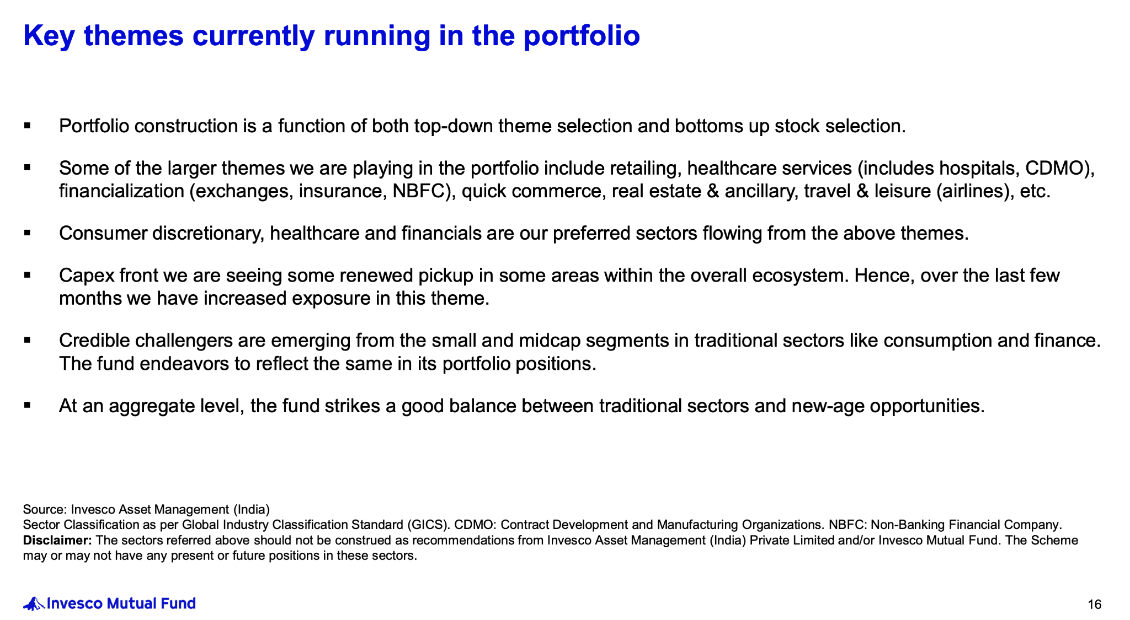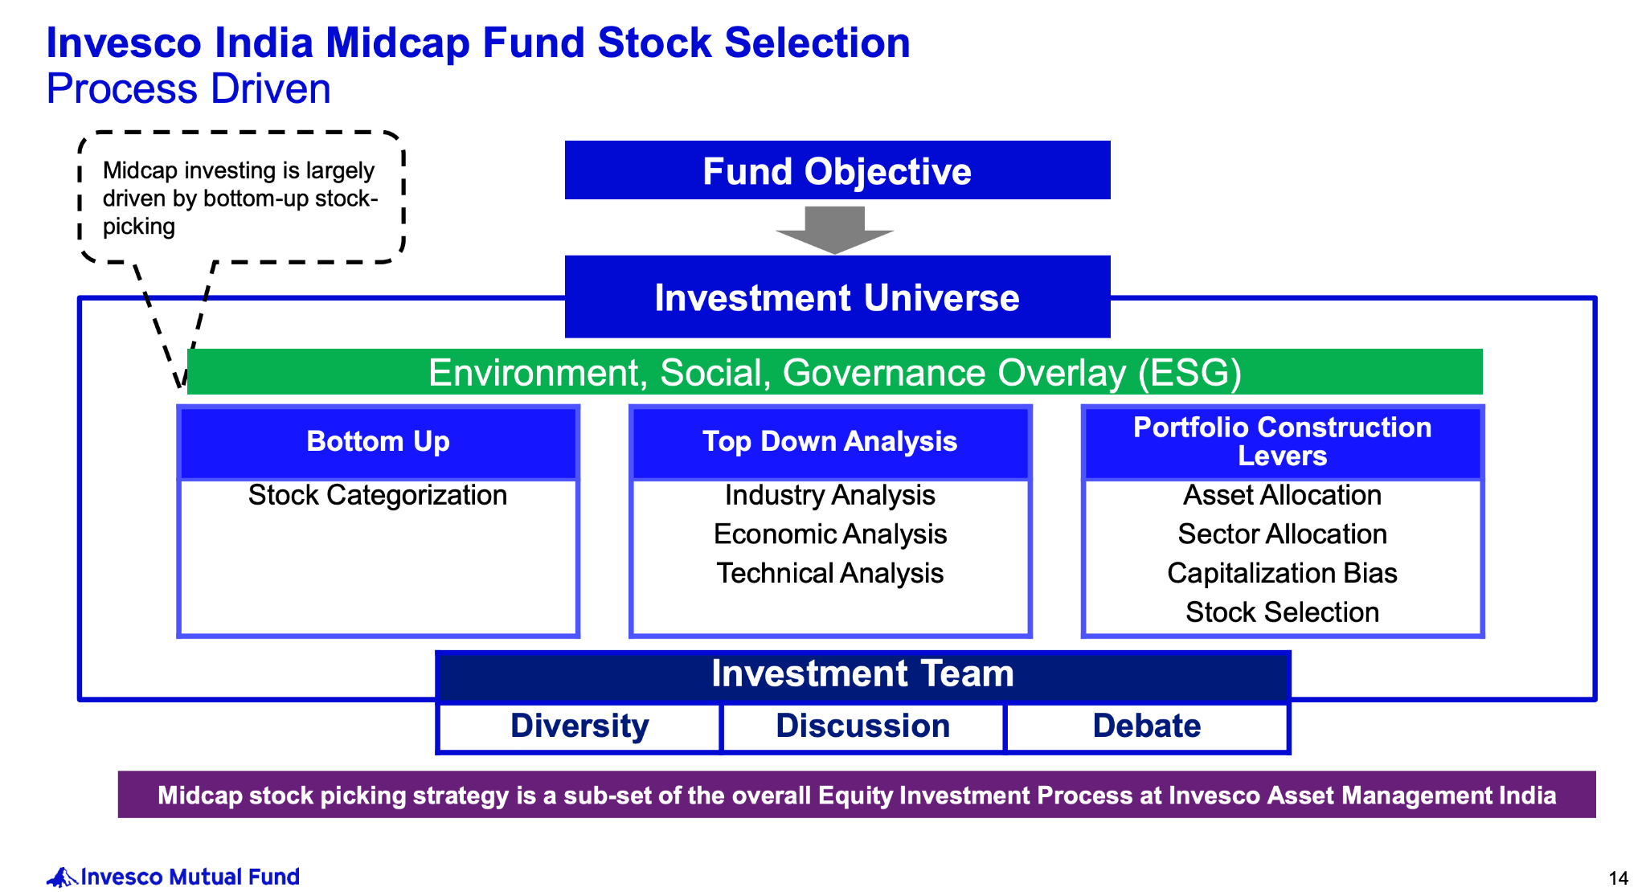
- This is the most concentrated of my three:
  - roughly 39 stocks
  - top 10 around 49%
- That concentration is intentional: the manager can take larger positions in companies where the team has high conviction.
- Historically, this has translated into very strong alpha:
  - ~19.9% 10Y CAGR
  - ~4.27% 10Y alpha
  - ~4.78% 15Y alpha
- Strong rolling-return and SIP record as well.
- Downside capture has also historically been below 100%, so the higher-conviction approach hasn't simply meant taking unlimited downside.
- More growth/opportunity oriented than HDFC ( p/e > 40 )
- 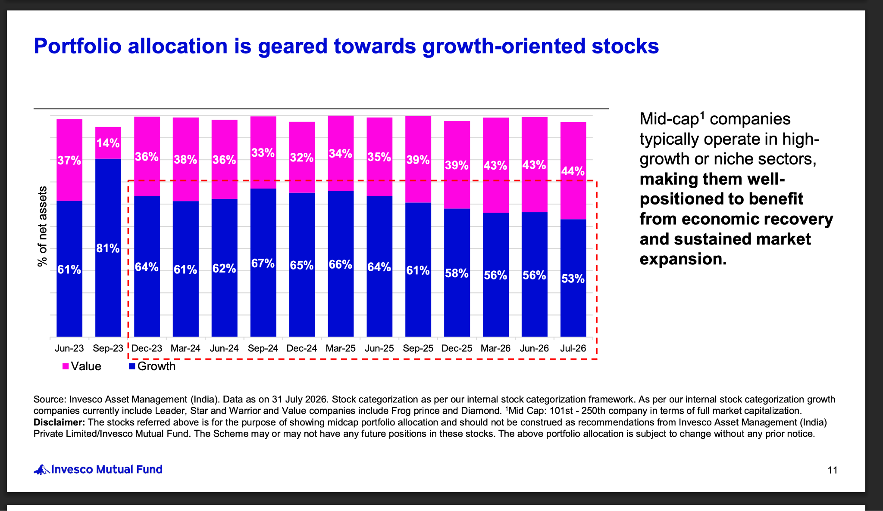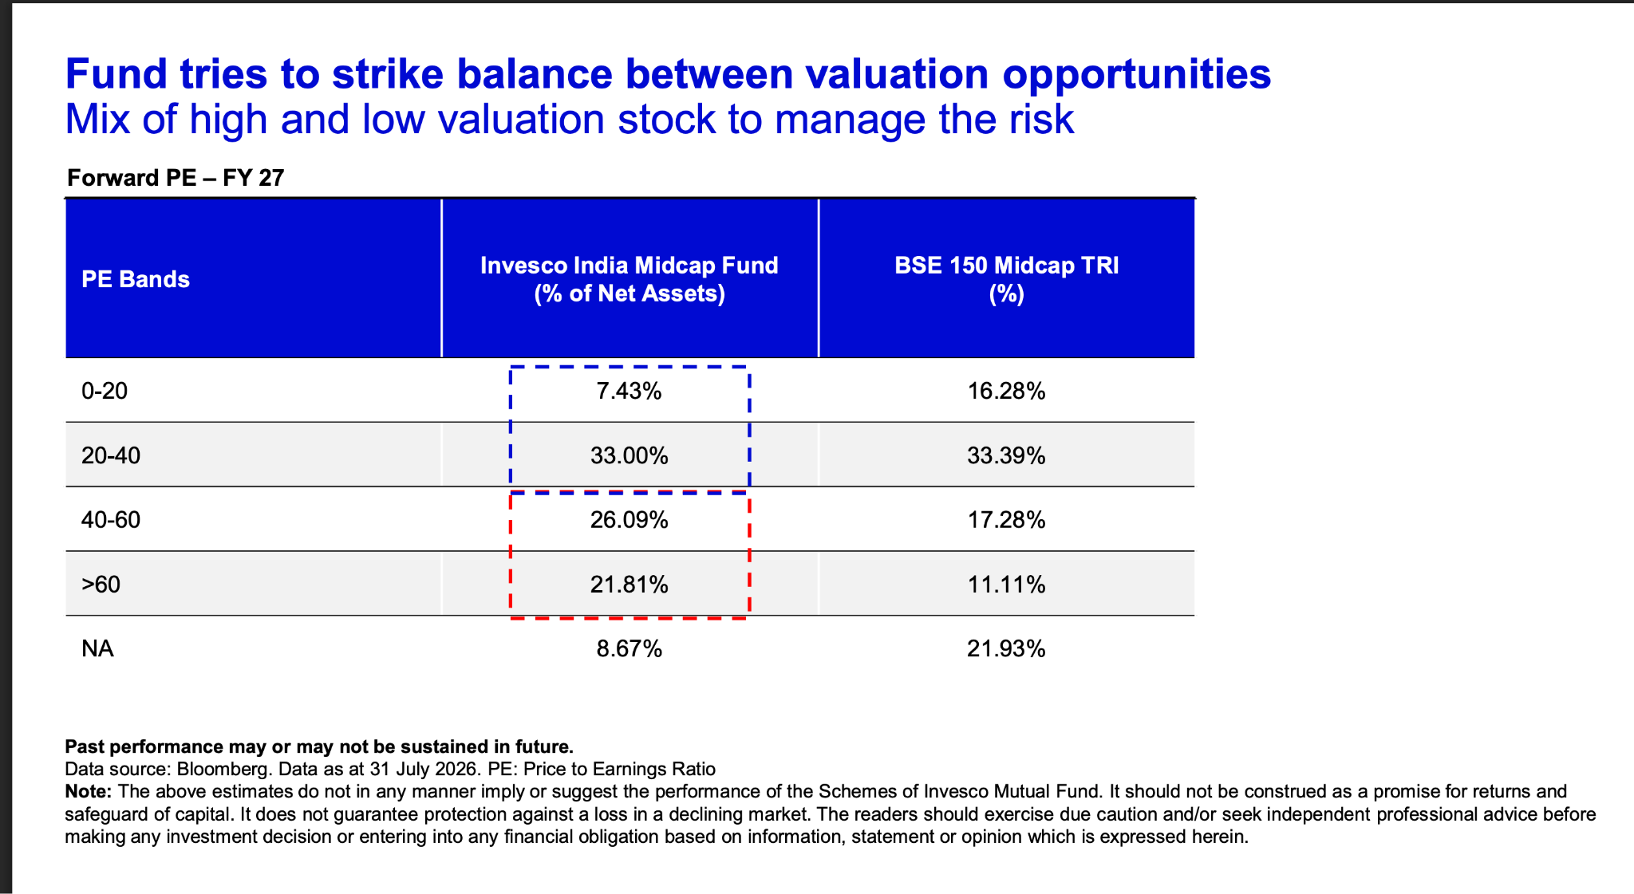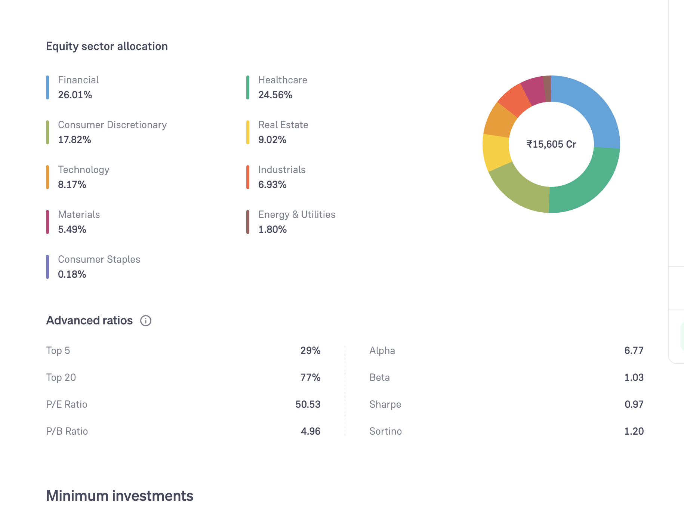, although I would not call it a pure growth fund.
- Gives my portfolio a deliberate higher-conviction component rather than having three highly diversified portfolios.
- The trade-off is obvious: higher concentration = greater company-specific risk.
- Current manager tenure is much shorter than HDFC's, so I don't give the historical 10–15 year record full attribution to the current manager.But he seems fine he has hands of taher badshah.
- https://www.invescomutualfund.com/docs/default-source/presentations-pdf/invesco-india-midcap-fund---31-july-2026.pdf?sfvrsn=bdad9fc2_0
- has only 20% overlap with midcap 150 idnex.
My thinking:
“I already have broad fundamental portfolios. I want one fund that is willing to make bigger bets when the manager has strong conviction. I accept the additional concentration risk in exchange for a genuinely different portfolio construction.”

3. HDFC Mid Cap ( for now not choosing this , choosign edeilweiss over this )
Why I chose it
- Old fund + exceptional manager continuity → started in 2007, and Chirag Setalvad has managed it since June 2007. He is also Head – Equities at HDFC AMC. ( key man risk )
- Has therefore gone through multiple complete market cycles under the same lead manager/process.
- Investment philosophy is bottom-up + quality + reasonable valuation + long-term + diversified.
- Very large AUM (~₹1 lakh crore+) → gives scale/liquidity, but I recognize that such a large AUM is a potential concern for a mid-cap fund.
- Portfolio is still reasonably diversified: roughly 79 stocks, with top 10 around 32%.
- Has a relatively balanced portfolio rather than making extremely large bets on a few companies.
- Historically has shown good downside protection, which matters to me because I don't want my entire mid-cap allocation to behave aggressively during corrections.
- The biggest reason I prefer it as a core fund is not that it has the highest return — it is the combination of long history + same manager + established process + diversification.
- Follow kind of garp philospohy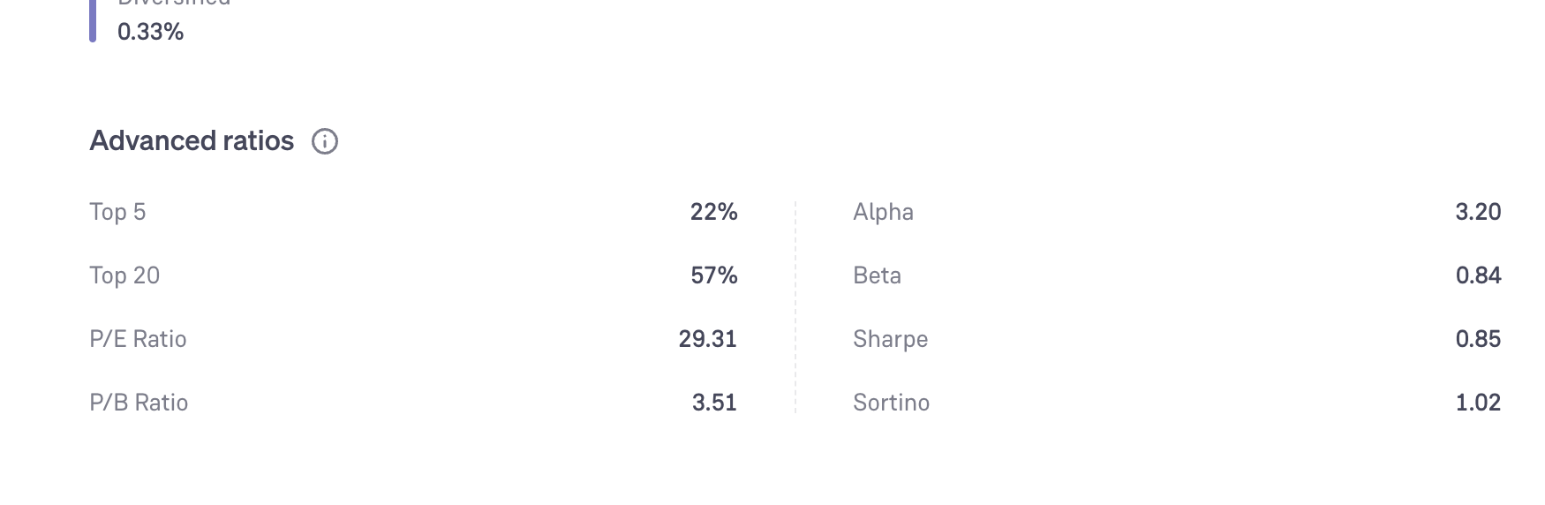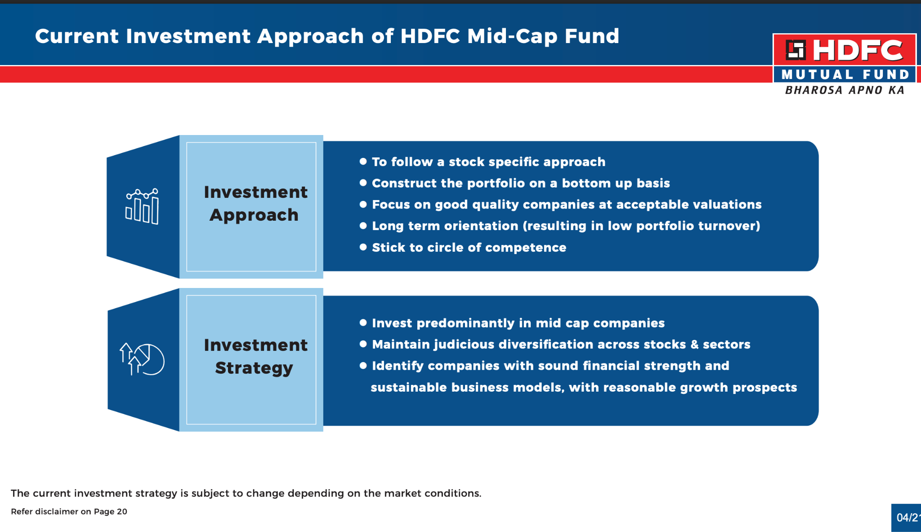
- https://files.hdfcfund.com/s3fs-public/Others/2026-06/HDFC%20Mid%20Cap%20Fund%20Presentation%20%28June%202026%29.pdf
- had 30% overlap with midcap 150index 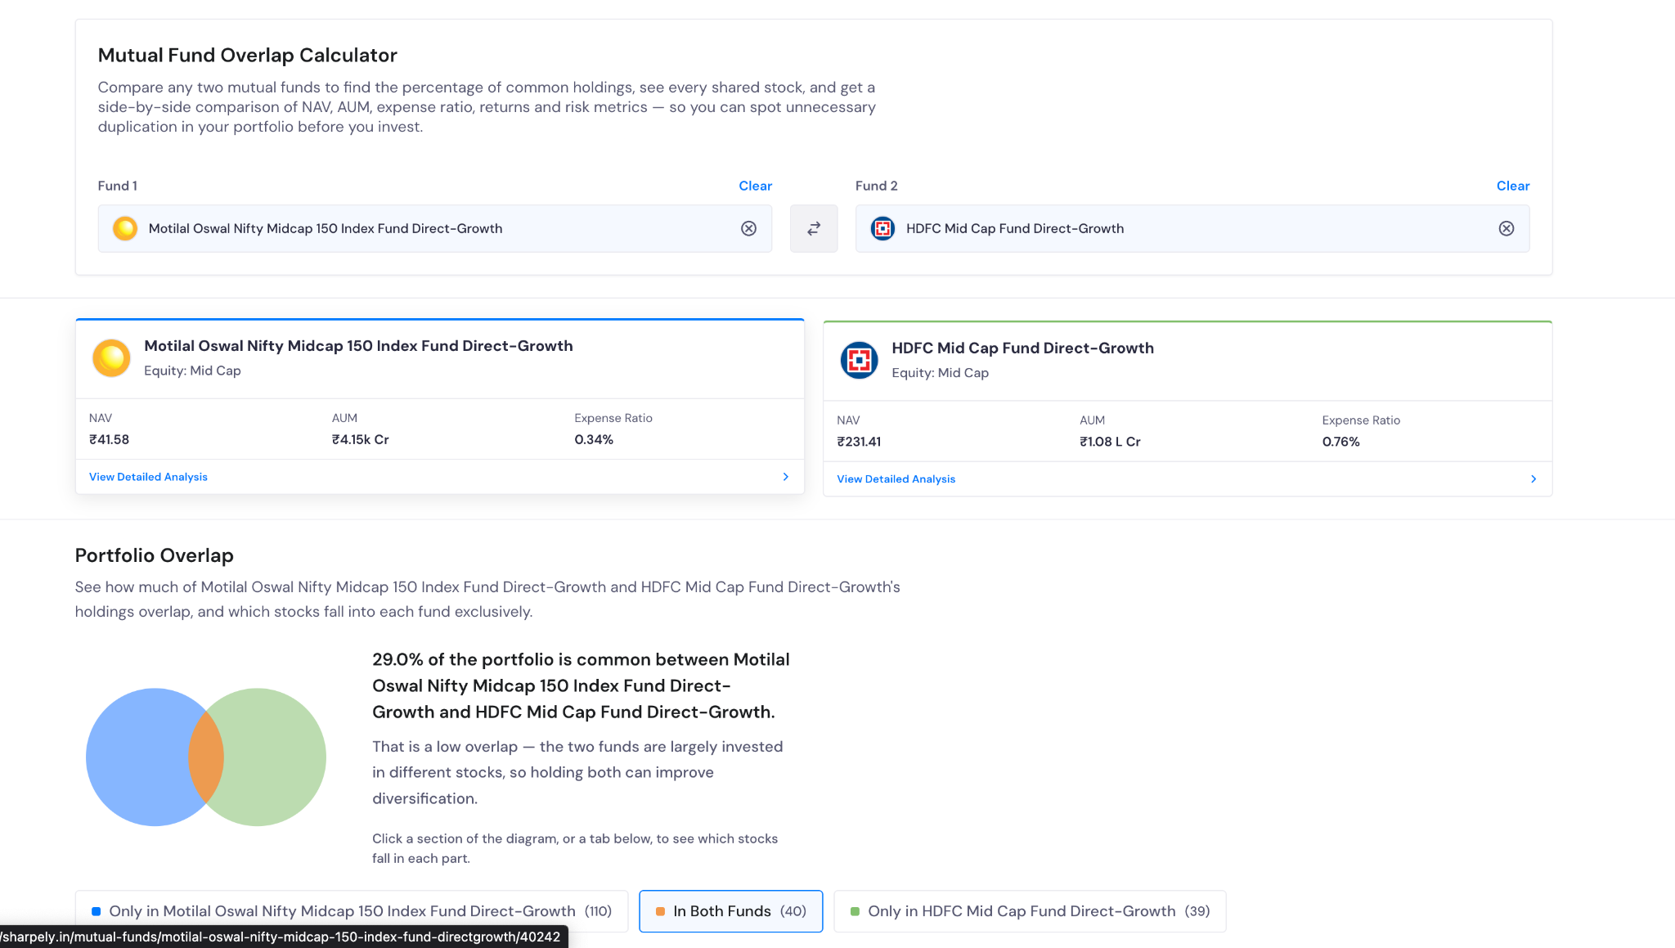
- as per vr this generated above average with low risk:
My thinking:
“Edeilweisis has better perfomance, persendation , diversified, excep fund manager. But i am bit baised about proper dociumentaiotn presentation by edeil proper detials stratedy etc.” So for now going with edeilwesis and ivnesco.

Flexi Cap:

Large Cap: ( aum >= 3 )

- ICICI Prudential Large Cap Fund, c 80k ,1.01 , onsider this great great. manger performance bit high expense ratio.you can see performance below

- SBI Large Cap Fund: 55k, 2013, 0.89, touching or not , not great like icici but not regret one 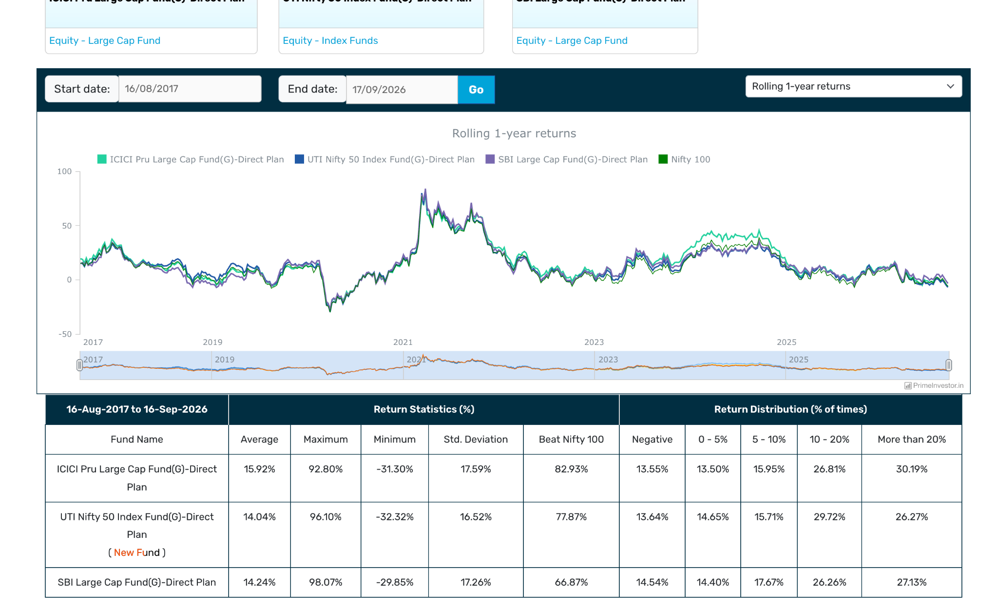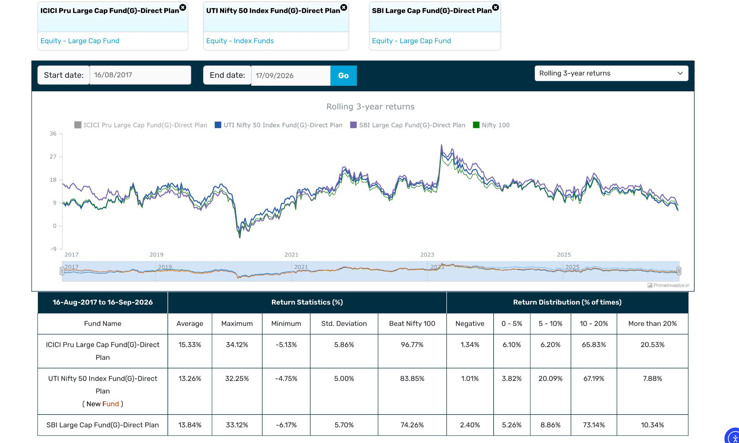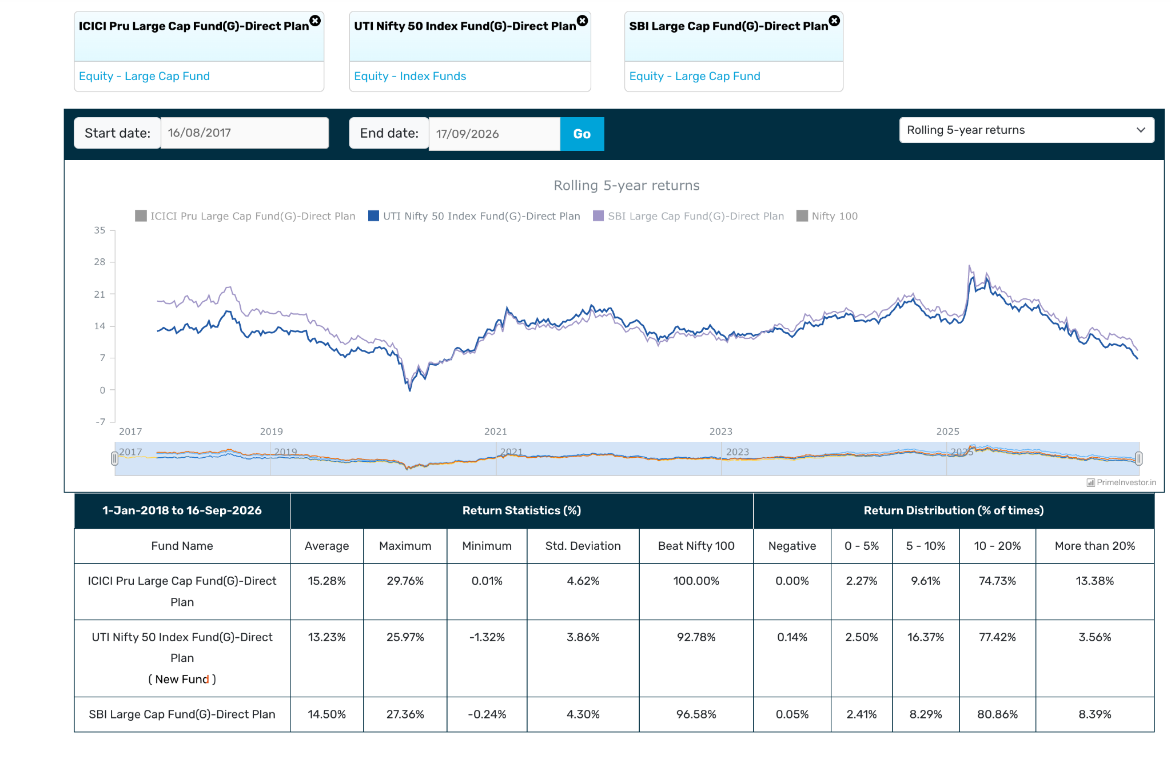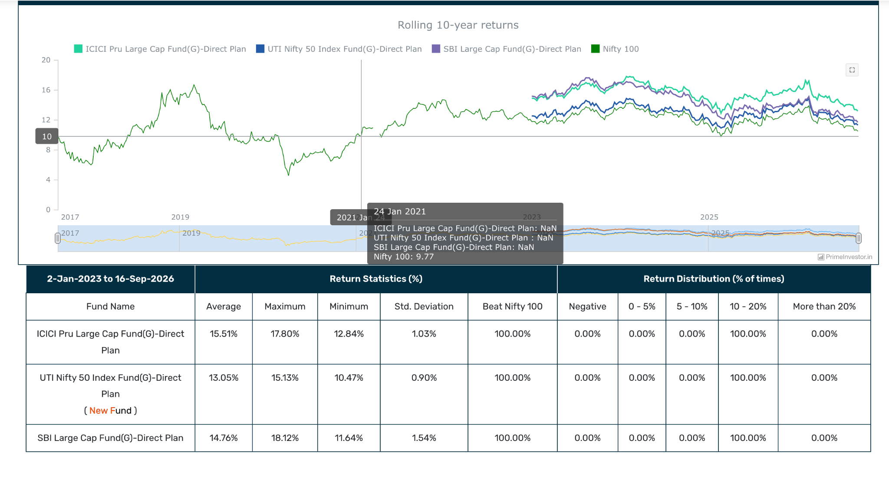

- Nippon India Large Cap Fund: consider this great perfomance. 54k, 0.87, 2013 10y better than icici, some time icici some time nippon over all nippon bit better seems ,but fund manager is icici better. 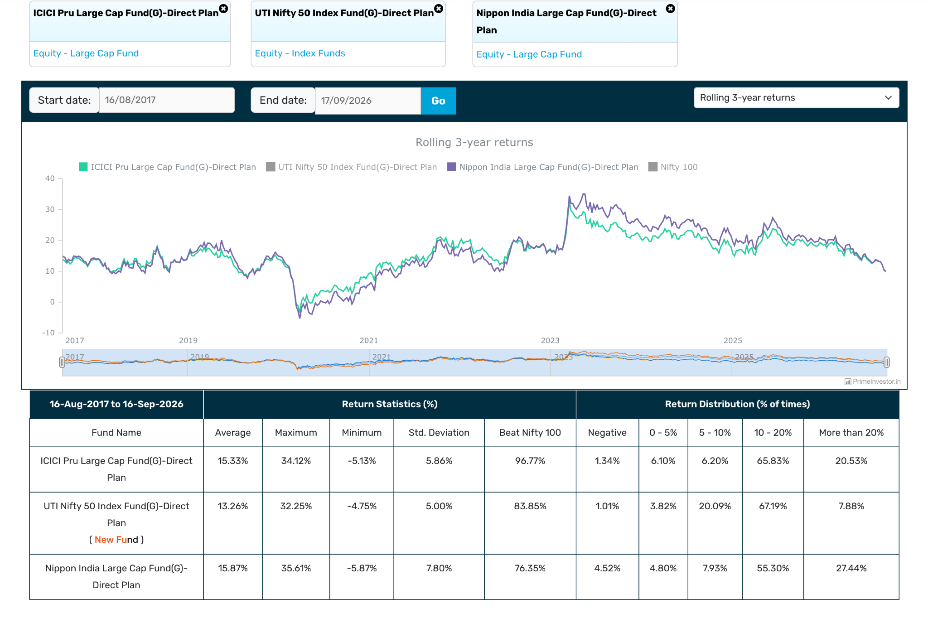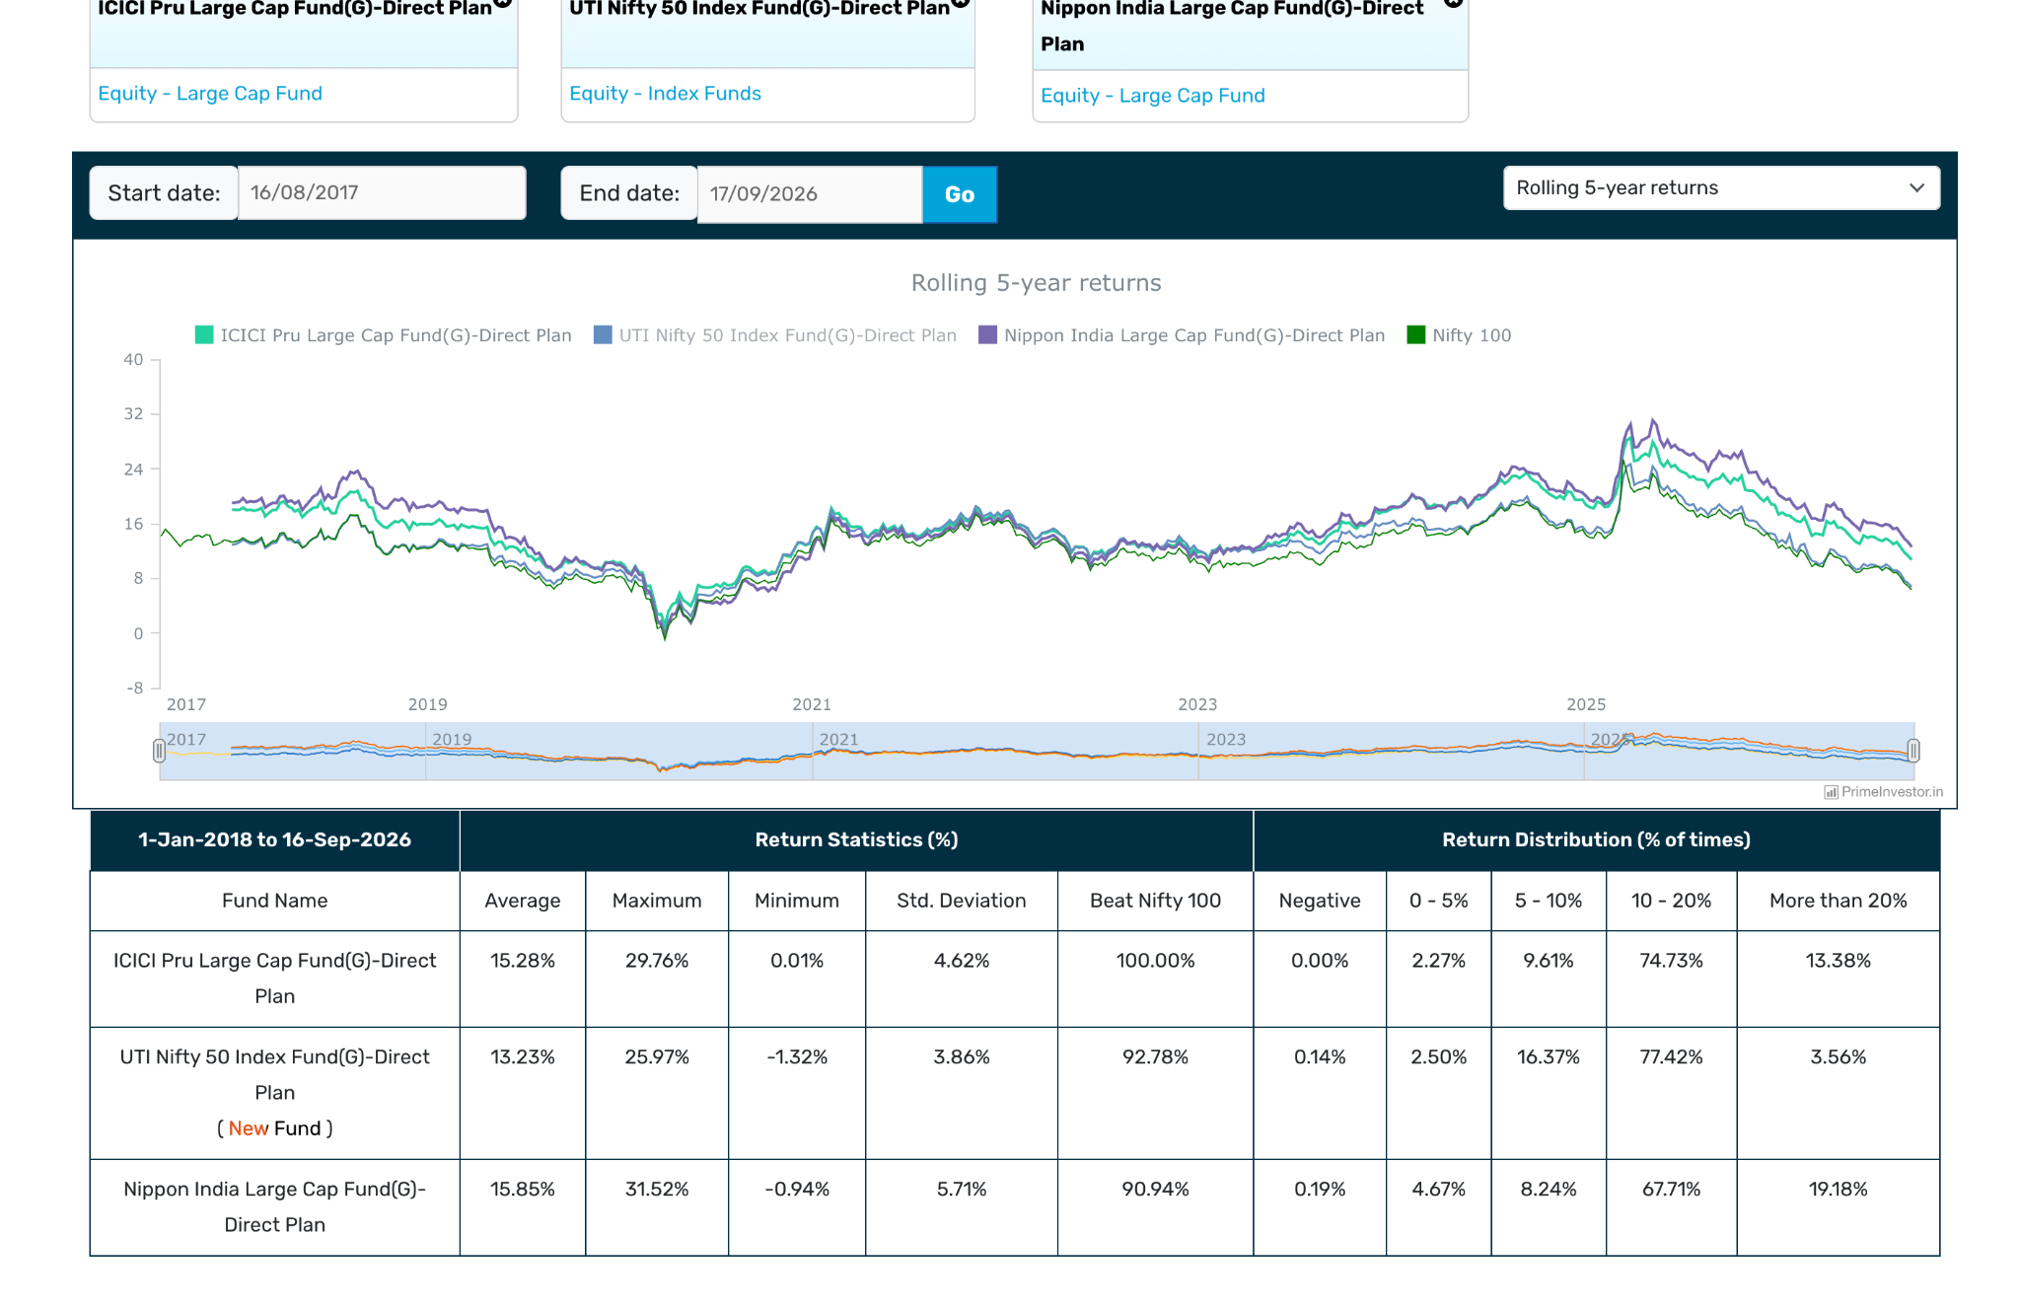
- HDFC Large Cap Fund: 40k, 1.03, 2013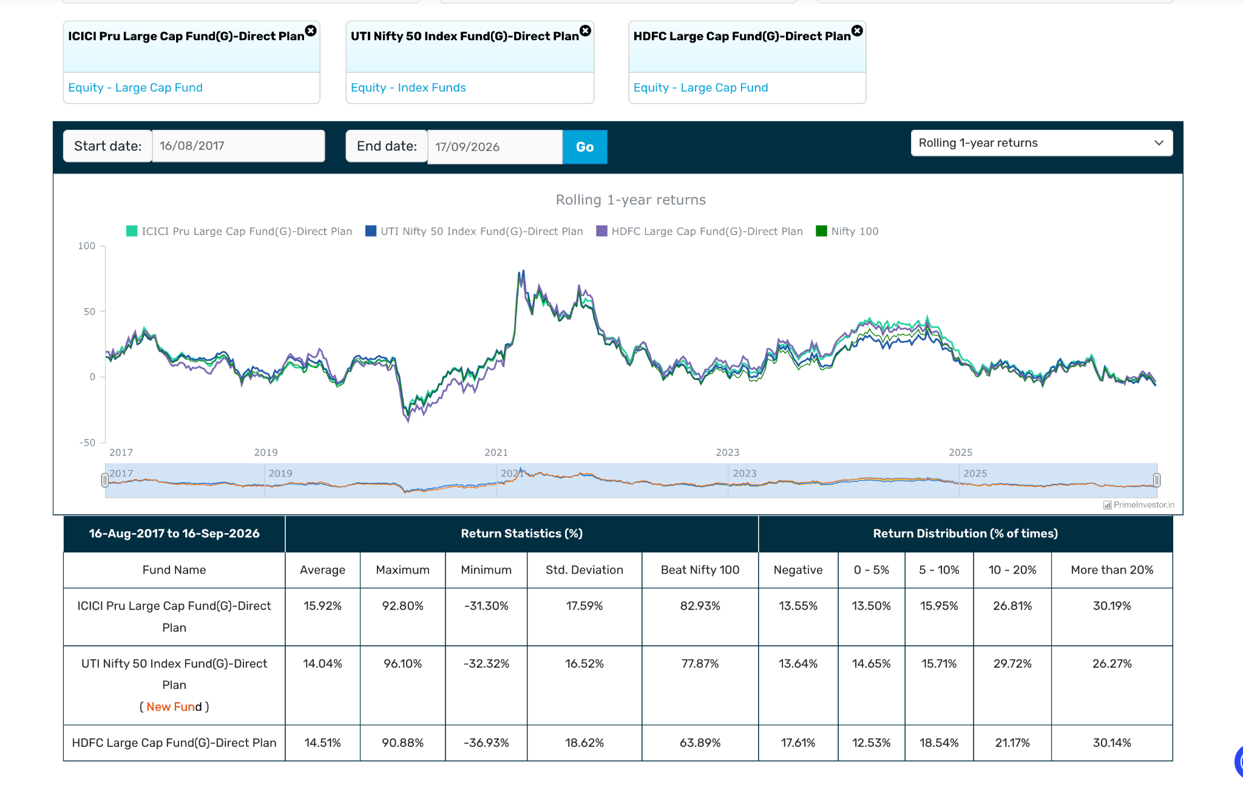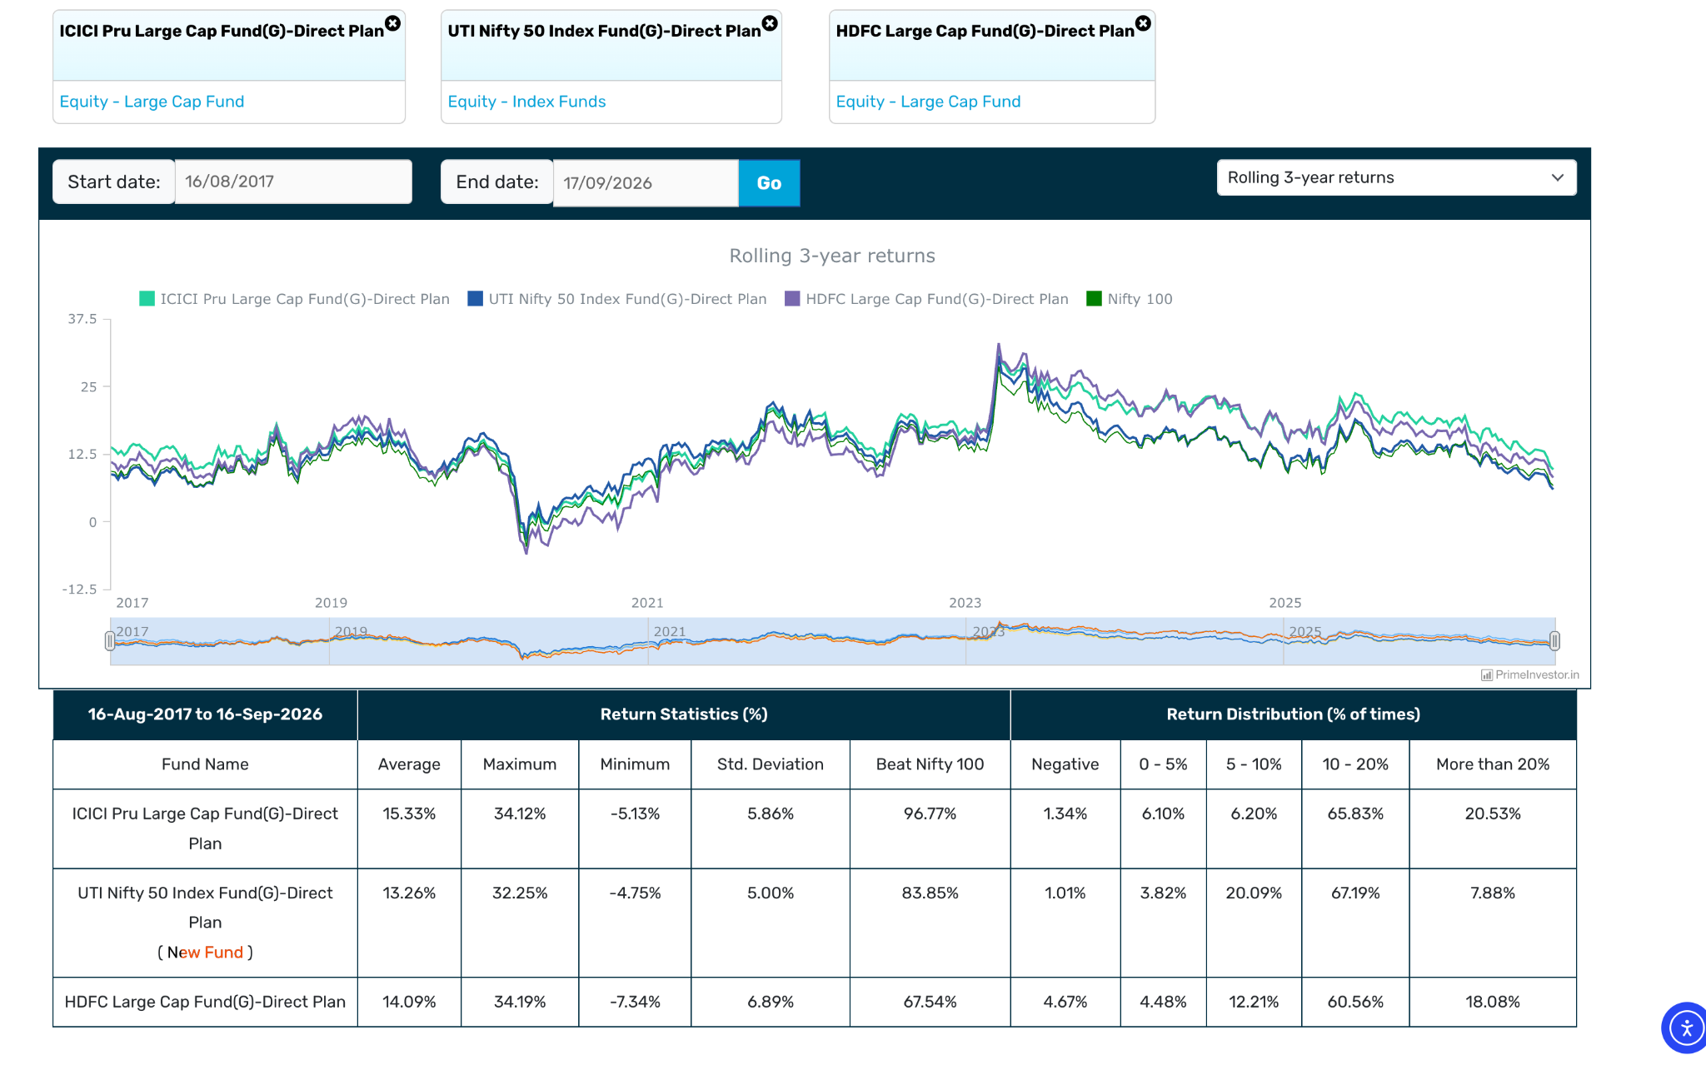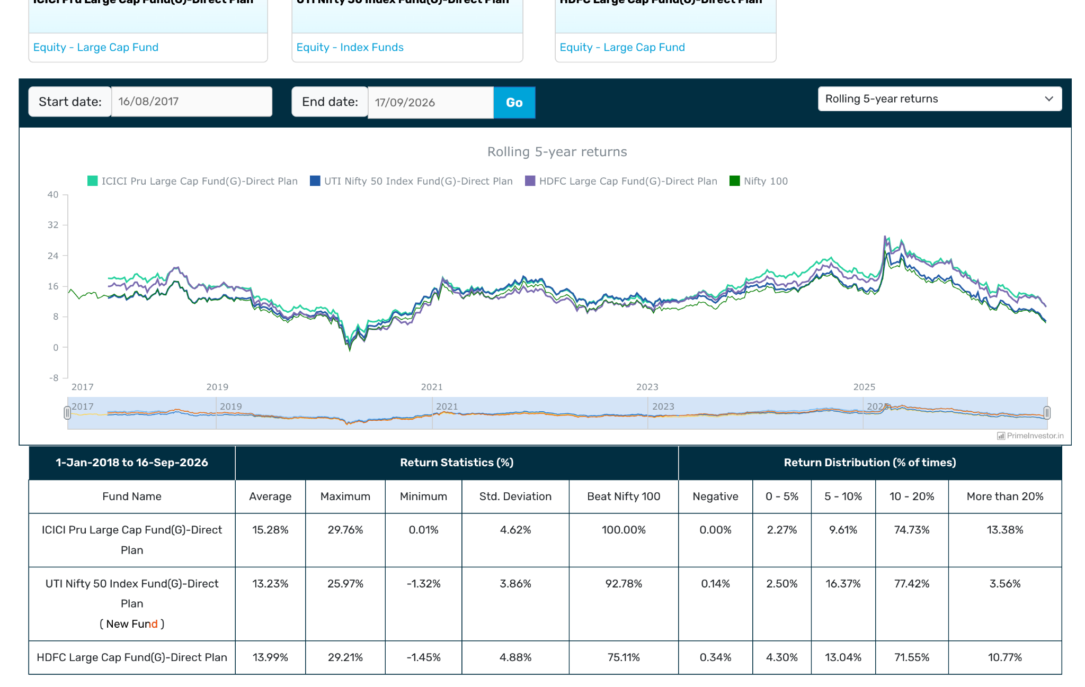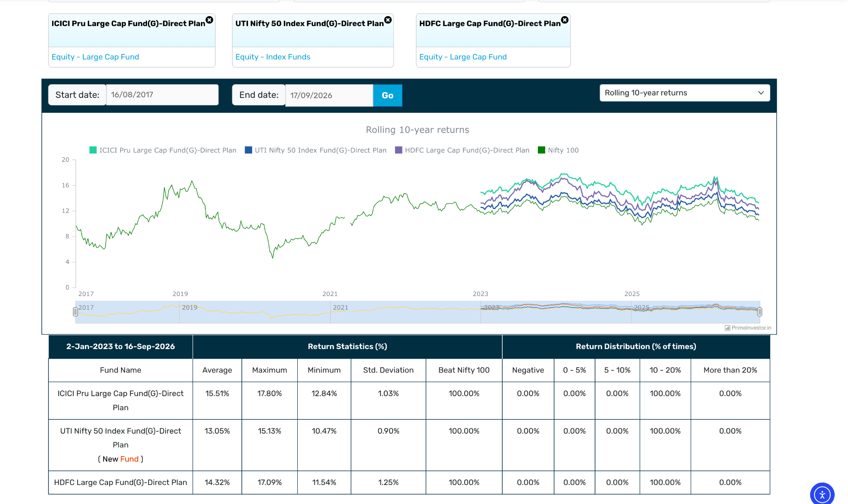
- Mirae Asset Large Cap Fund: 38k, 0.76 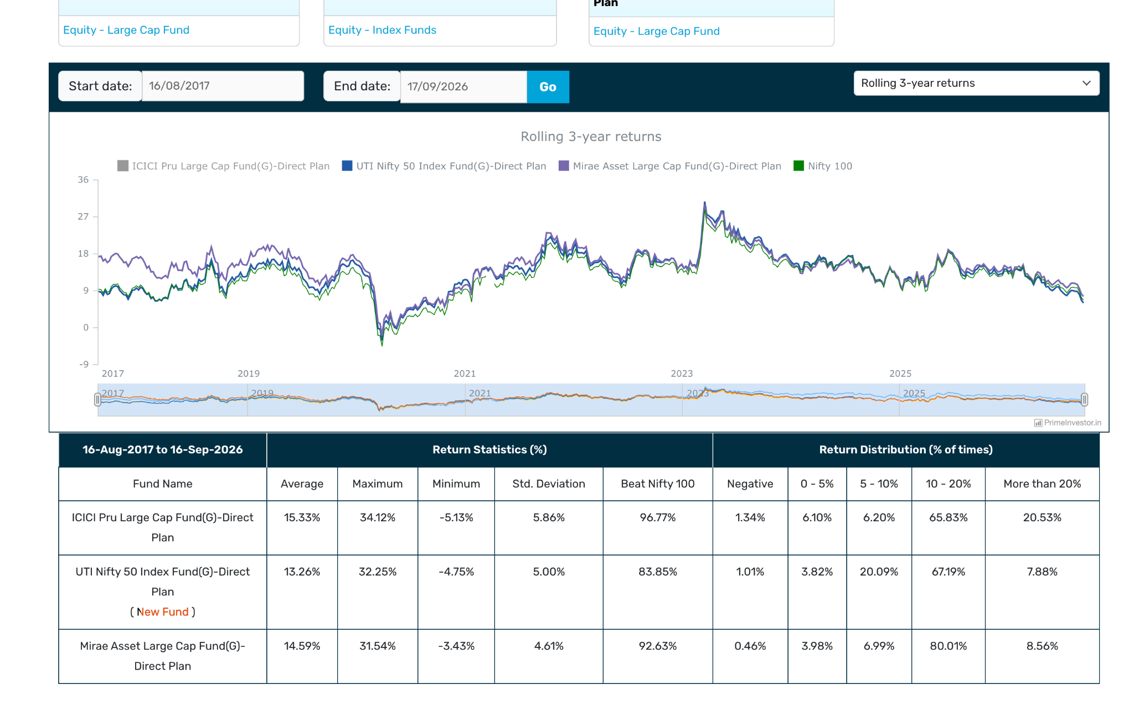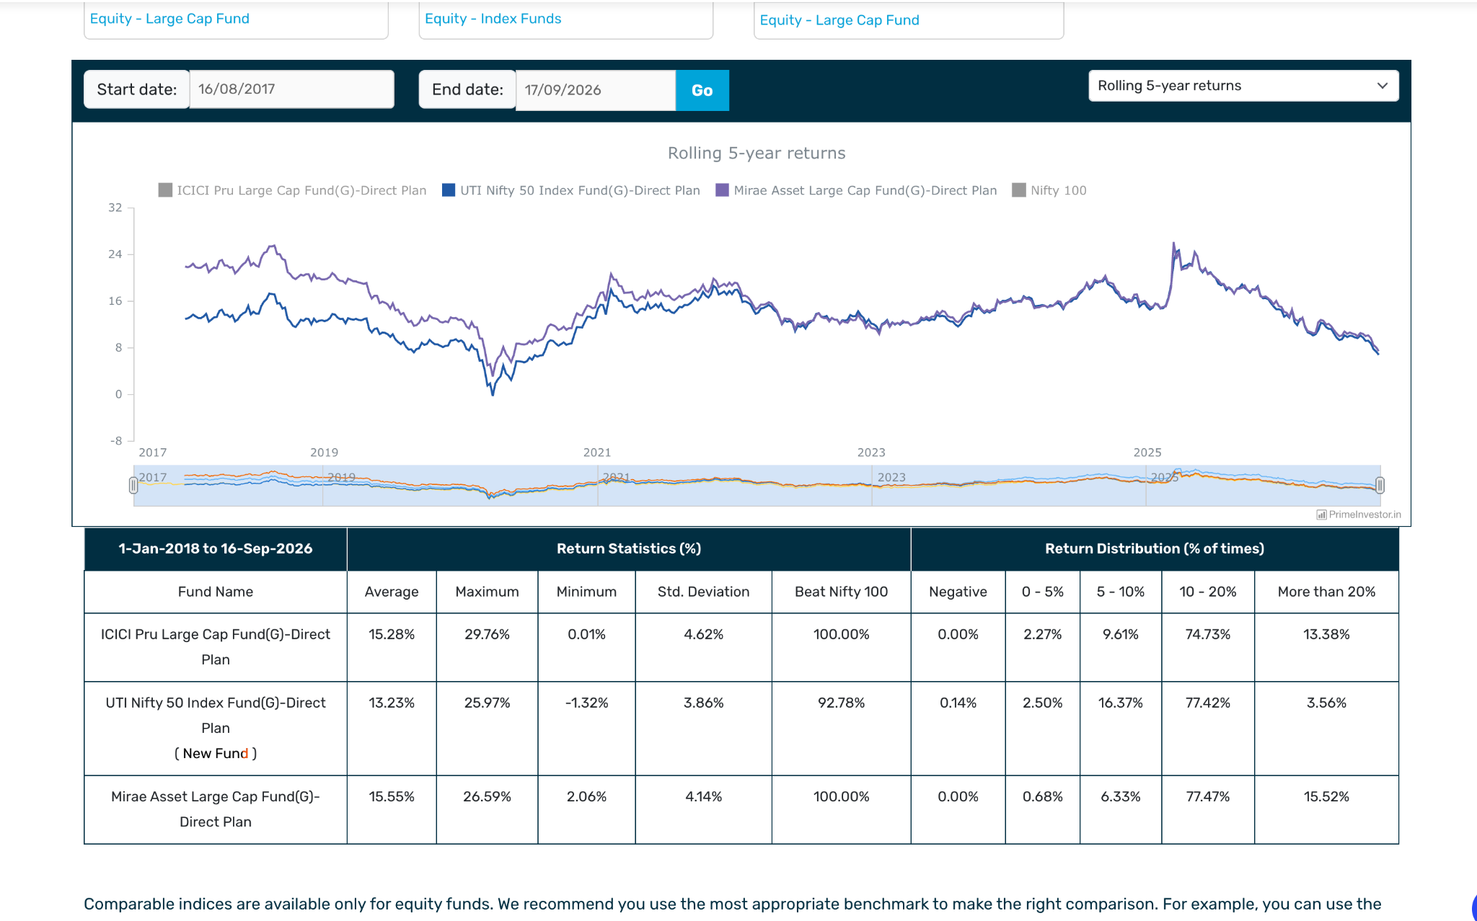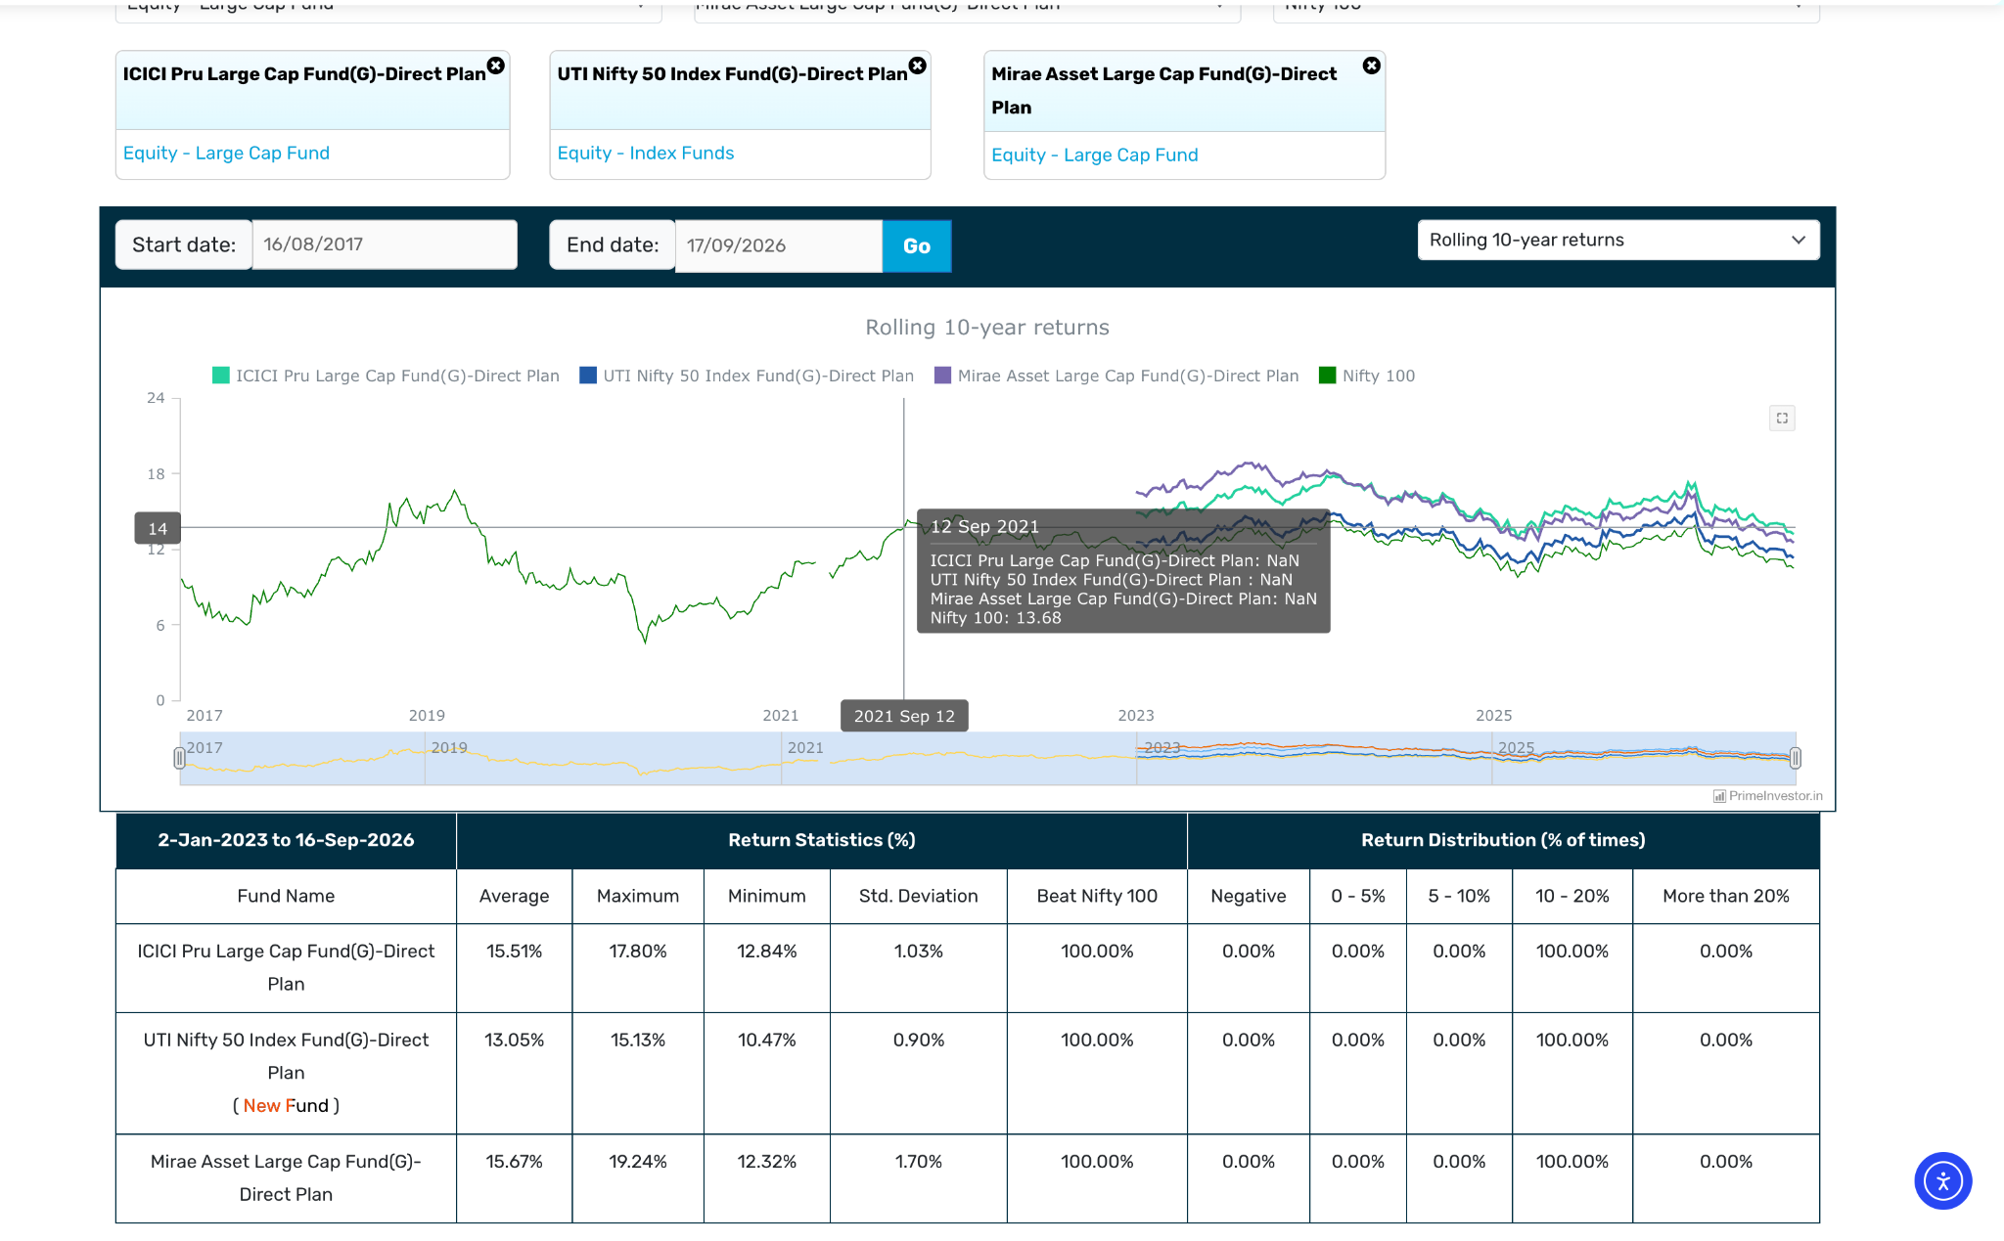
- Axis Large Cap Fund: 2013, 31k, 0.93, not great but able to beat bench mark and nifty 50 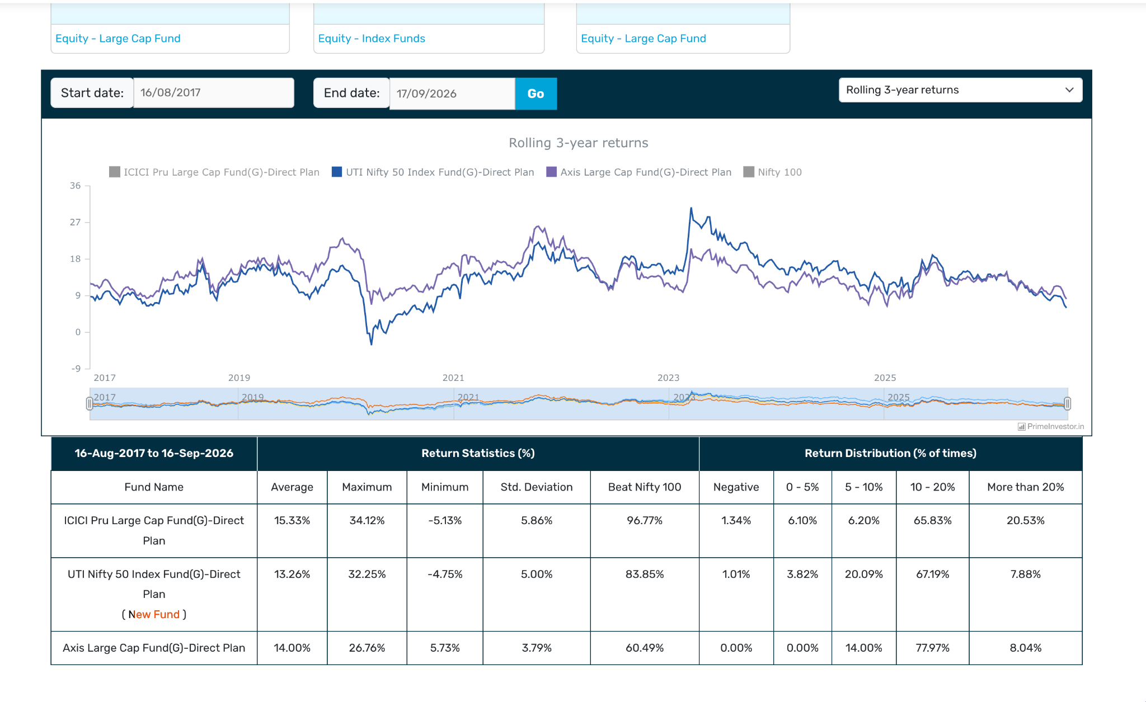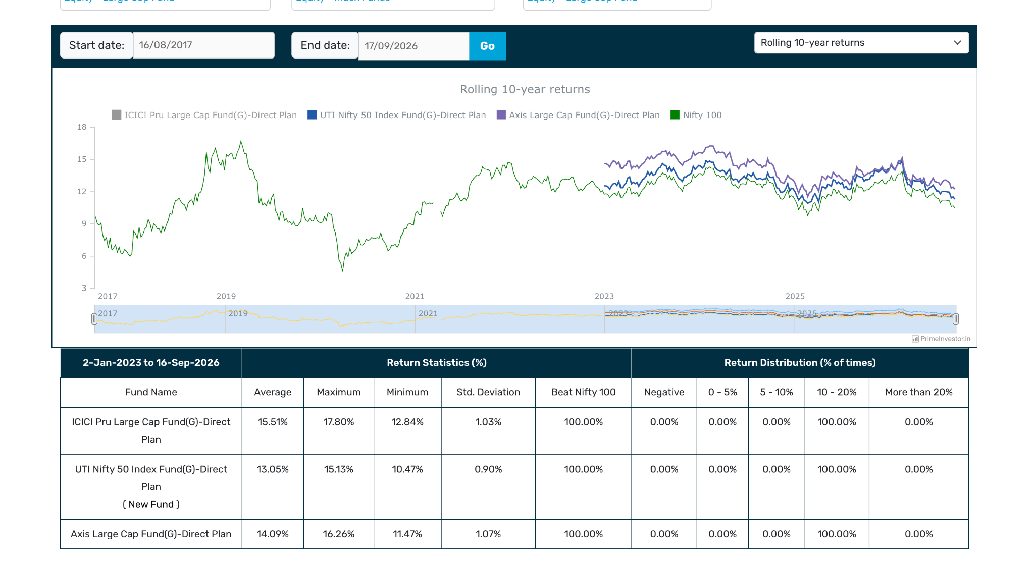
- Aditya Birla Sun Life Large Cap Fund: 2013, 29.7k, 1.04, not great but beating ( lately seems under perf or touch ), not great like icici. but touch or some time undersat perf. not that much differnet. 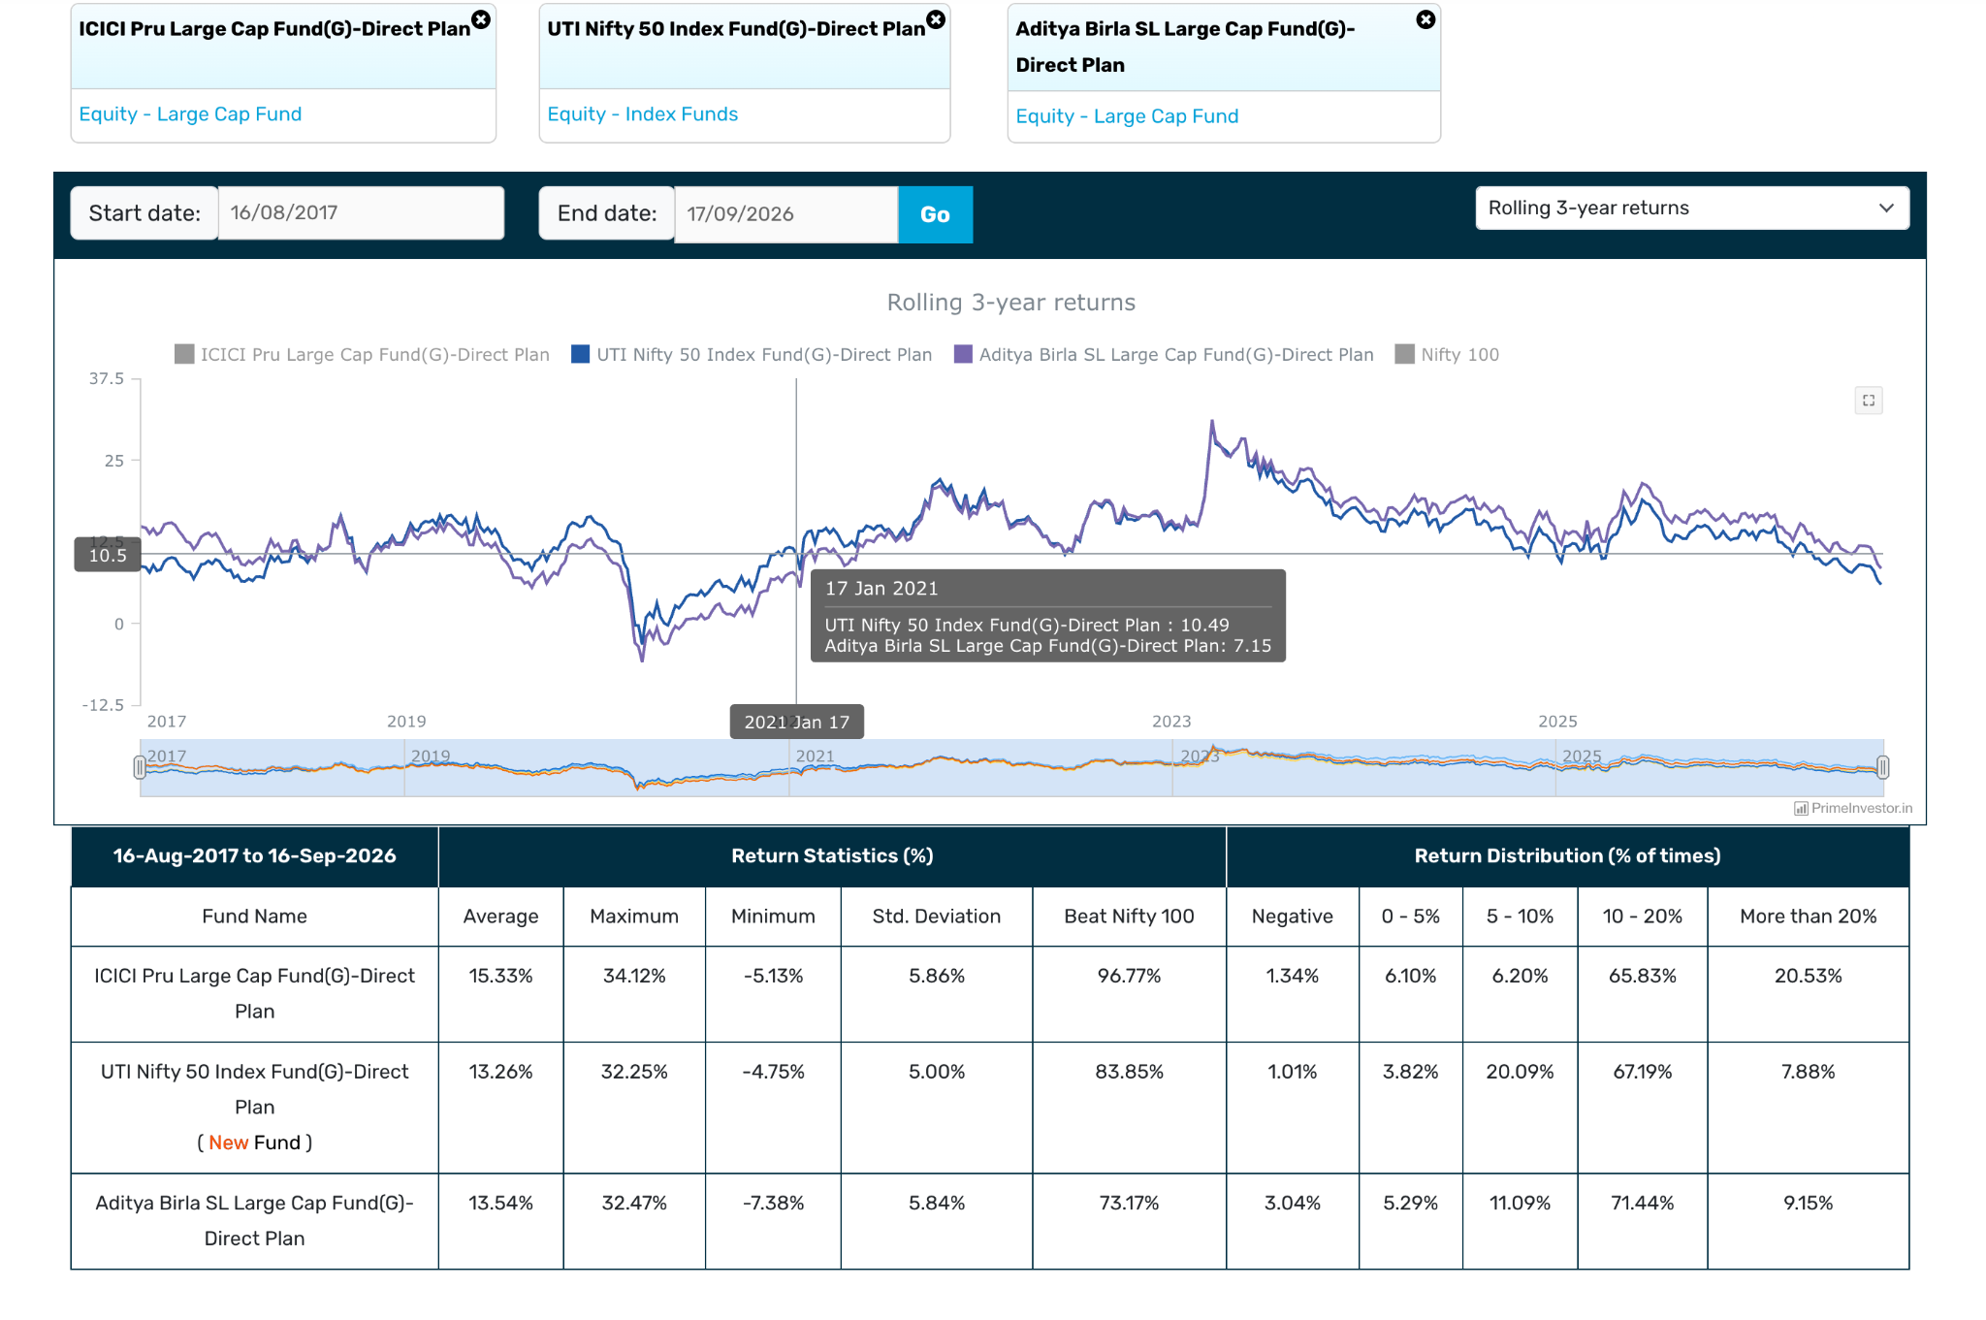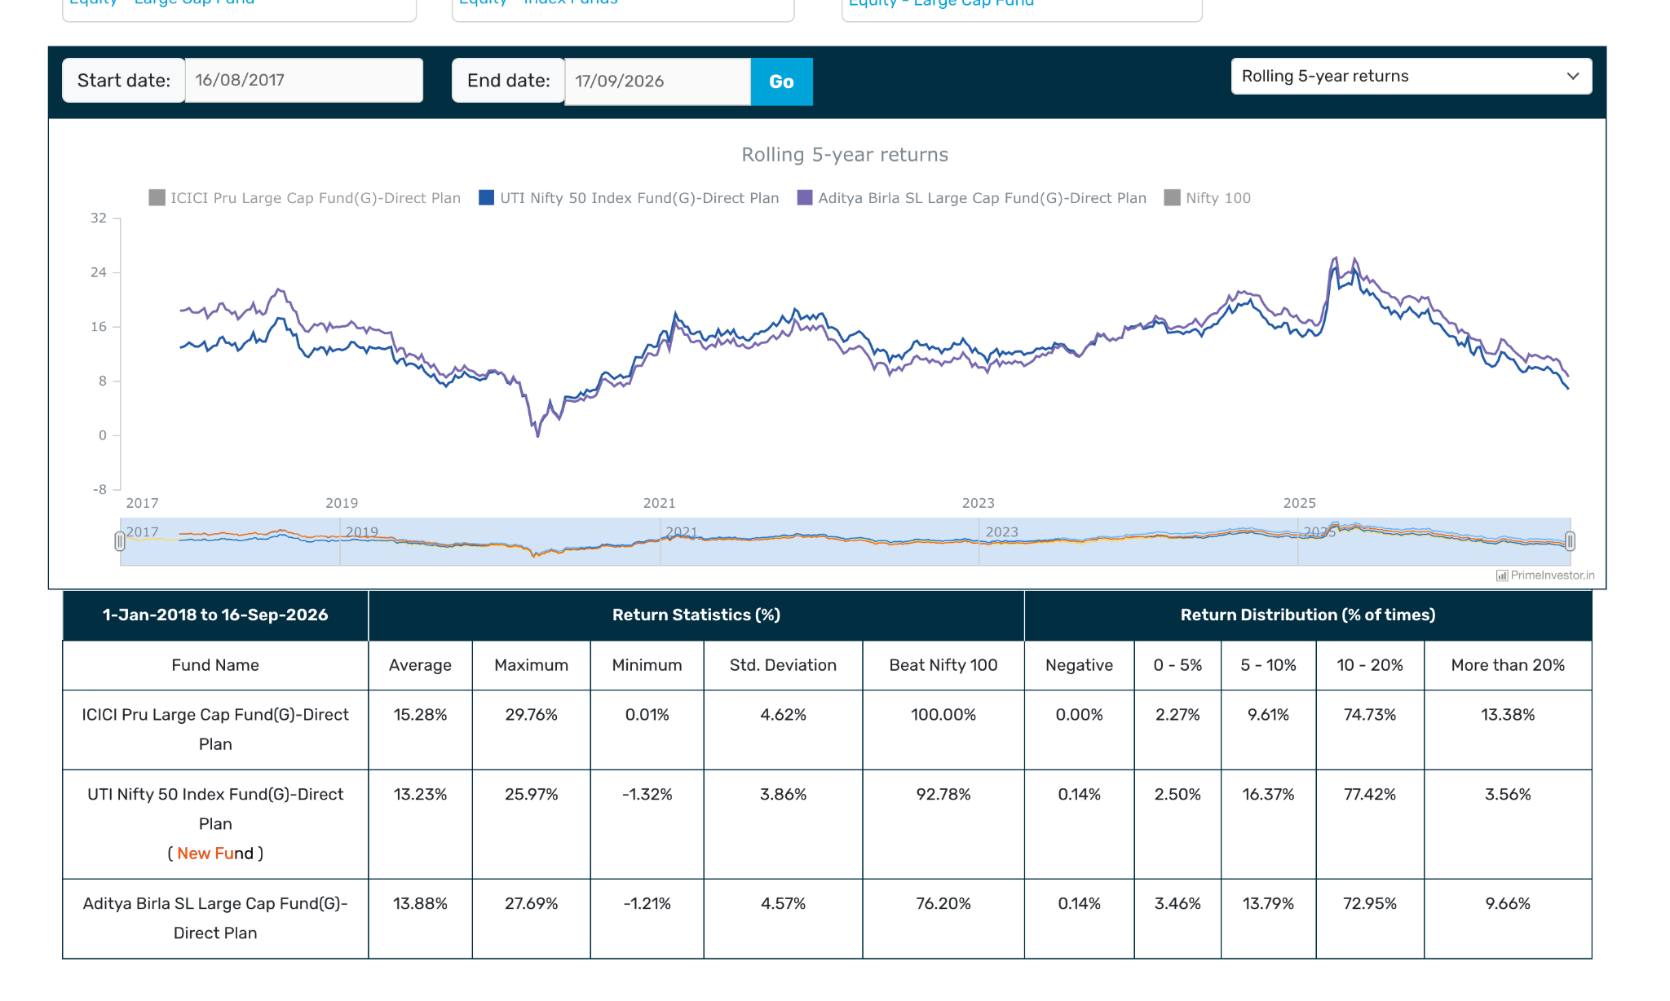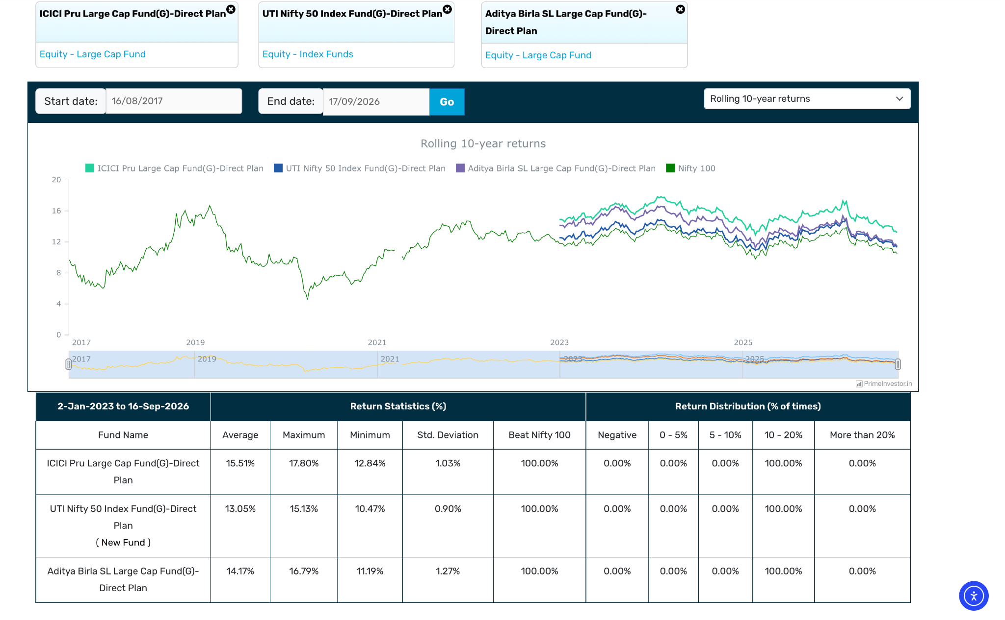
- Canara Robeco Large Cap Fund: 17k, 2013, 0.63, 10y similar to icici great , even beating icici . low down side capture conisider this also comparision. 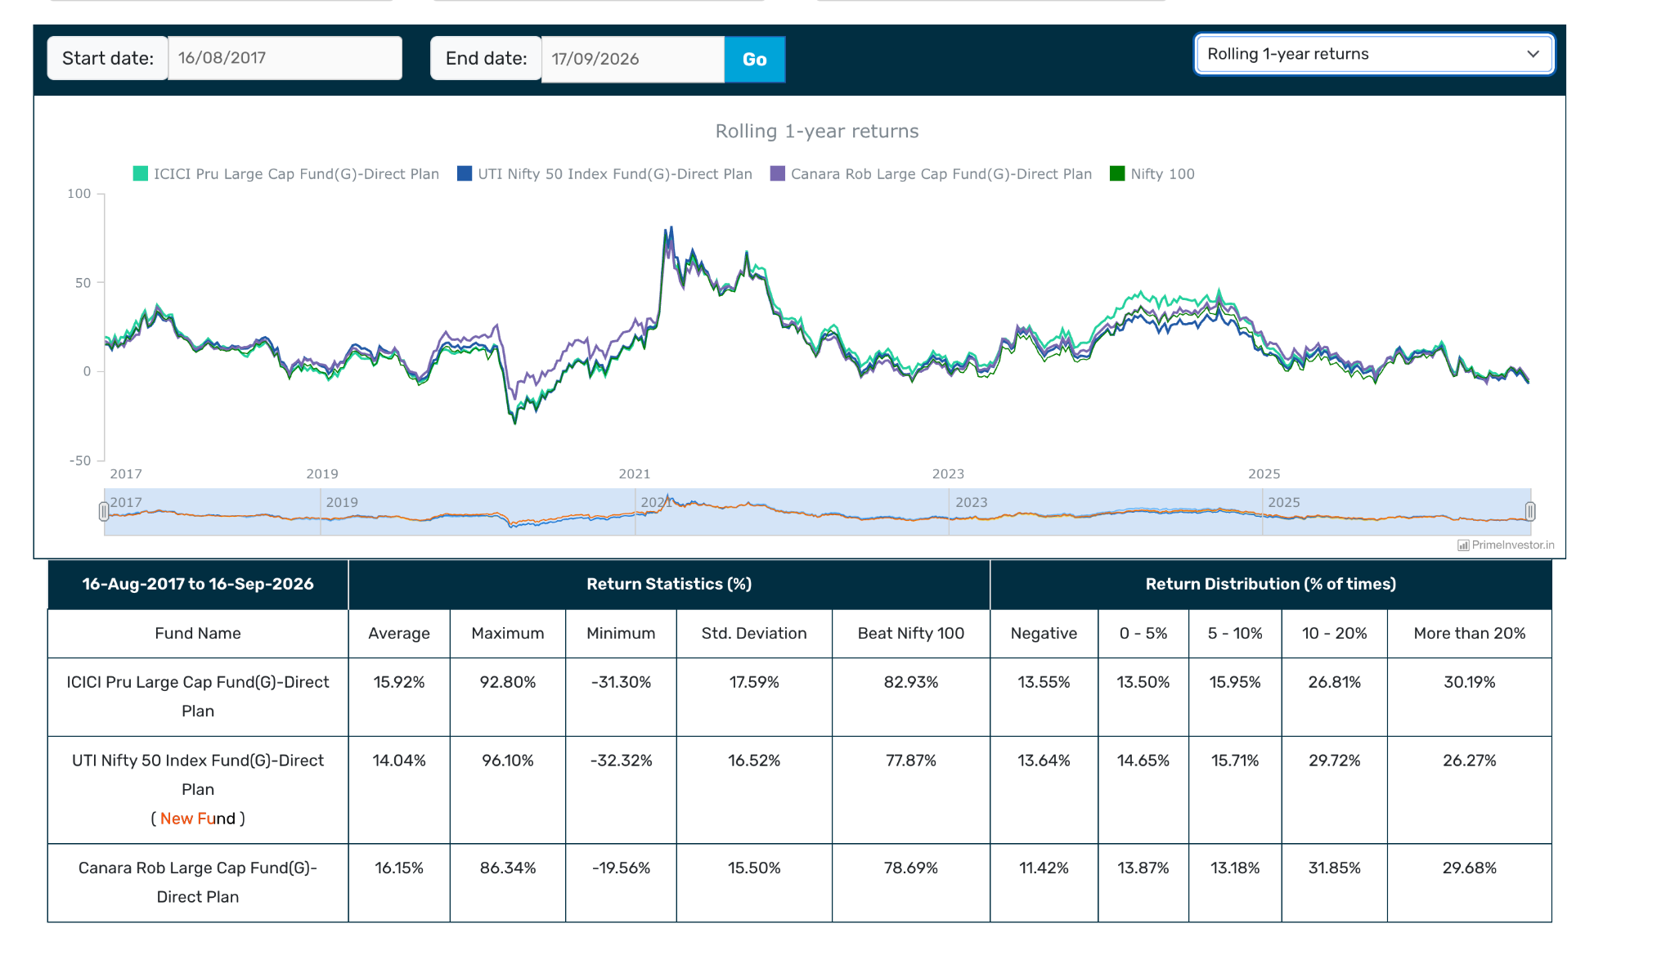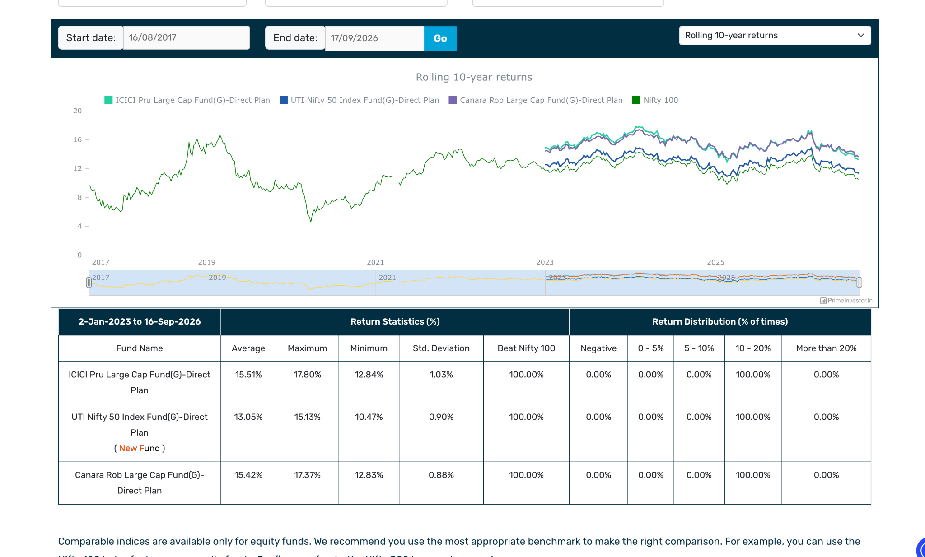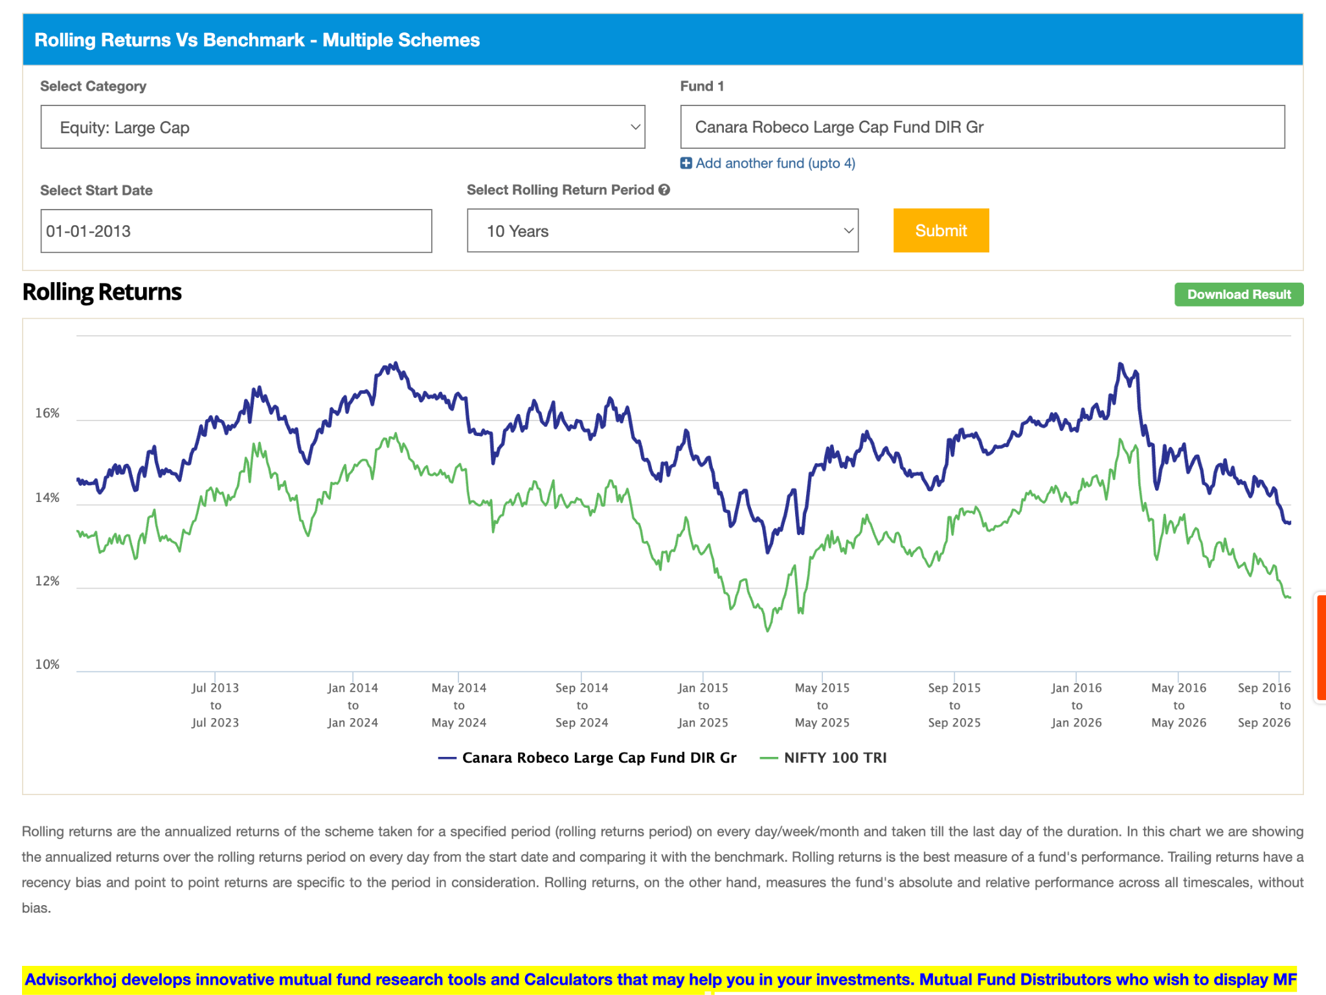
- UTI Large Cap Fund: 2013, 1.1%, 12k. not great but able to beat benchmark good 100% 10y ( benchmark without expense ratio not ) , in 1-3y bit her andthe but not that low . no regret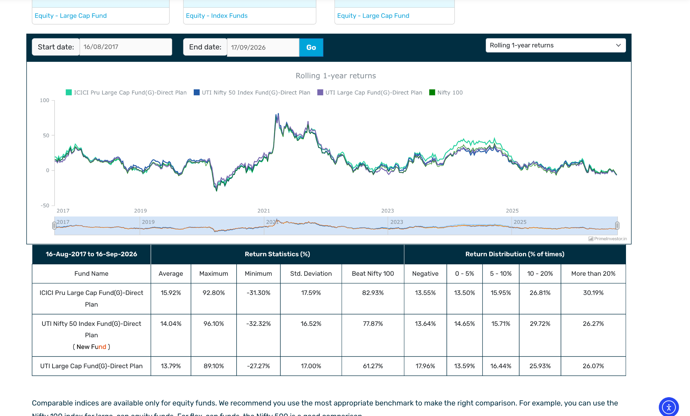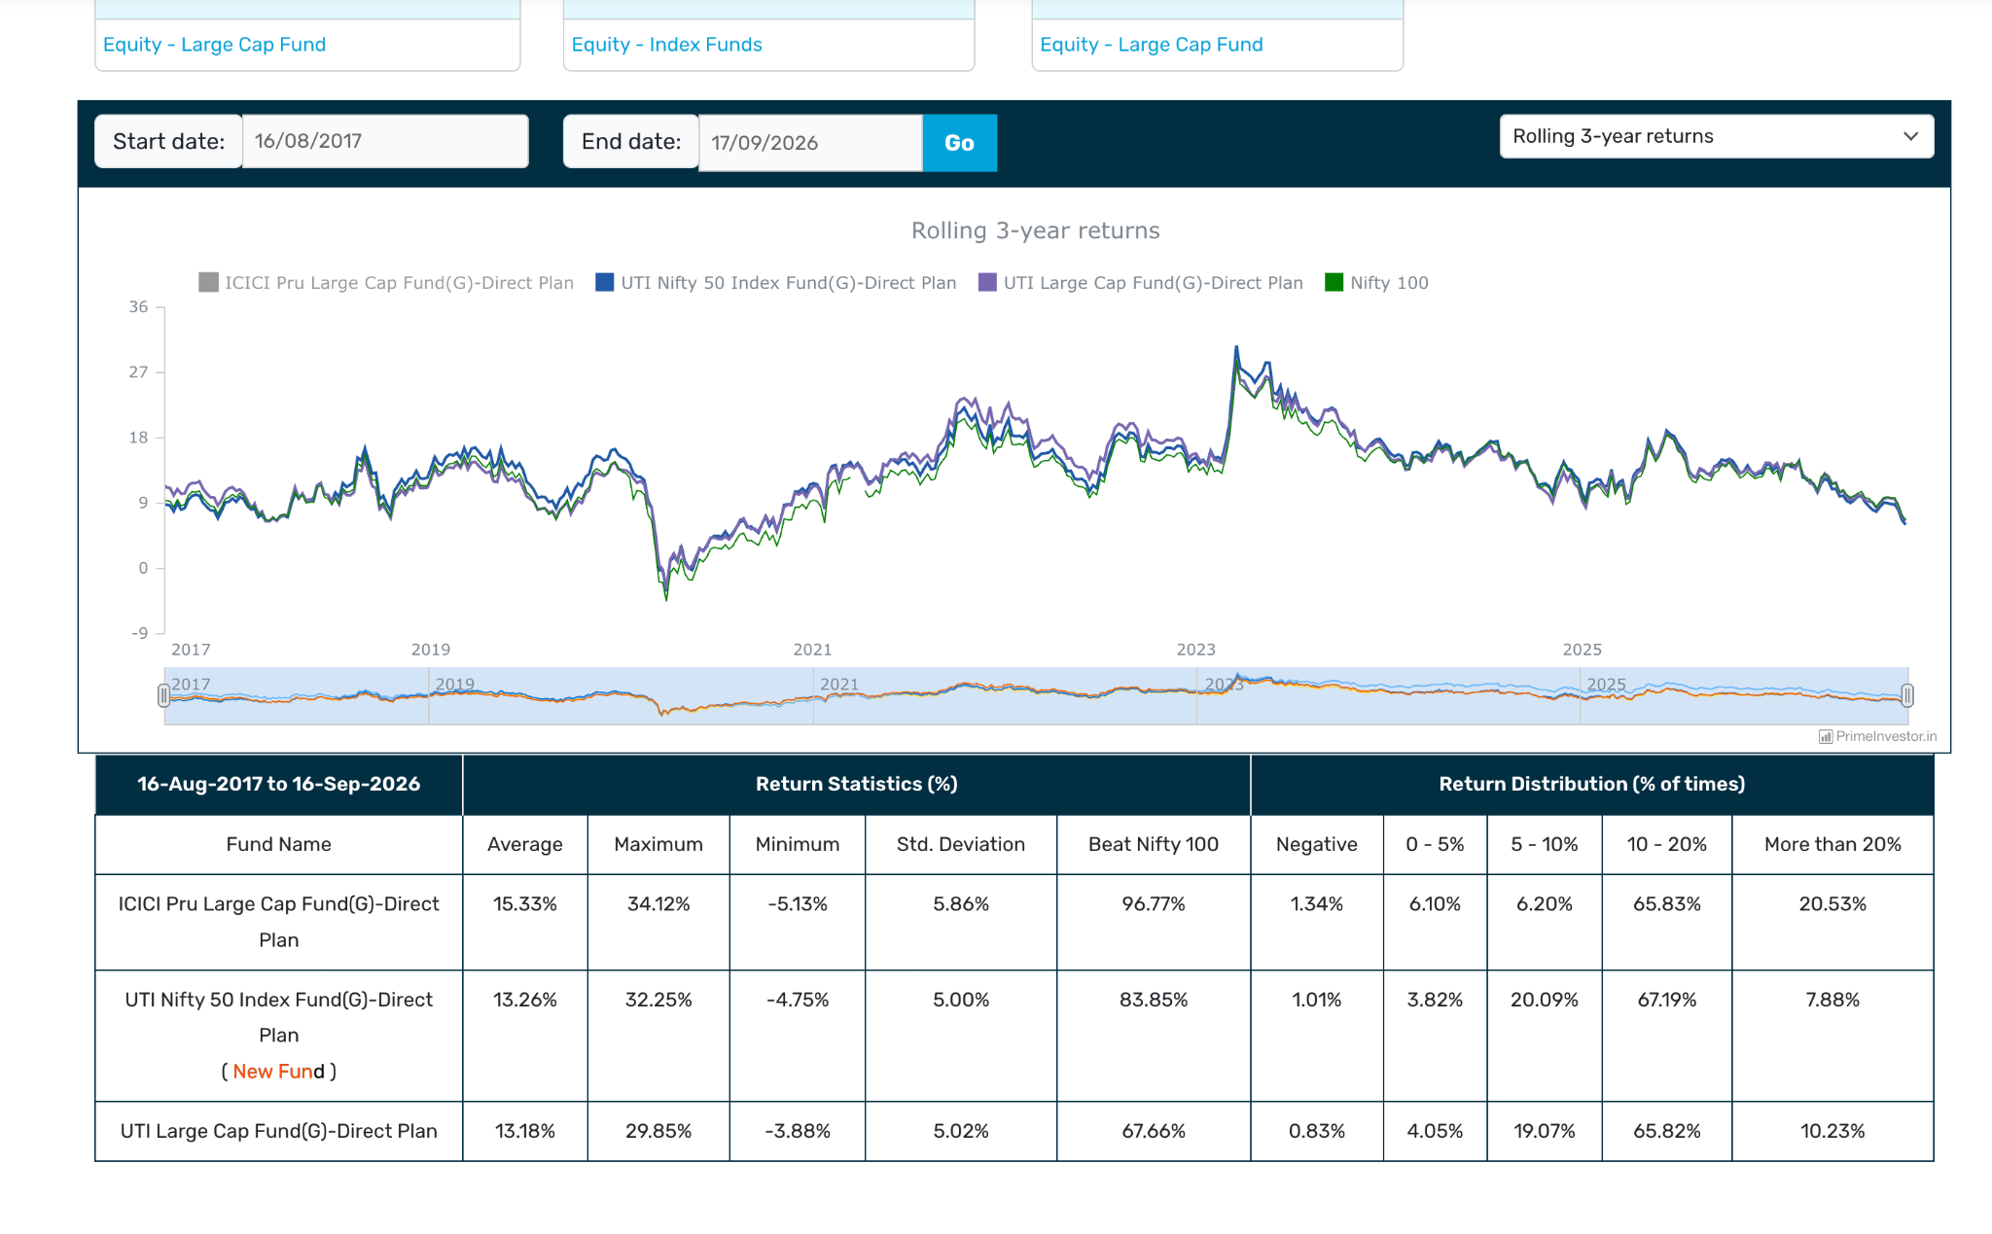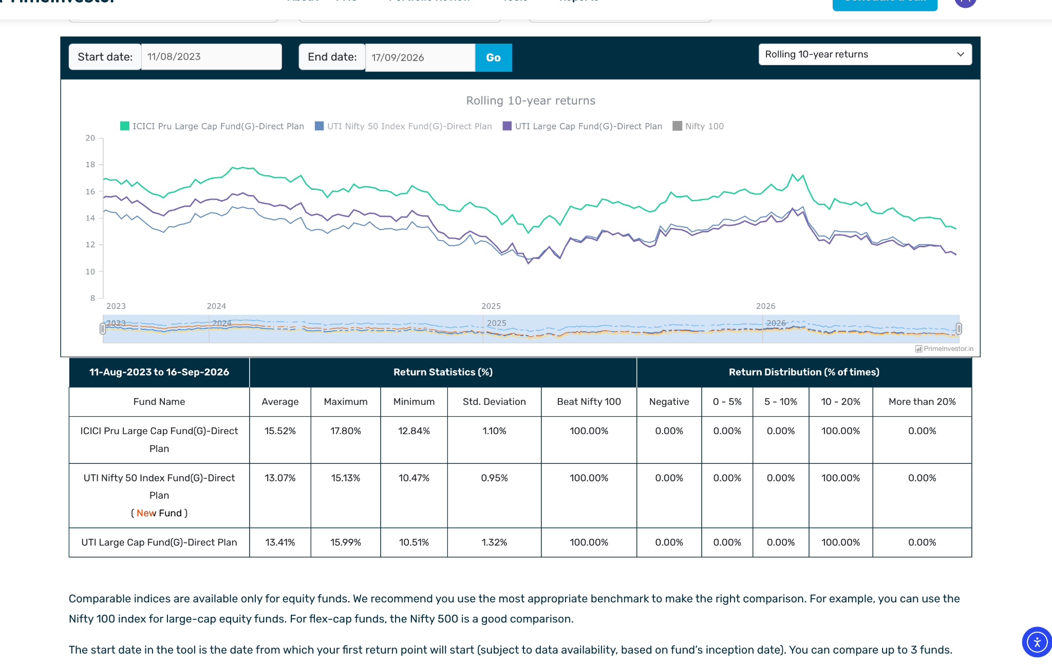
- Kotak Large Cap Fund: ~11k, great bit low than icici then able to beat index and nifty 50 greatly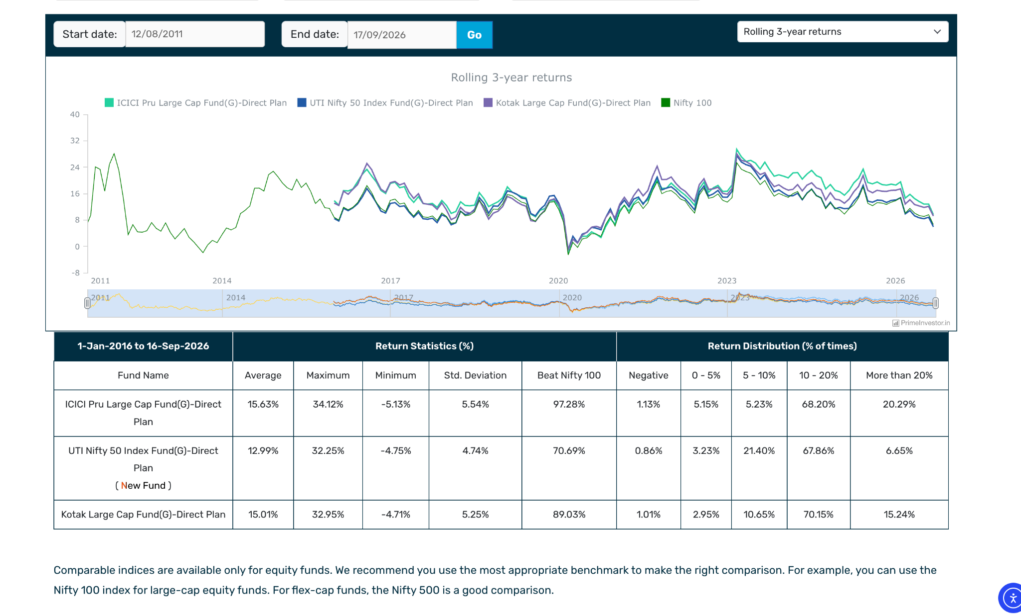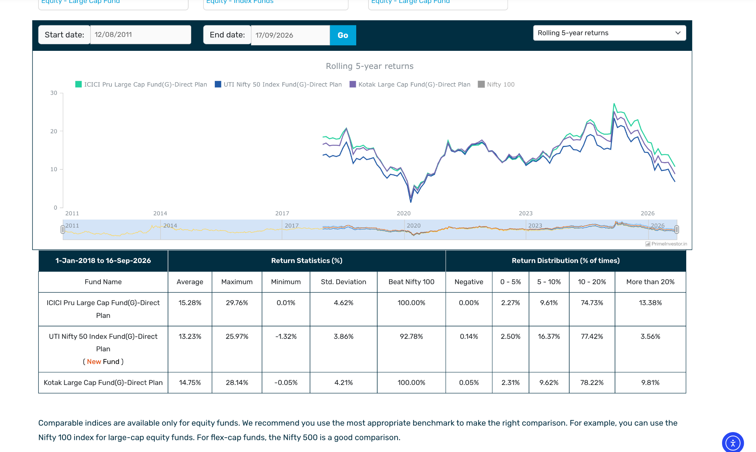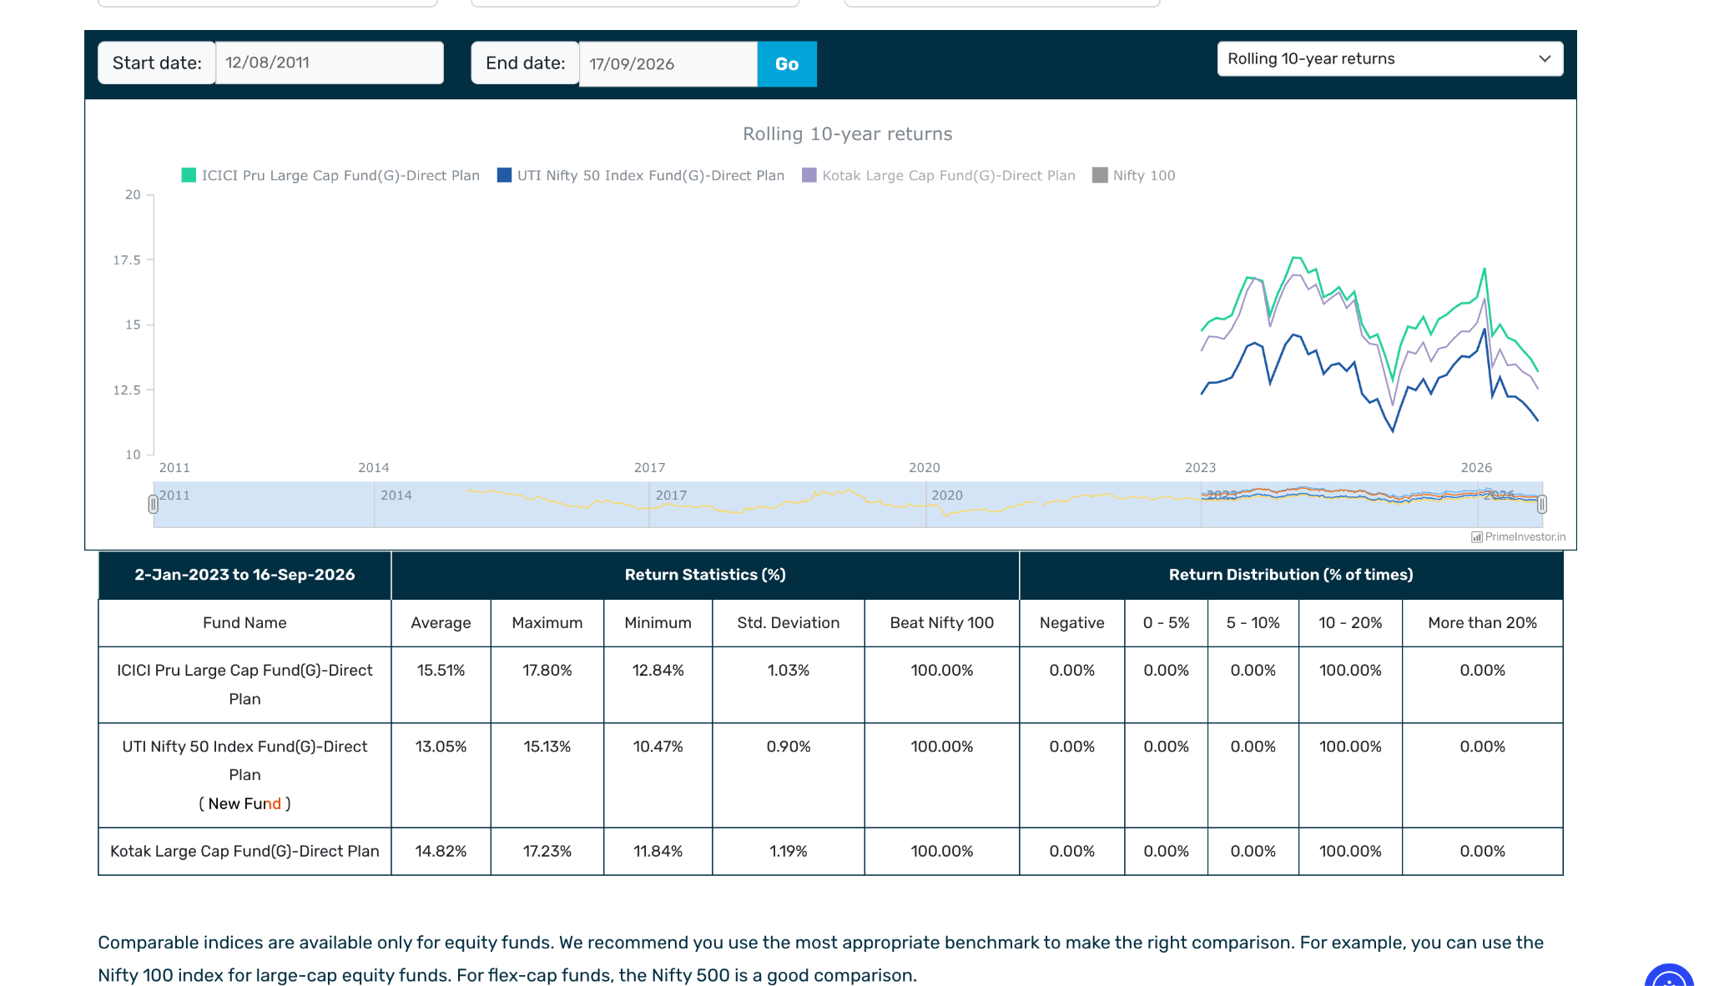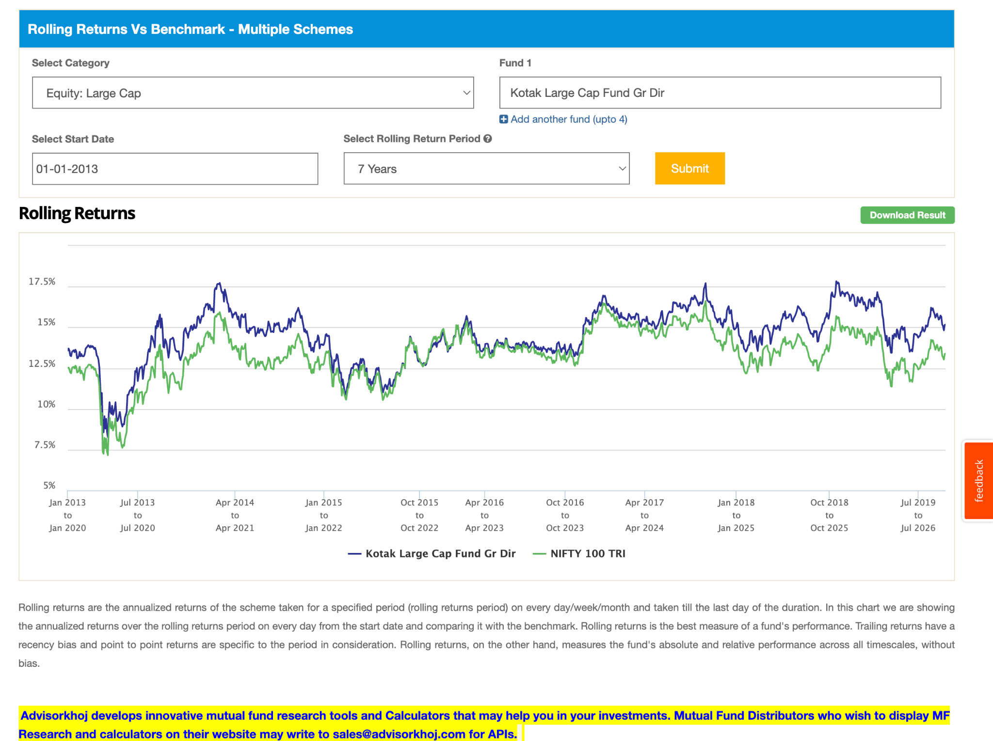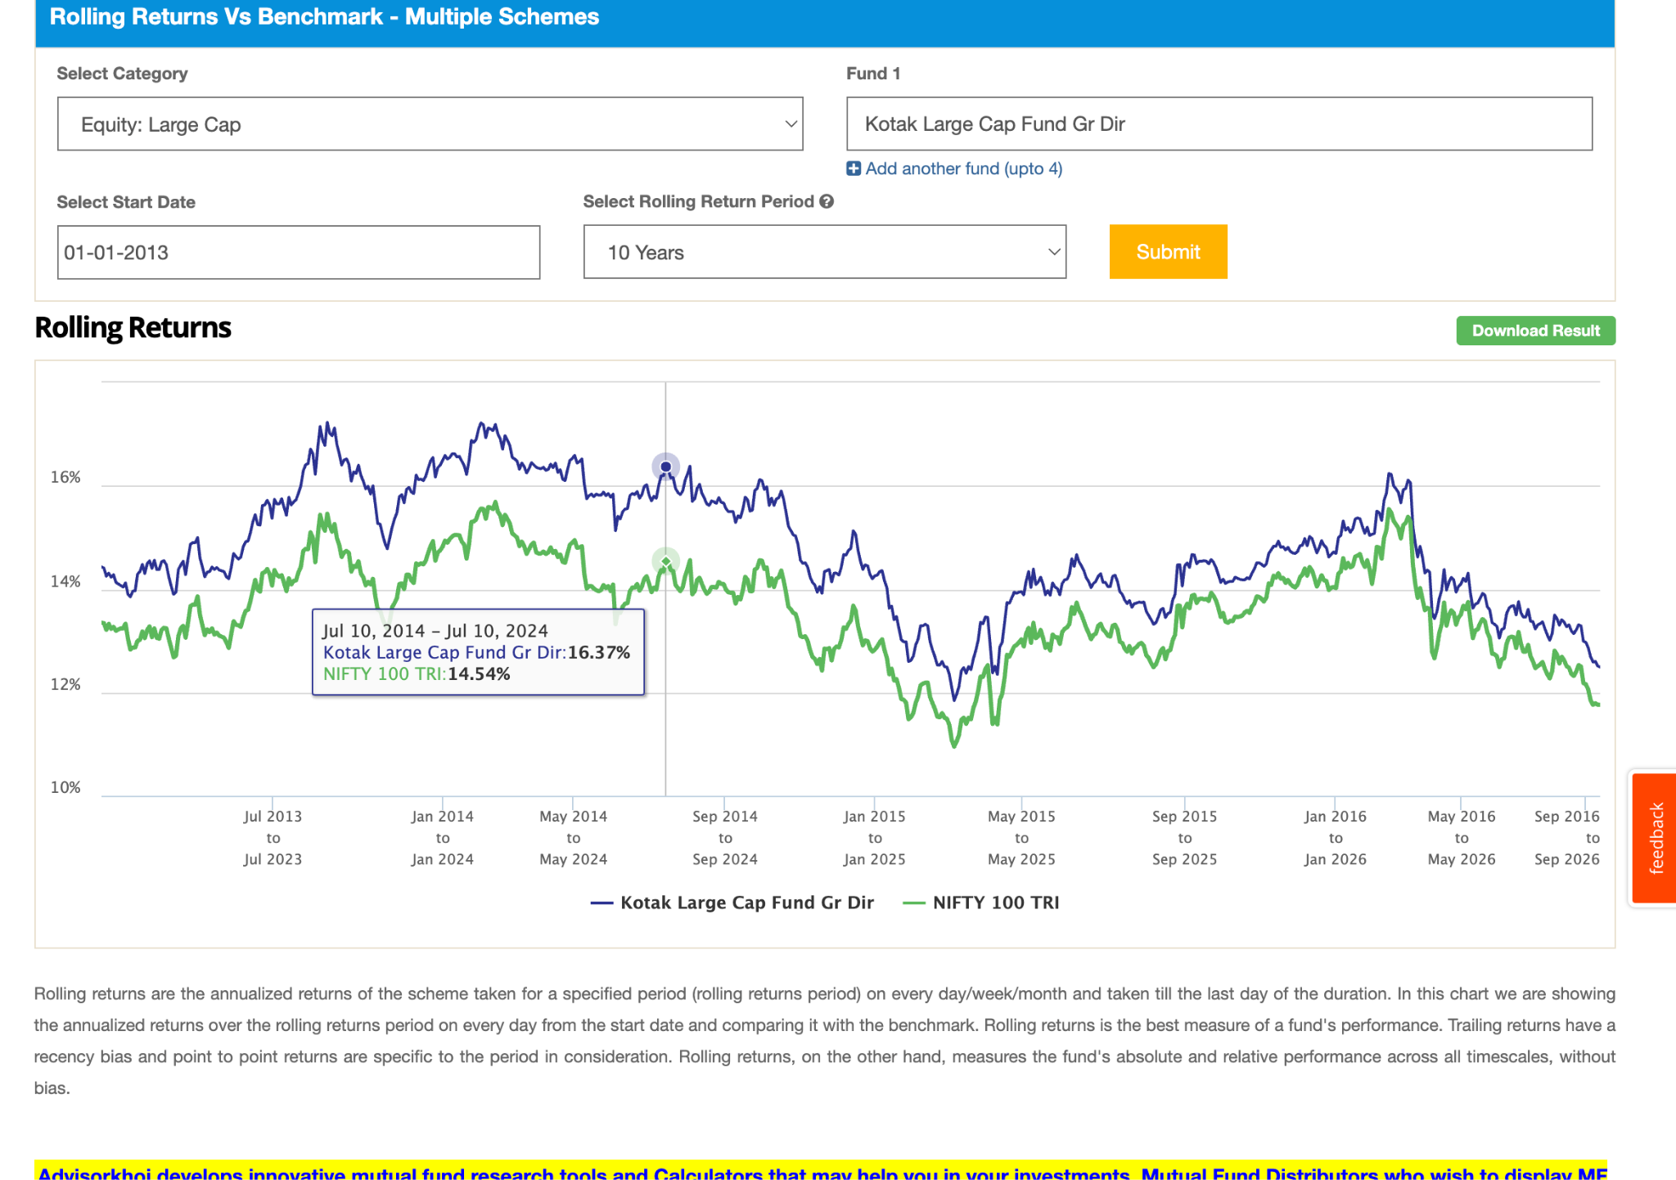
- Franklin India Large Cap Fund: 2013, 7.5k, 1.5 , not good perfomance in 10y less 1-3% , may be becuase of high expense , 50% beating. 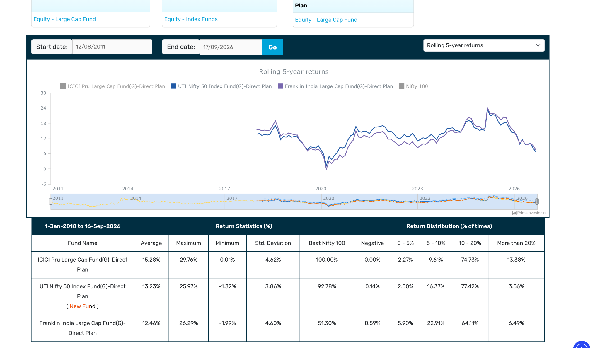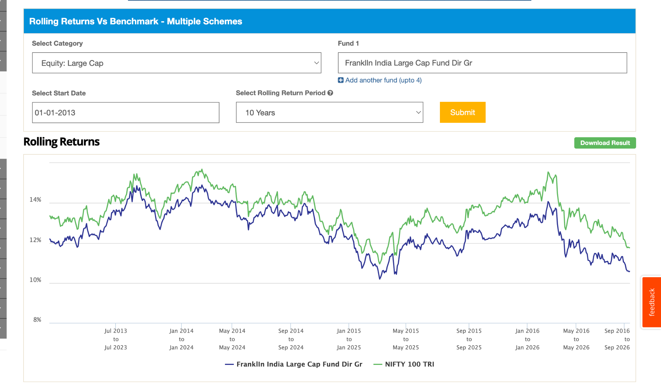ratio. 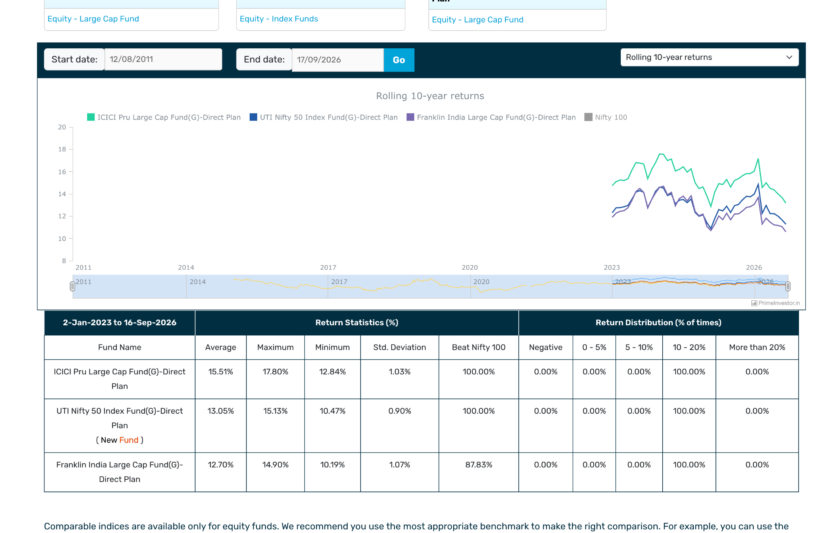
- DSP Large Cap Fund: 2013, 7k, 1.2: not great perf. in long term but still able to touch benchmark not much diff.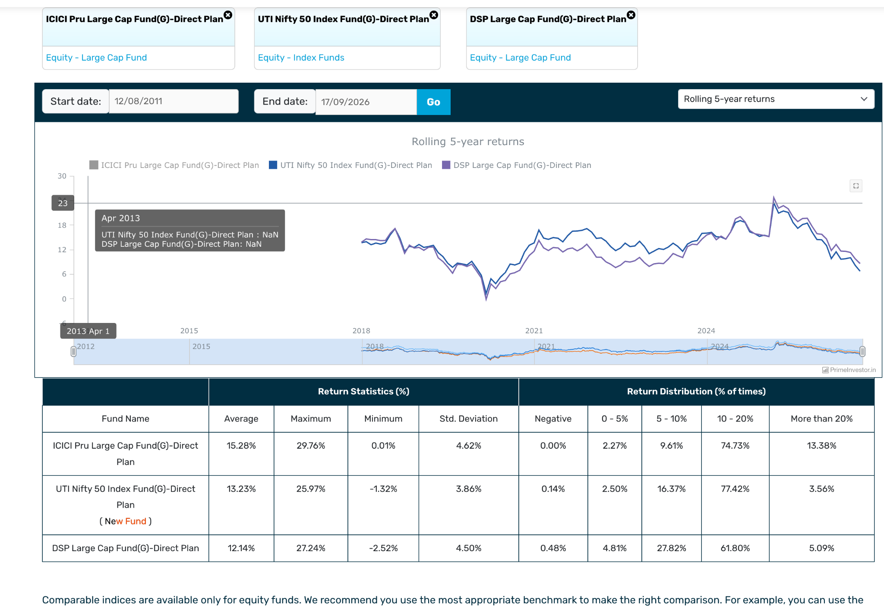l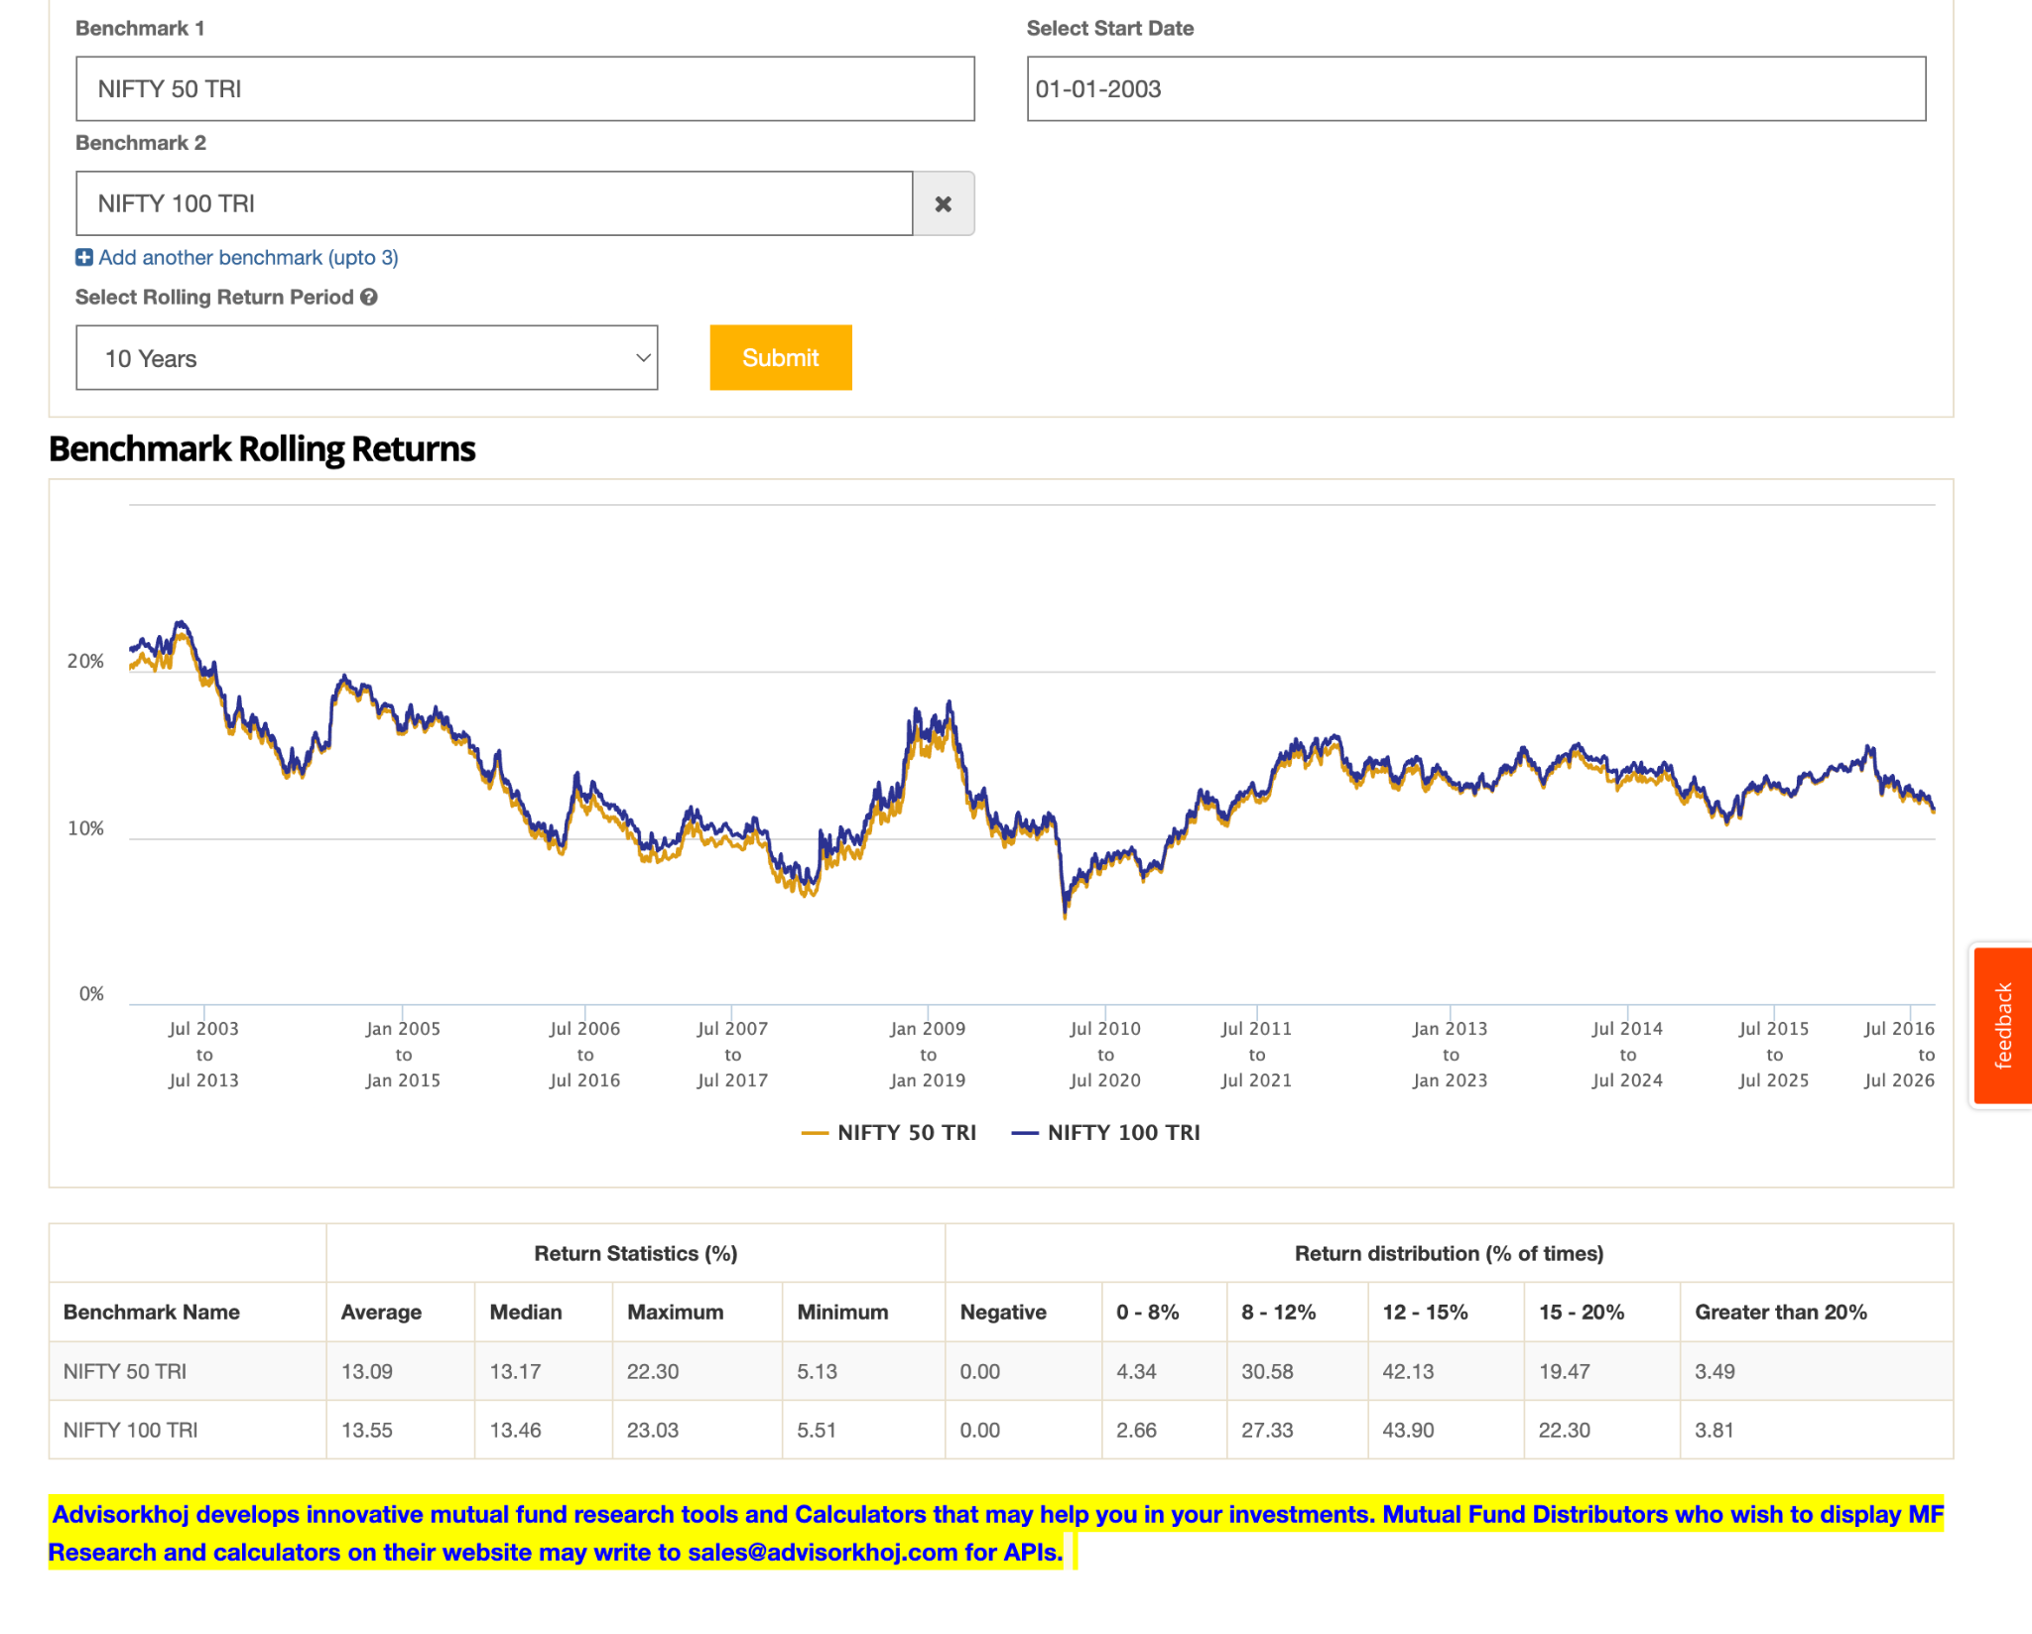.
- Quant Large Cap Fund: ( 4y, 3.5k, 1.53 ), not much data but still able to beat. seems more volatile. more cyclic but good performance overall.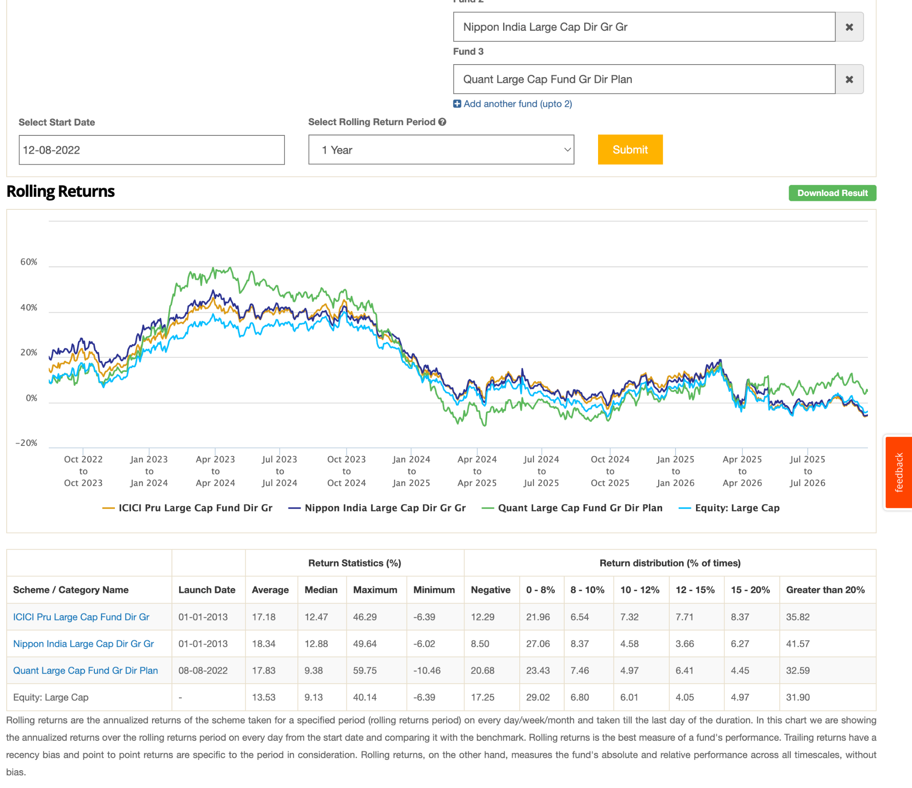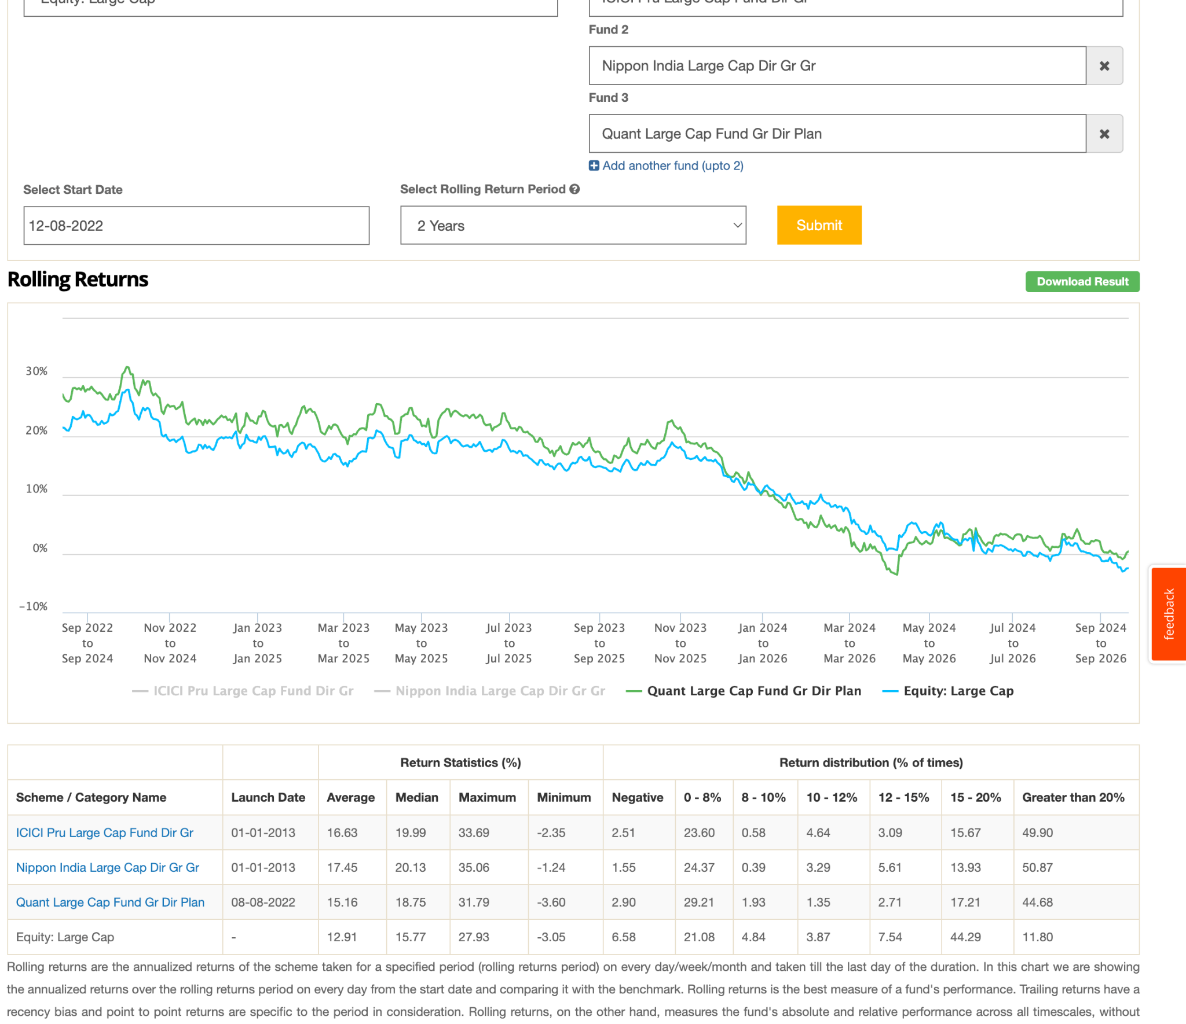
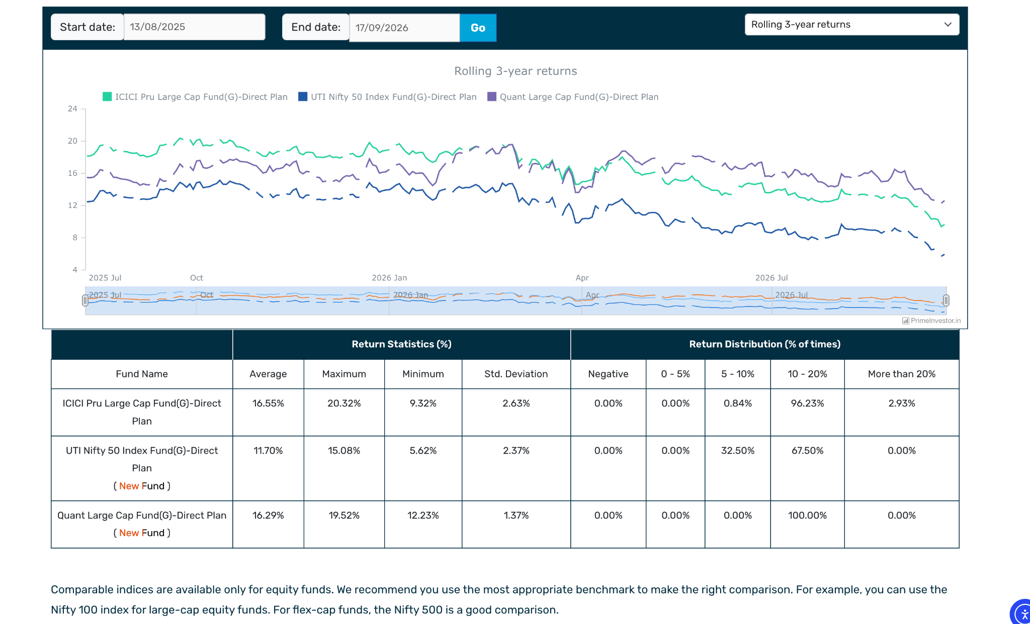
- Motilal Oswal Large Cap Fund: new ( 1-2y, 3k ). 1.02 can't just here: 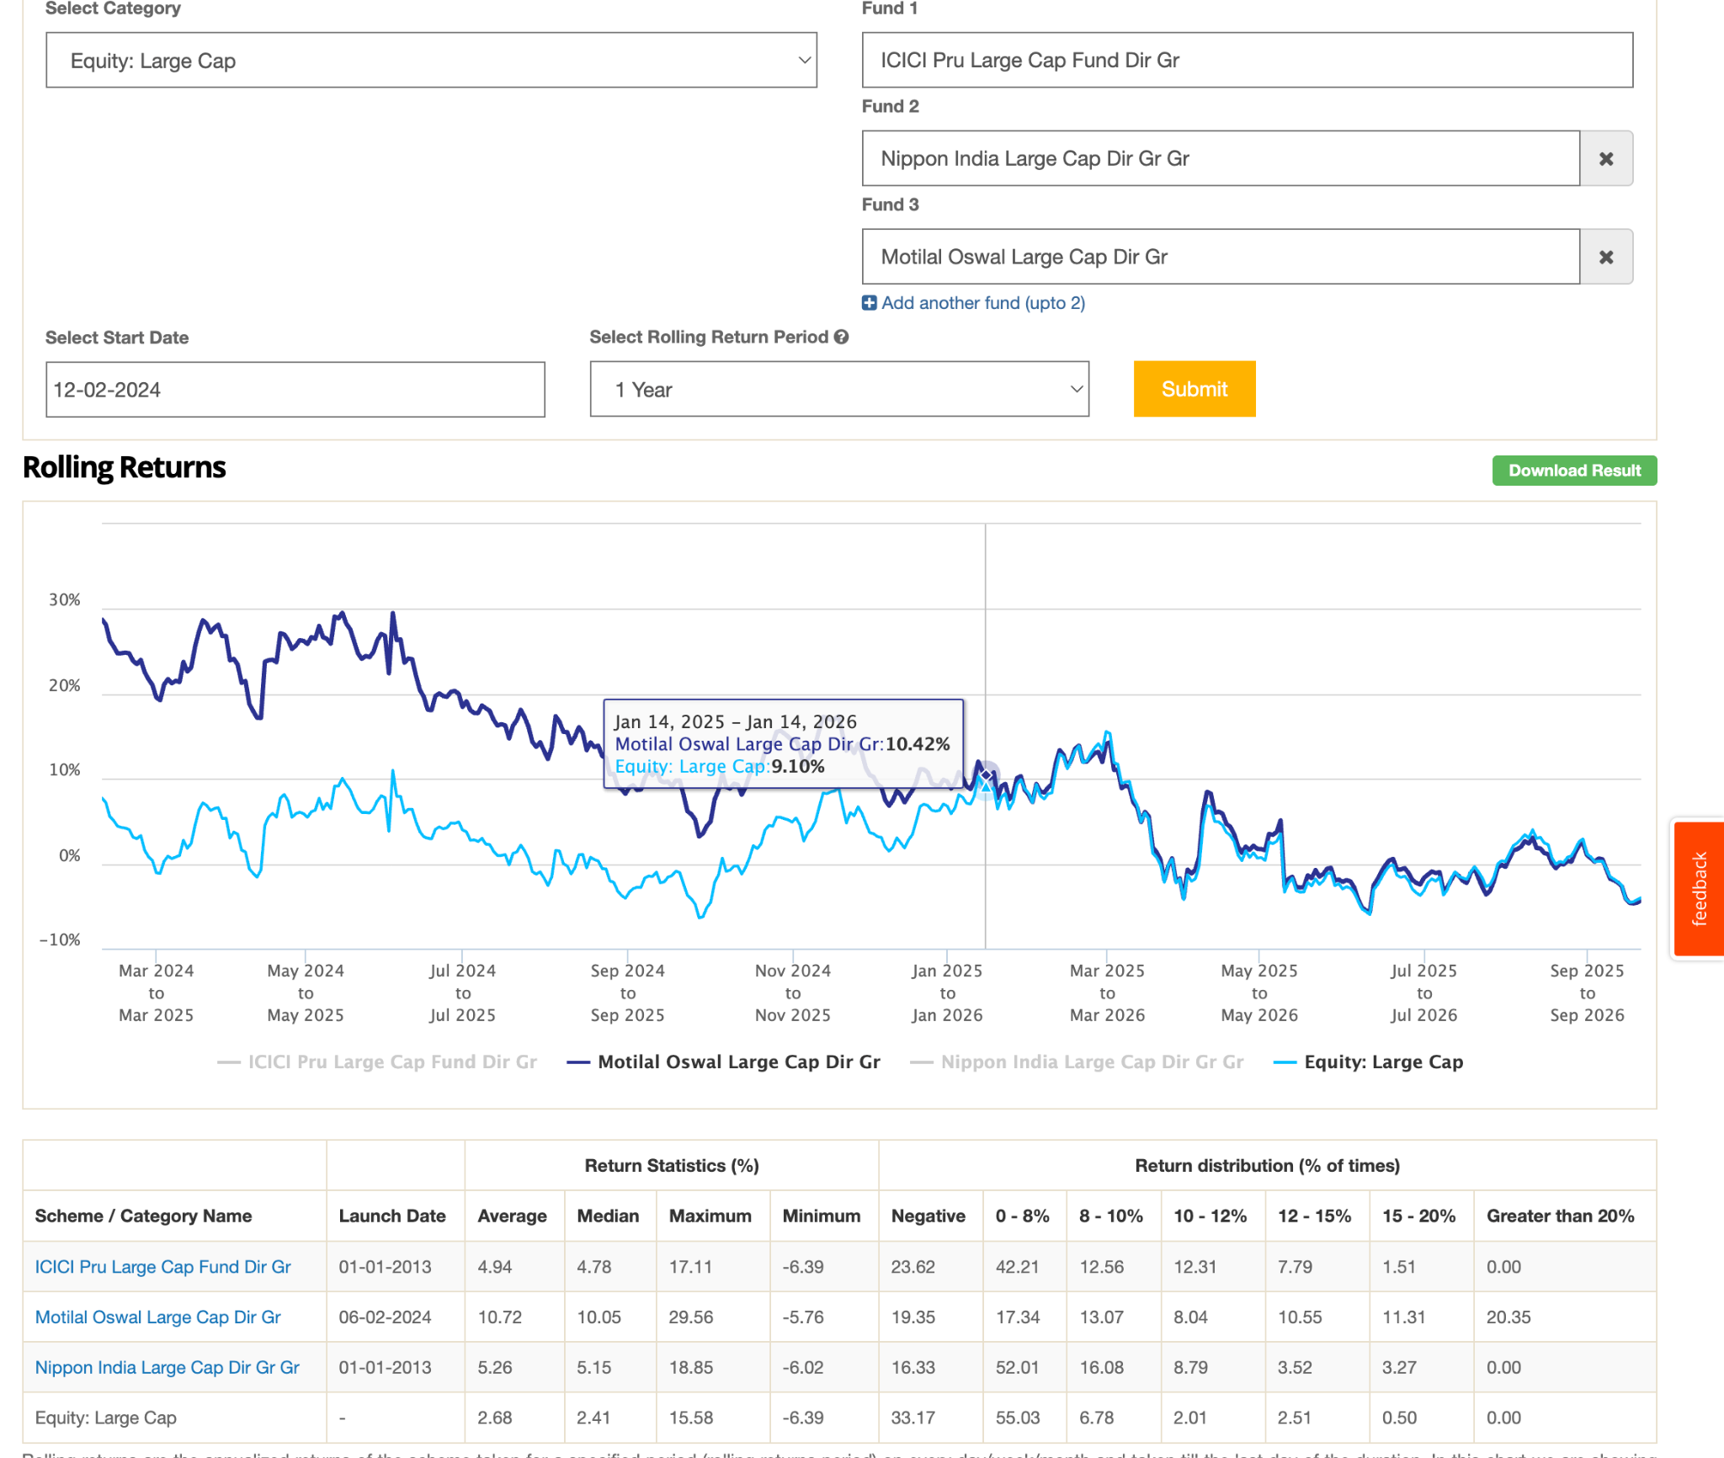

- Sundaram Large Cap Fund ( 3k, 5Y old, ) just beating index. in one year bit up and down overall less than index.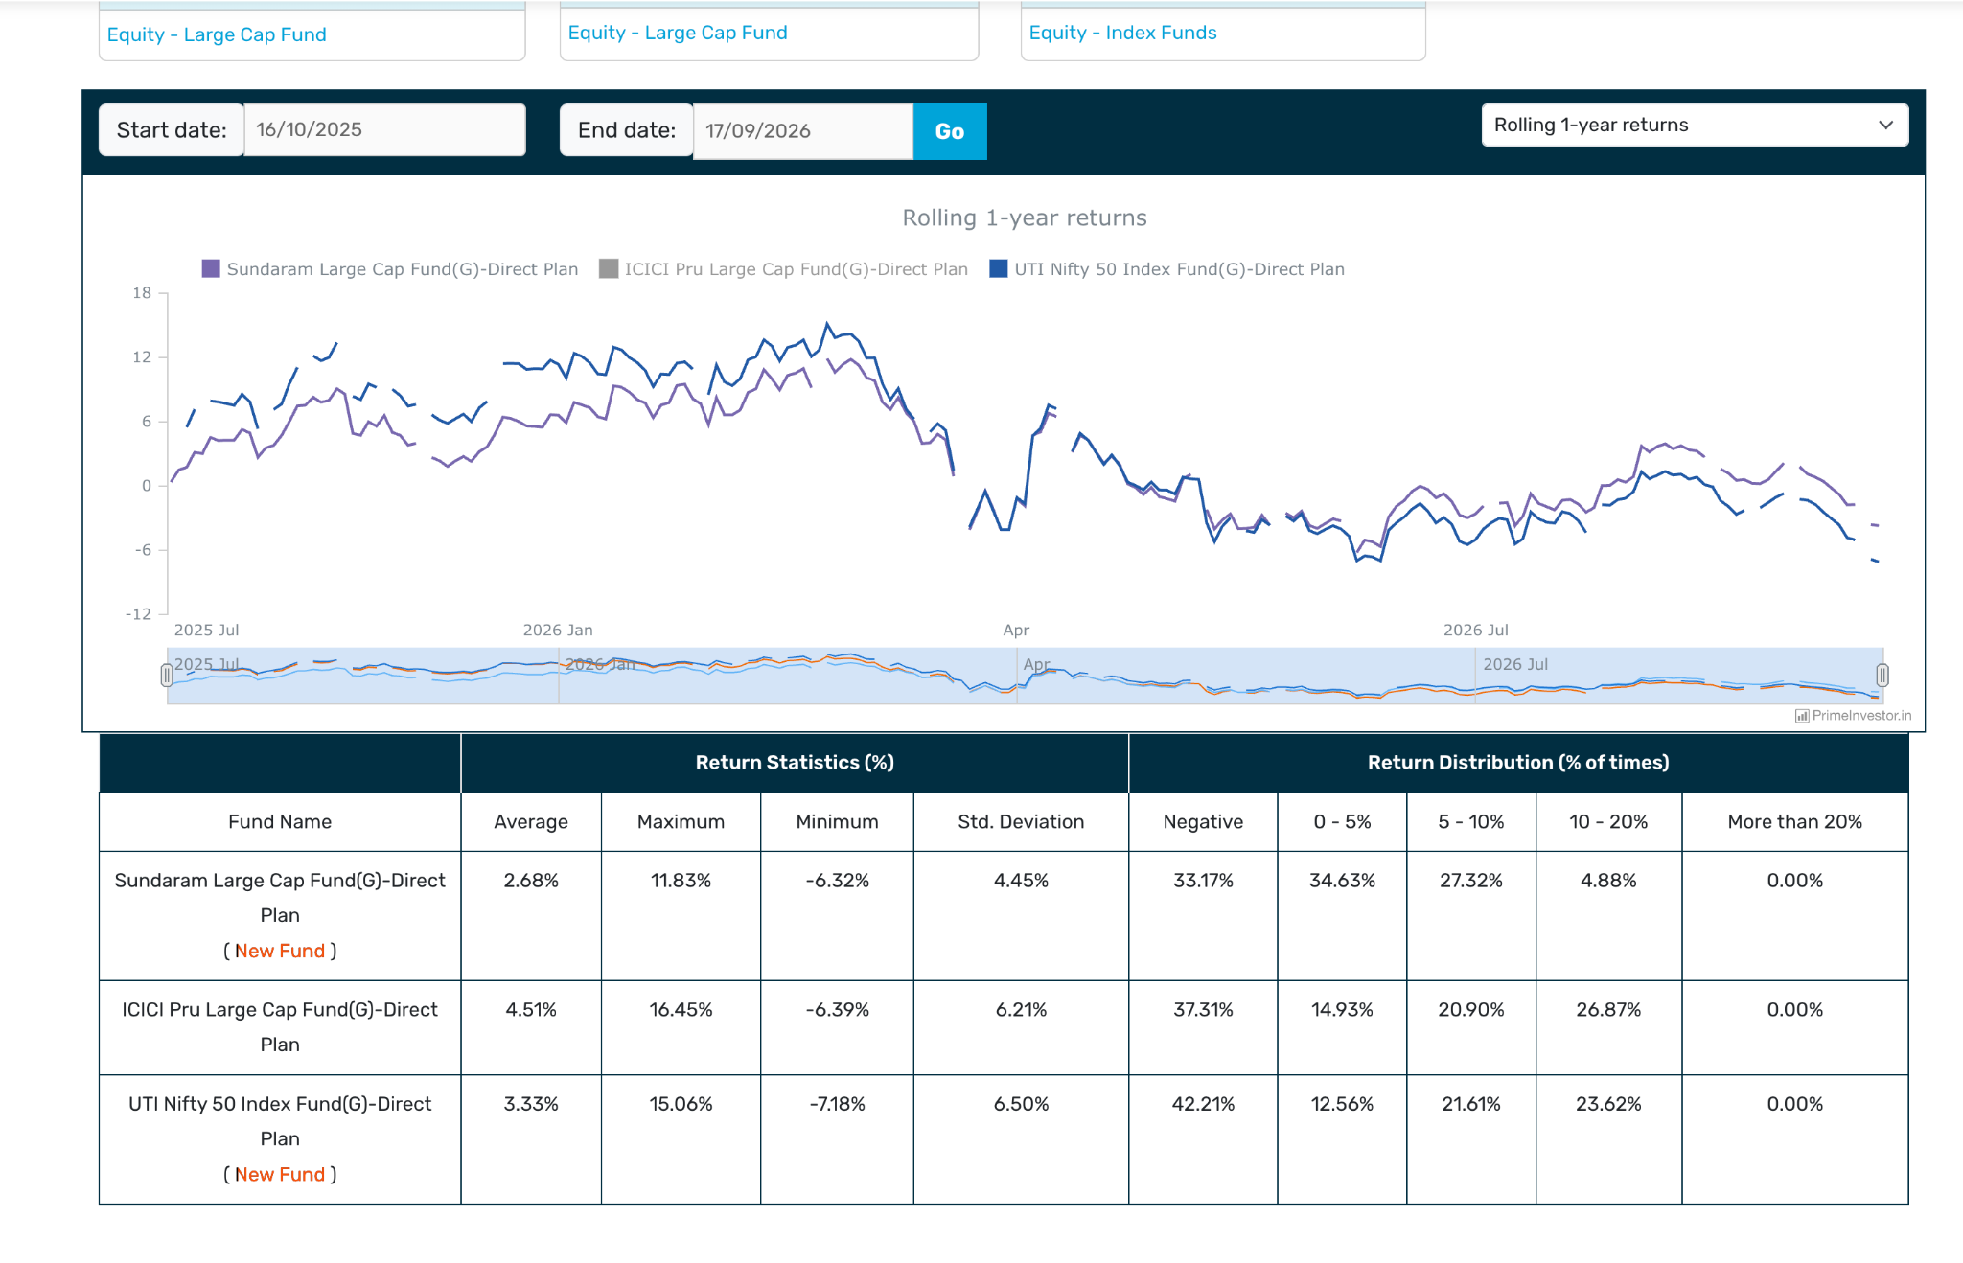

- As per above result, its seems better option is active fund ( lets keep that money in nifty 50 or later remove, but invest in active only at worst cast mostly touch or bit low but most of them not understa performa ce. that yt video was consider 1 year rolling, that is nto correct way to judge funds.
- choose out of ( may be 2 for now, but later might switch to one or as per observation )
- icici , cananra, nippon
- 10 y nipon better
- 7y canara seems better
- seems icici middle of canara and nipon and hey are opposie
- one thing is sure canara has great down side protection 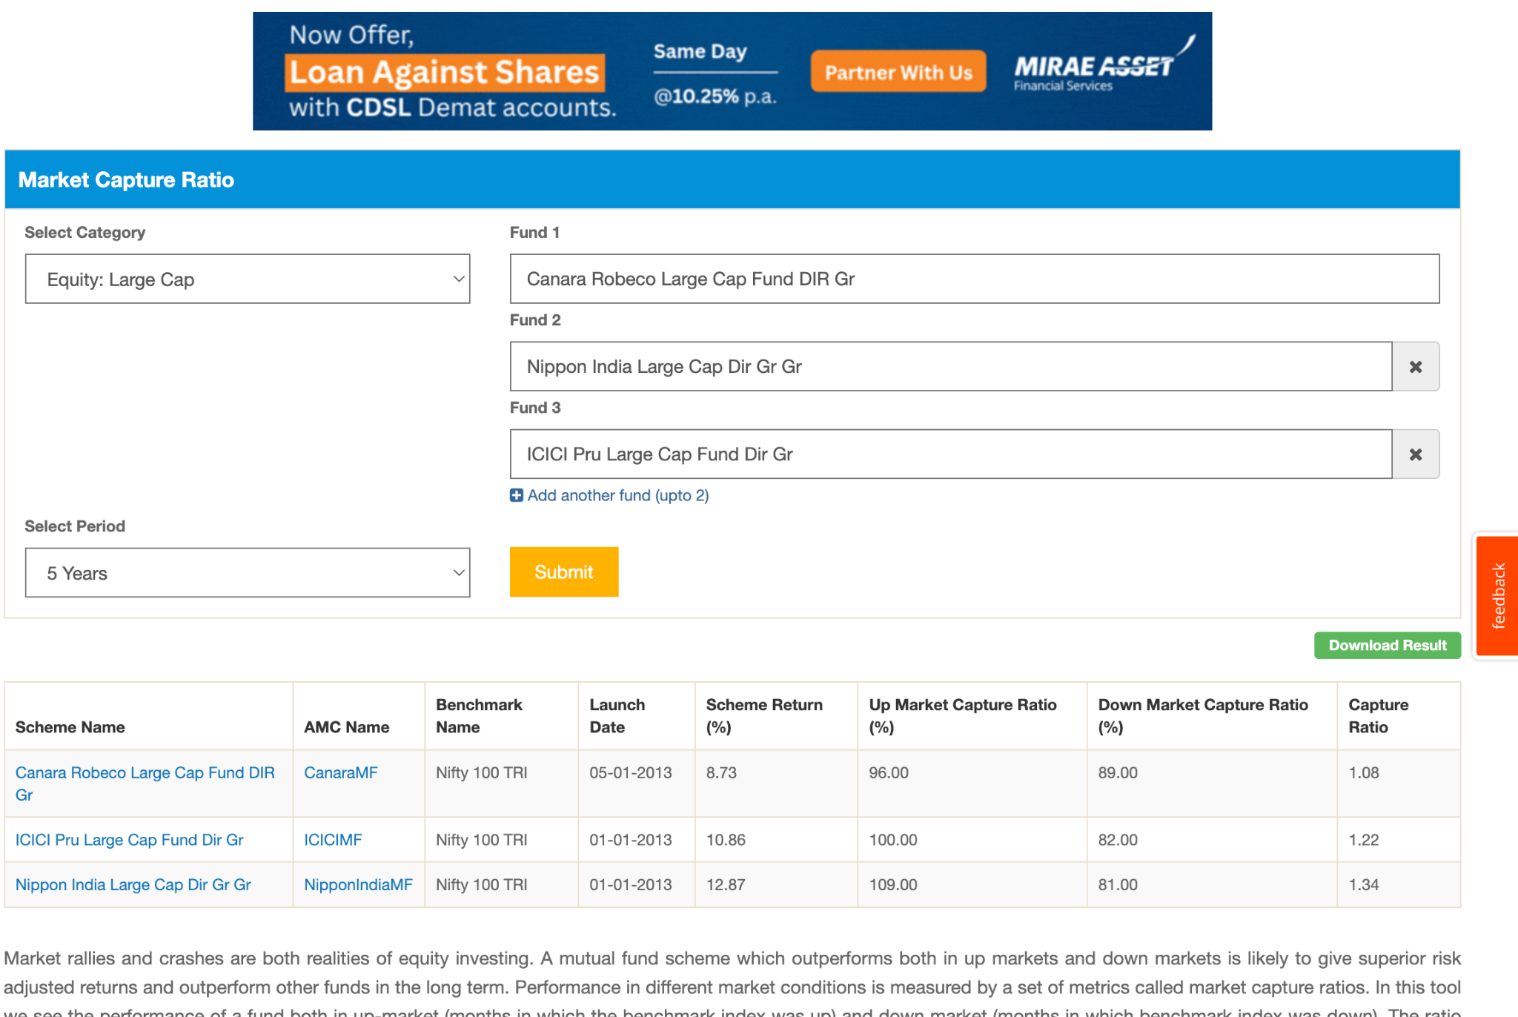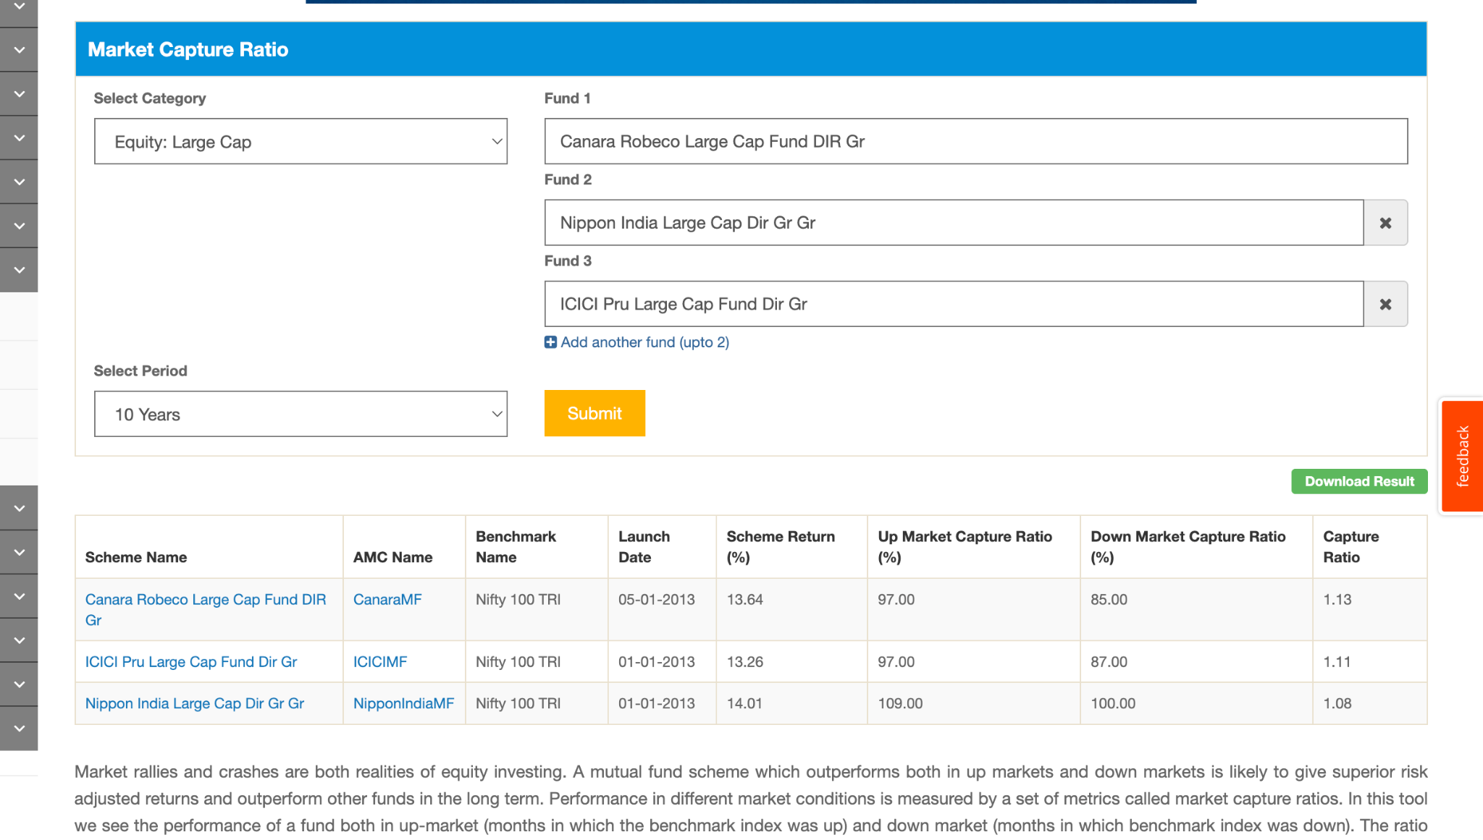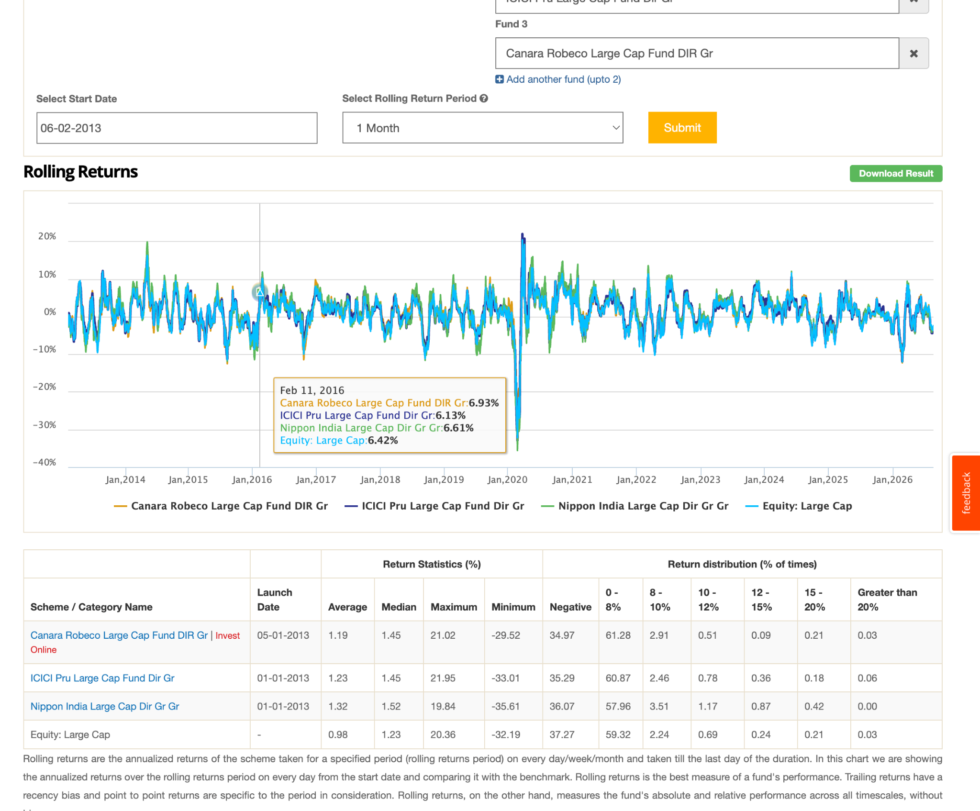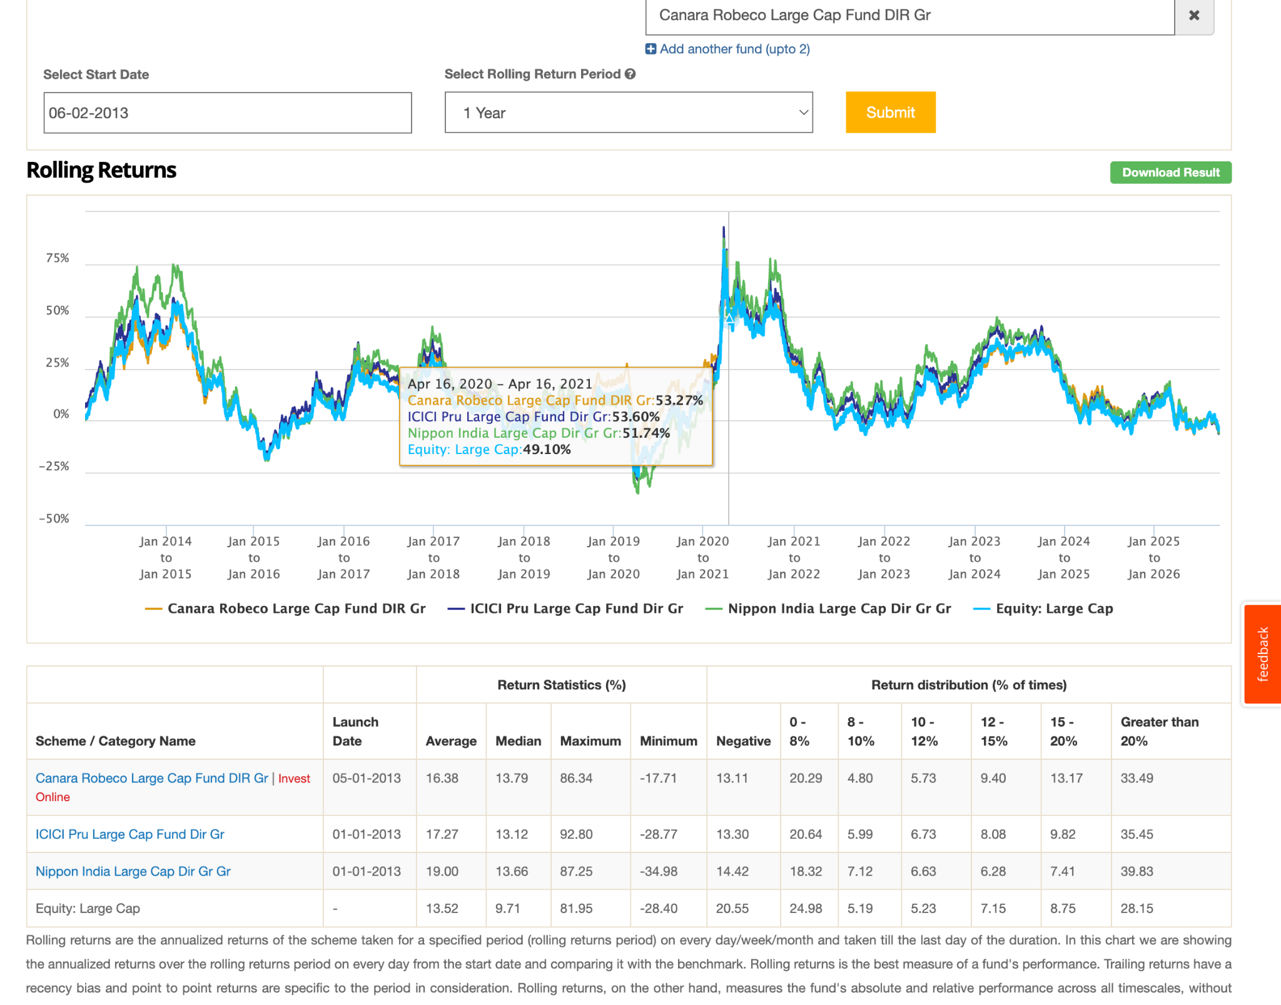
- 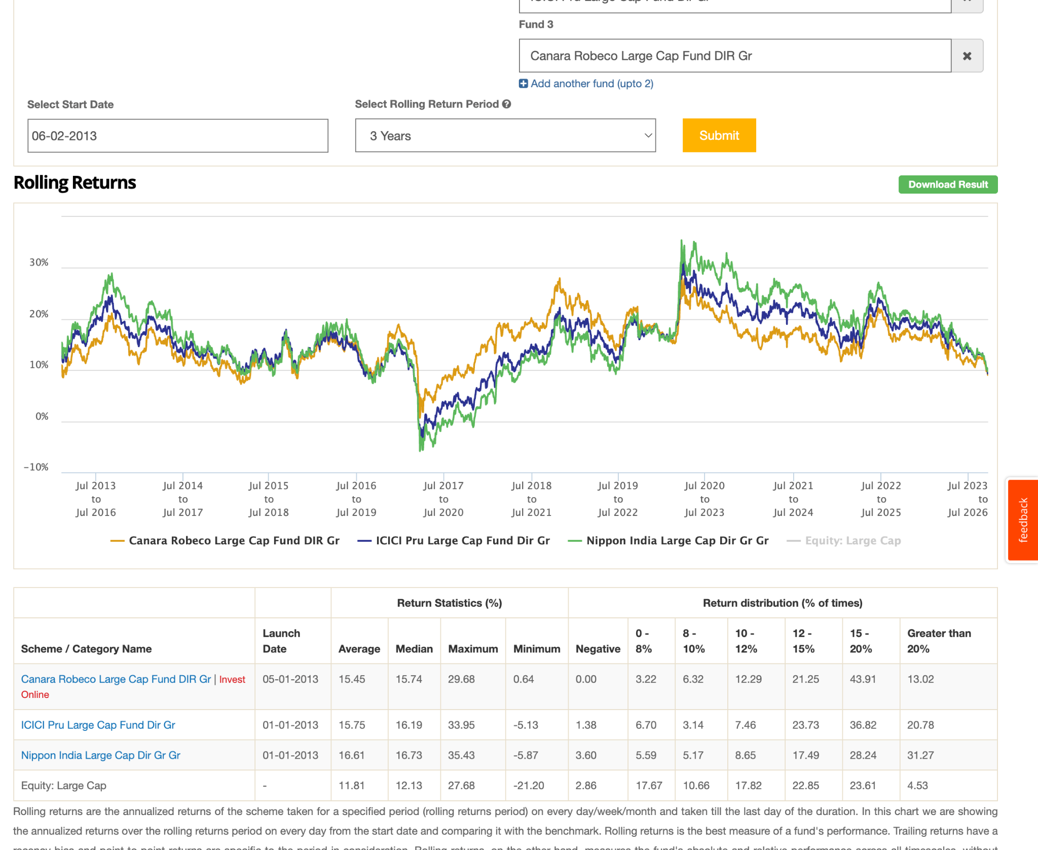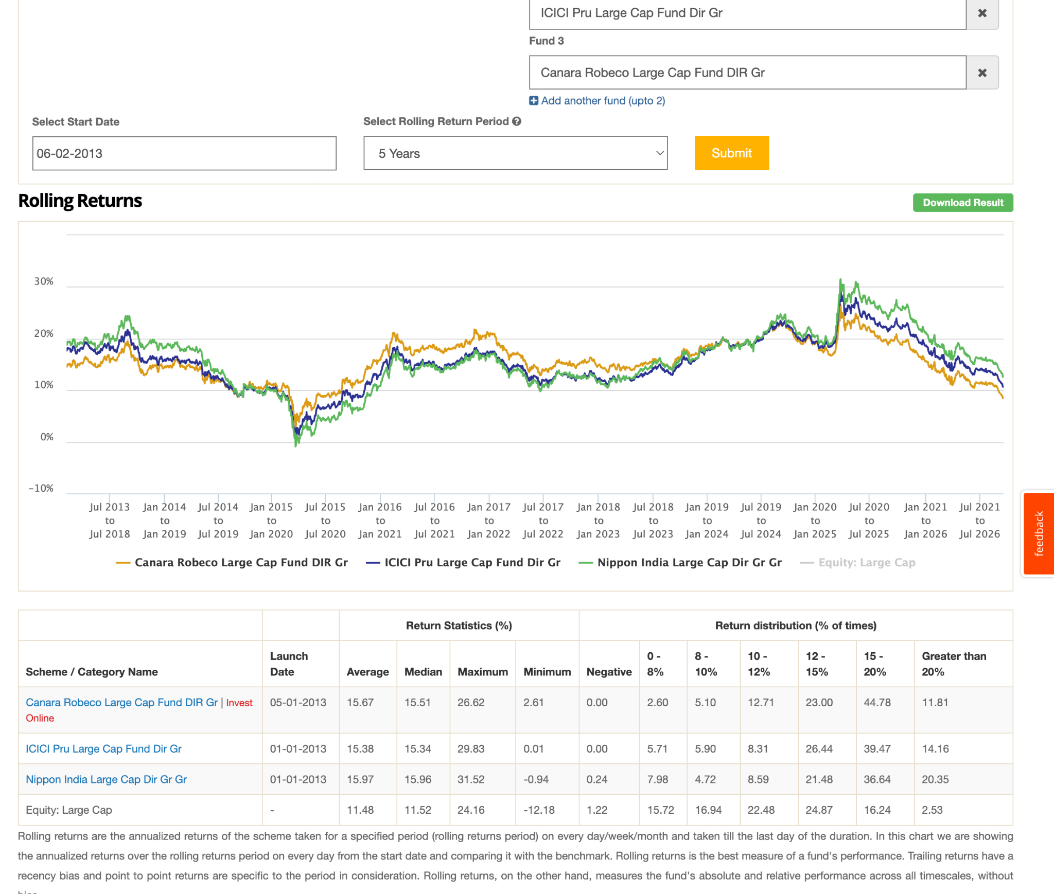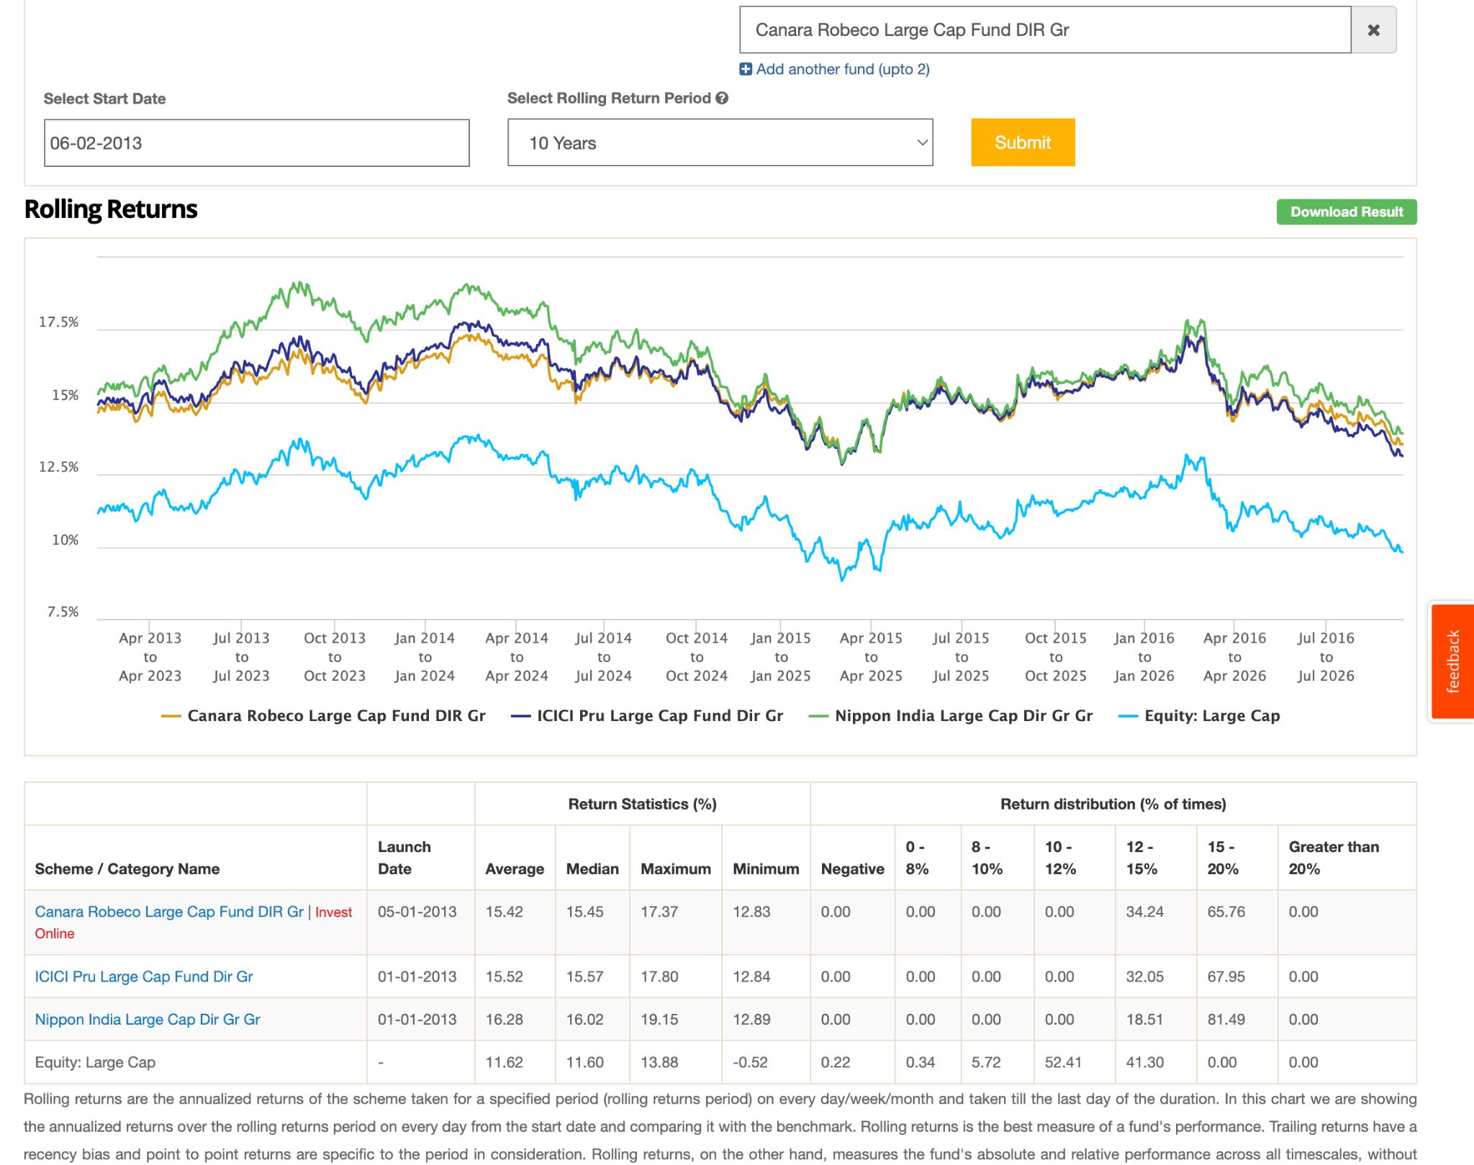

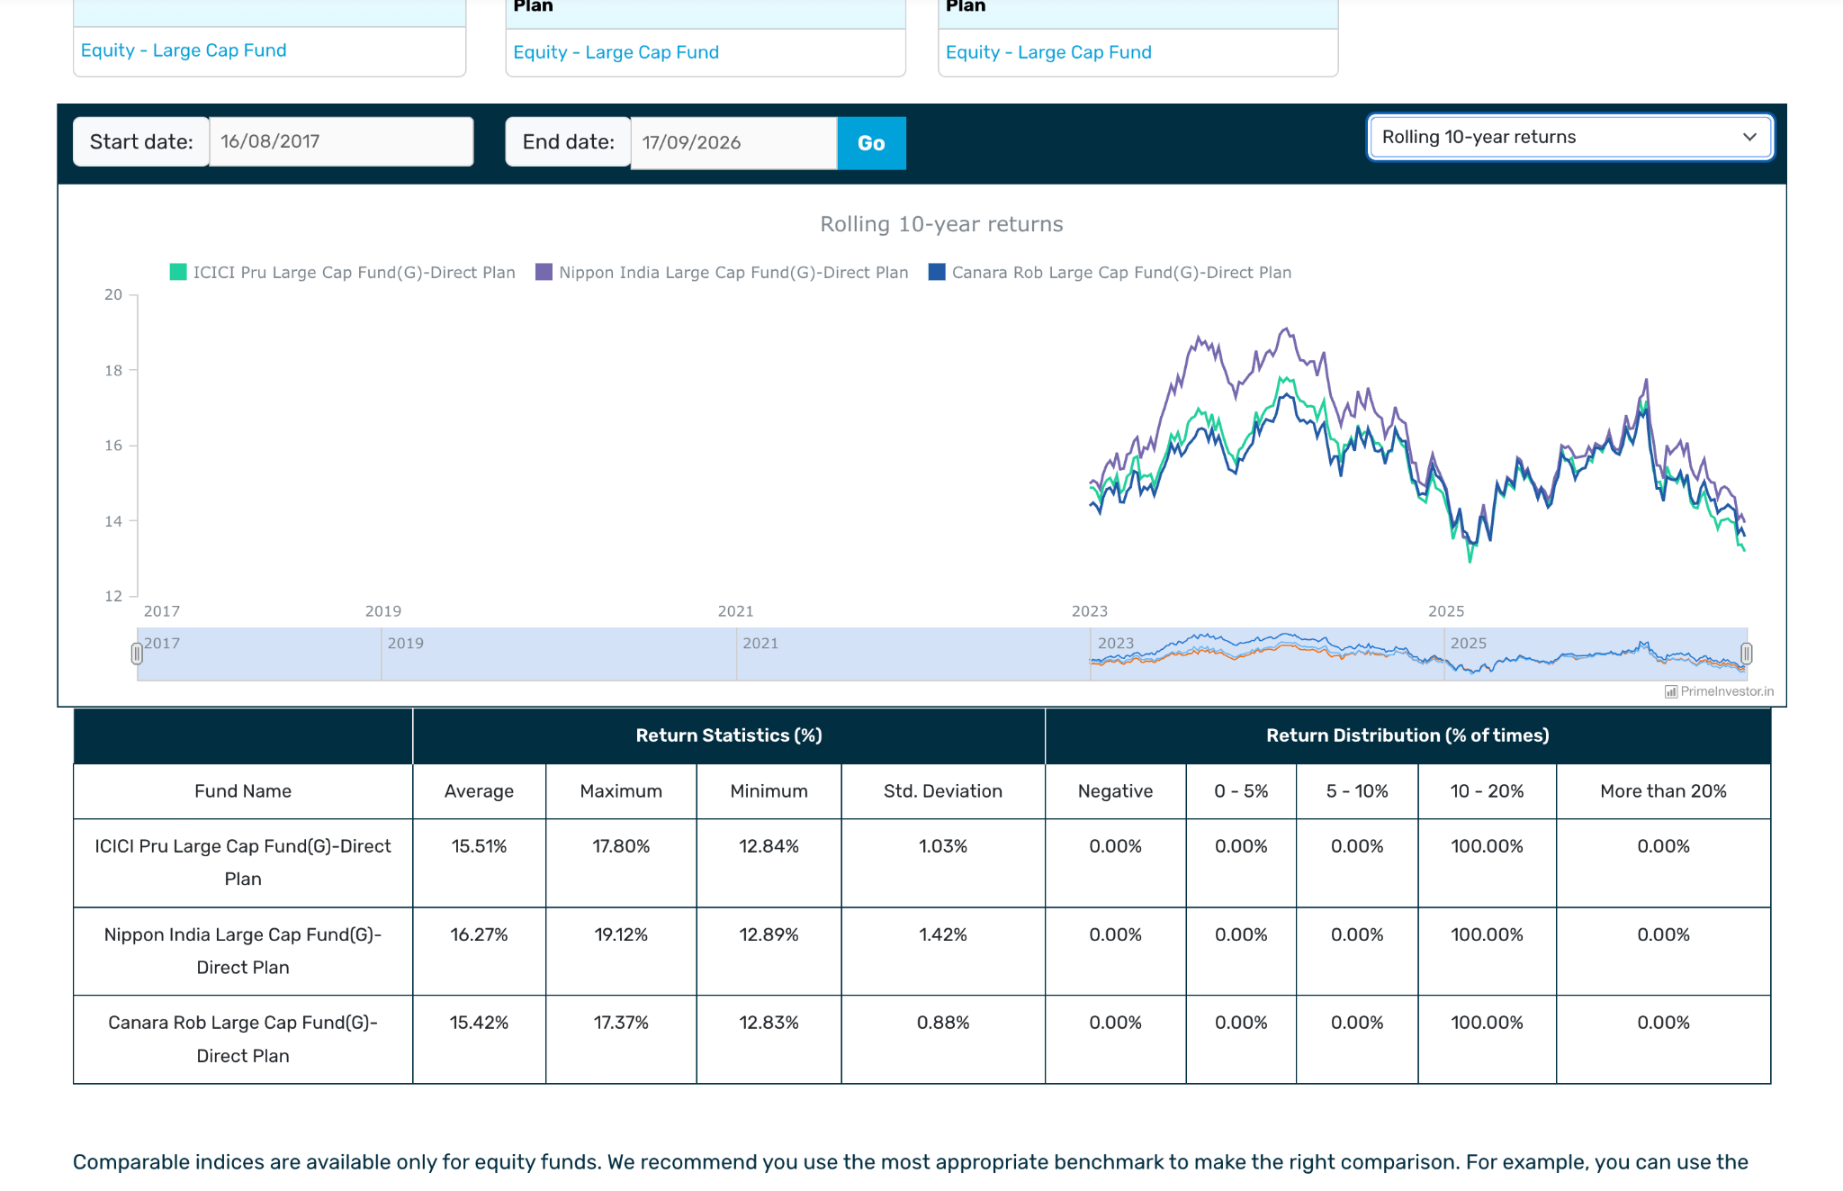

According to this chatgpt:
https://chatgpt.com/c/6ab0e9d5-11b4-83ee-95e8-31457a60d8a0
- nippon -> canara -> icici.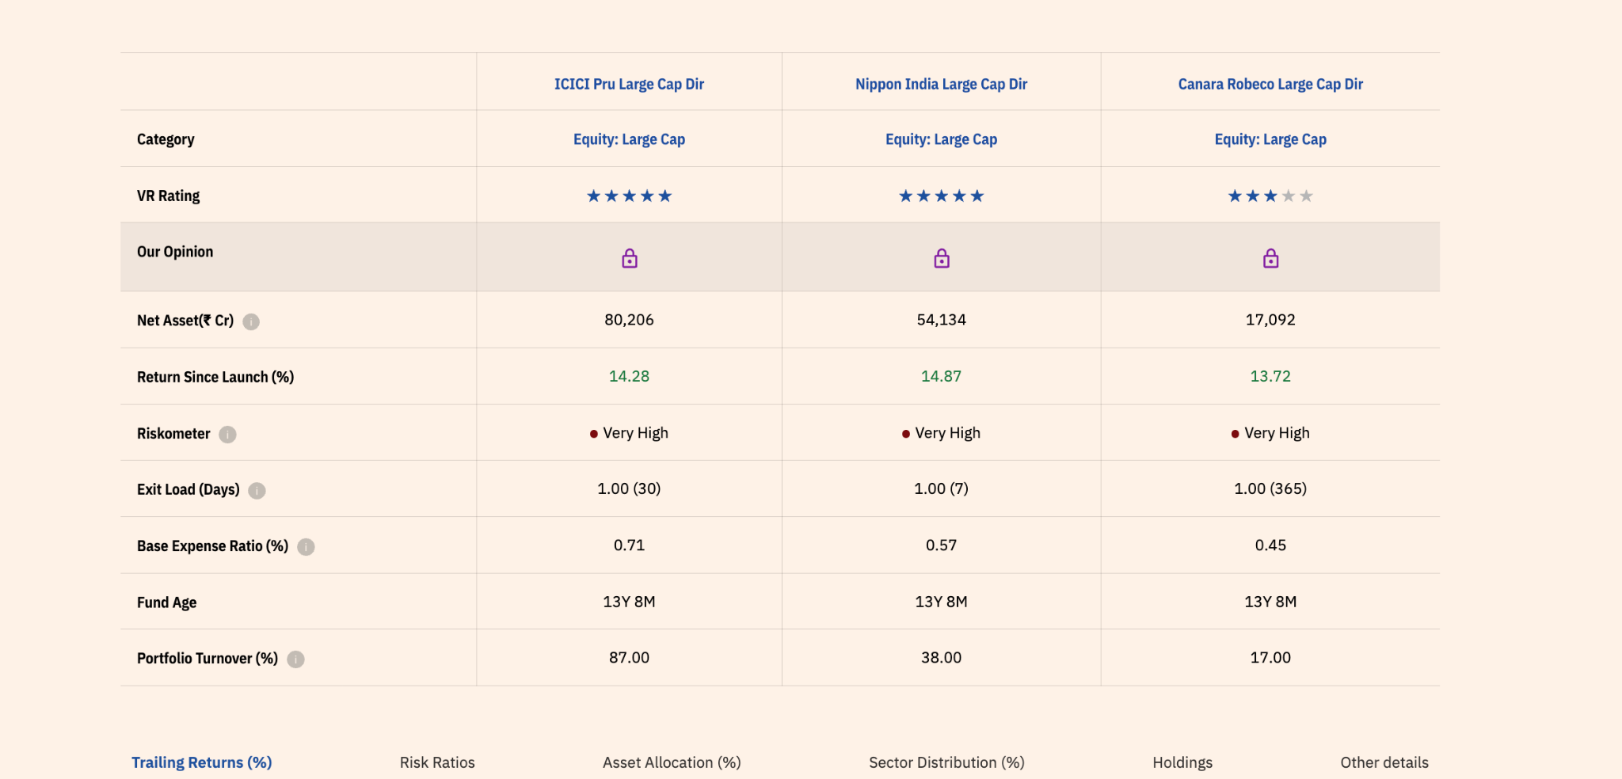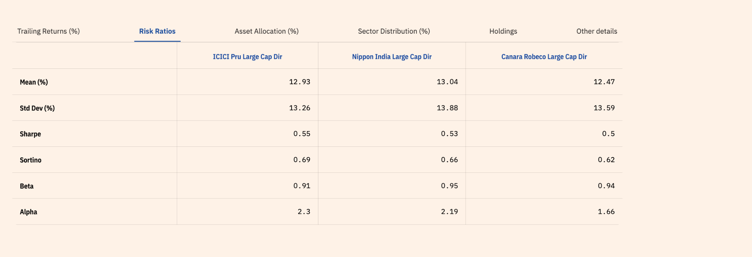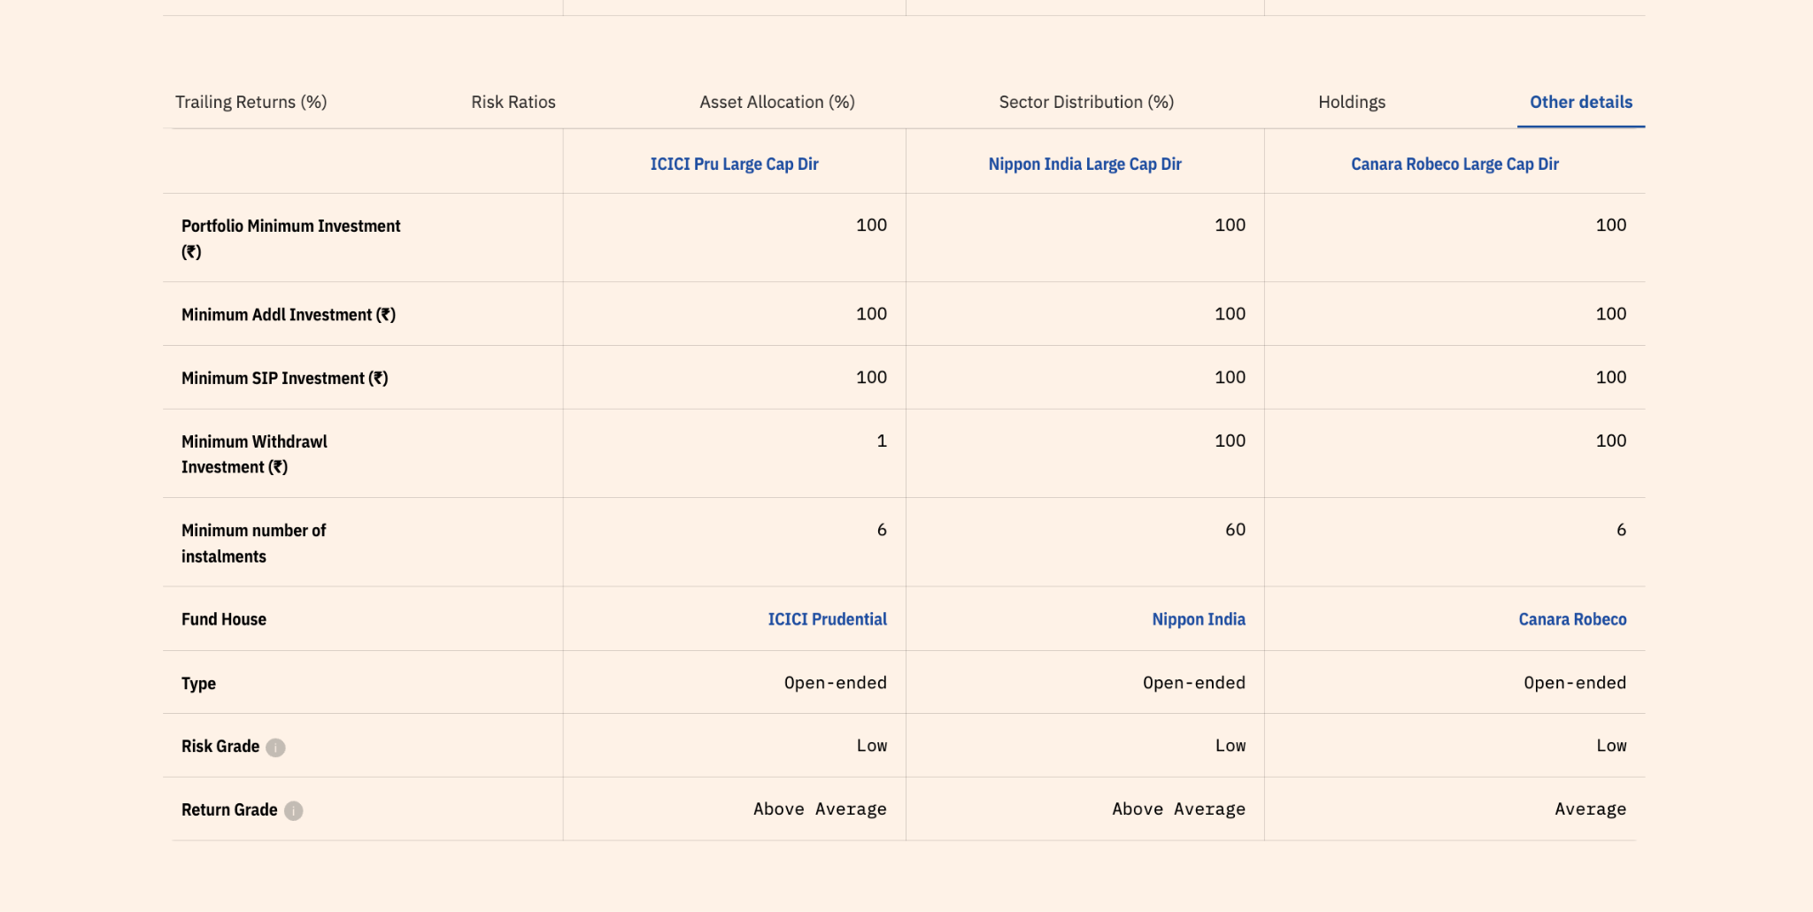 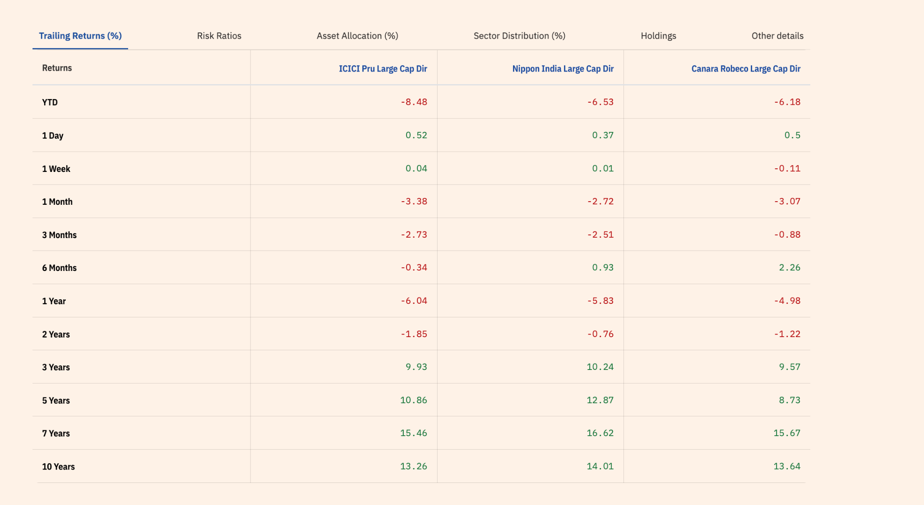but these are depend upon recent data.

1. Nippon India Large Cap
Why I chose it
- Old fund, old scheme
- manager continuity:
  - Sailesh Raj Bhan has managed the fund since August 2007.
  - Bhavik Dave has been assistant fund manager since August 2024.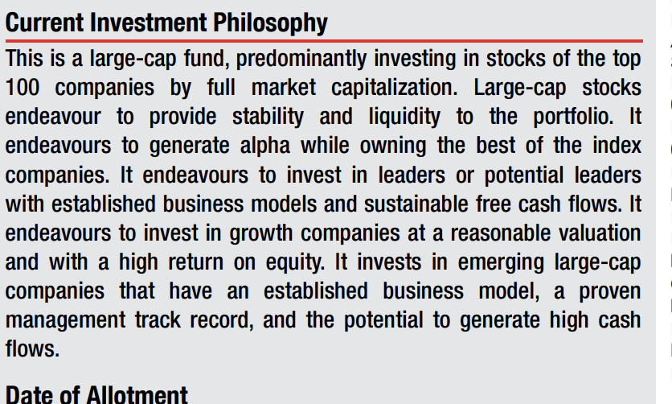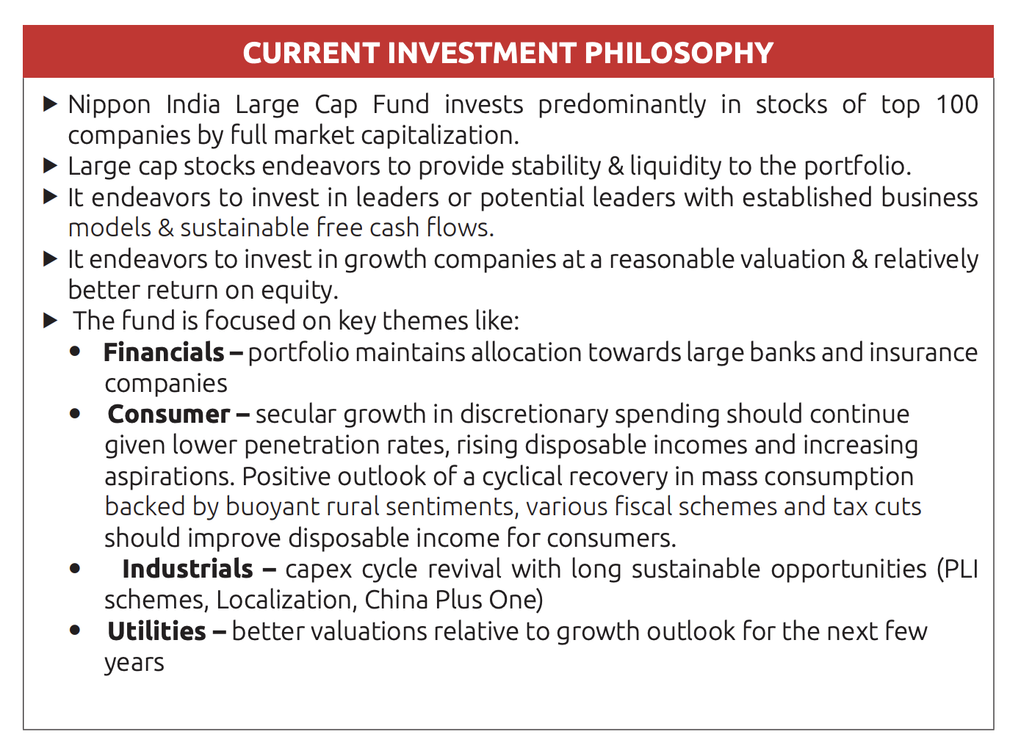
- the style roughly as GARP / quality-growth, rather than pure value or pure momentum.
- Very long manager tenure
- The historical record is also respectable:, in rolling beating
- 69 stocks
- 0.87% expense ratio
- great performance than other in rolling average most of the 10, 7,5,3.y.
- presentation: https://mf.nipponindiaim.com/FundsAndPerformance/Presentation/NipponIndia-Large-Cap-Fund-PPT-July-26.pdf
- relative more volite than other.

2. ICICI Prudential Large Cap
Why I chose it
- Old fund
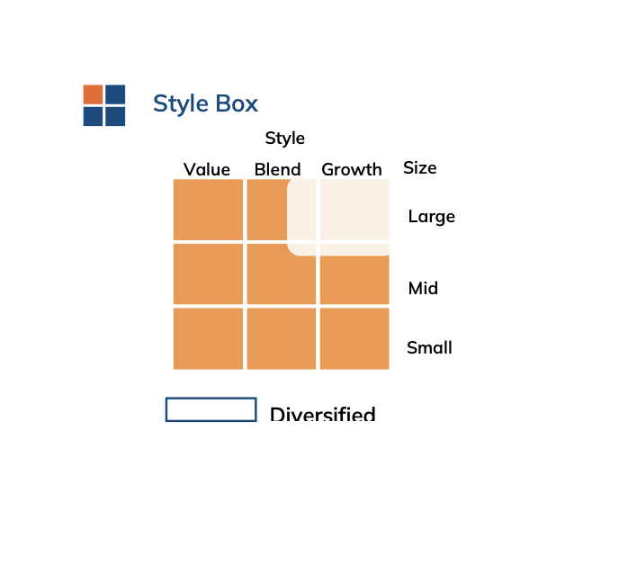.
- Since narayan is fm , mostly value and contarian thinking ( 2025 present, not found new also not much info )
- An interesting part of the strategy is that it follows a sector-neutral approach relative to its benchmark.
  - In simple words: it doesn't want the portfolio's sector allocation to move dramatically away from the benchmark.
  - So it can take stock-level bets while keeping the overall sector structure relatively diversified.
- The fund describes itself as Growth Style.
- high aum 80k
- 100 stocks. ,
- less alpha generate than nippon.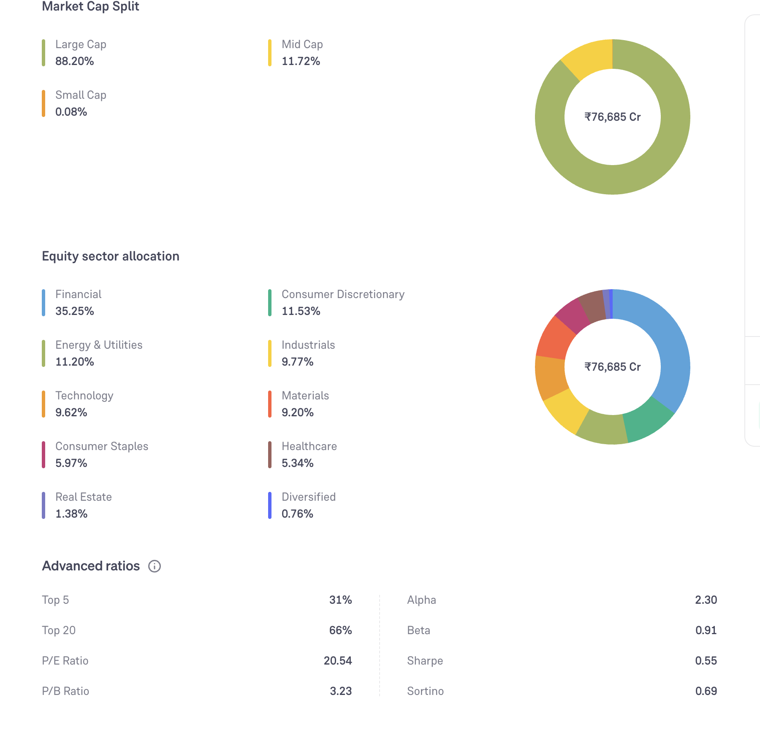
- Manager team.
  - Sankaran Naren started managing the fund only in February 2026.
  - Vaibhav Dusad has managed it since January 2021.
  - Sharmila D'Silva came in March 2026 for the relevant overseas/derivative responsibilities.
  - Previous manager Anish Tawakley ceased to be fund manager in February 2026.
- Sankaran Naren is famous
- The fund's investment approach is also somewhat benchmark-conscious. That can make it easier to use as a core large-cap fund, but it also means I wouldn't expect the portfolio to look radically different from the large-cap universe.

3. Canara Robeco Large Cap
Why I chose it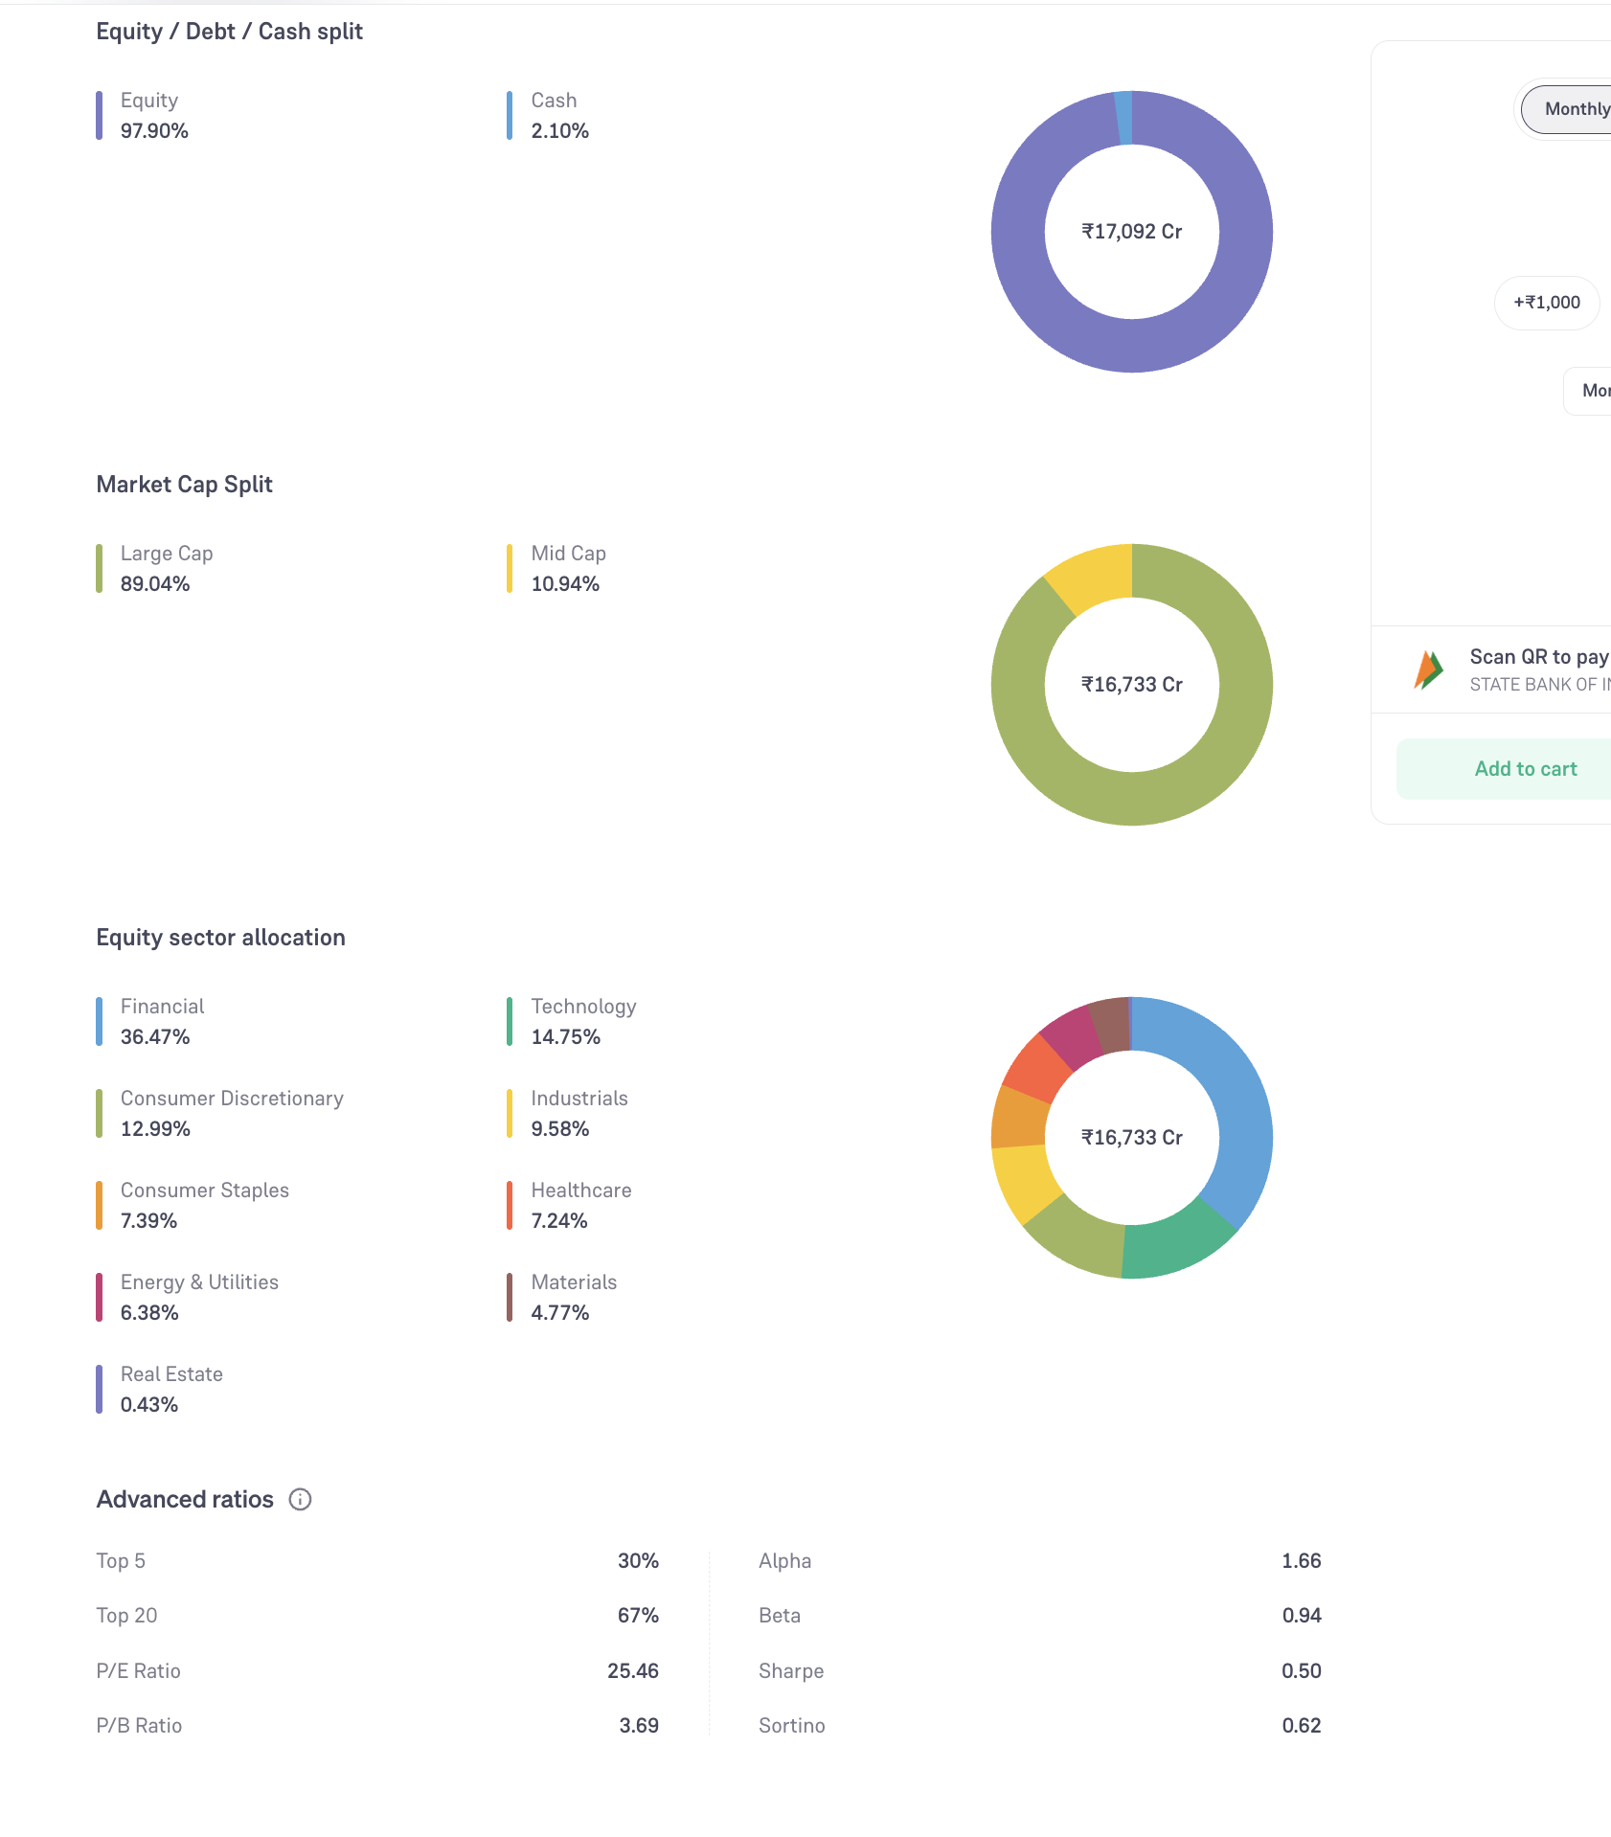
- Old fund
- 19th rank amc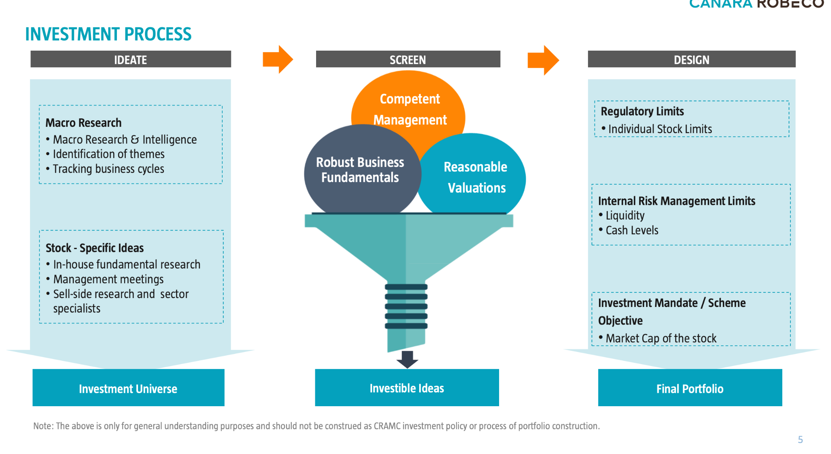
- Current management has relatively good continuity:
  - Shridatta Bhandwaldar → managing since July 2016
  - Vishal Mishra → managing since June 2021.
- 3 star raing on VR and groww
- 63 stocks
- AUM is around ₹17,136 crore
- less aum as compare to toher.

- Not taking canara because of AMC, its rank is 19th. but definatey observe.
- nippon and icici has large aum , but shouldnt' beproblem in large cap.
- both has overlapping of 60%
- both have ~38% overlapping with PPFCF.
- lets pick both , nippon 60: , icici: 40 or 55, 45. and pause nifty 50.

